Gwangju Institute of Science and Technology
Course Registration System

User’s Manual

Overview of Course Registration System

You can search for necessary information in the GIST Academic Calendar by year/ month.
All Times
Academic Calendar

Search for a Course
You can search and inquire for the necessary curriculum in the course.
All Times

Select the department and details on course that you are interested in and register. Or you can also register through search; you can check the details and time schedule after completing the course registration.

By Term
Register for a Course

[Basic Service Composition of Course Registration]

Students can systematically plan their semester in advance through academic calendar and course search. They can also receive information on their department about necessary course registration guides and precautions in advance, and view timetable and view information easily during course registration. It also has printing function enabled.

- Academic calendar is an academic history information service that allows students to view necessary information for academic work based on the current year/month, and they can also check the same schedule content on the portal system.

- Course search is an externally provided service, thus external students without log-in can search for courses opened in the current year/semester in GIST and check the courses they are interested in.

- Course registration can be accessed using GIST student’s personal information (ID, password). During the course registration period, students can search for subjects by departments and register for them. After course registration is completed, the students can print and view the timetable and the course registration details.

Access to the Course Registration System and Precautions

- URL: https://zeus.gist.ac.kr/sys/lecture/lecture_main.do

- Students can access the GIST course registration page for a convenient course registration.

- Precautions

1) No multiple logins allowed
- Students cannot login using multiple browser in one computer or login using one information from multiple computers.

2) Browser and Optimal Resolution
- Can be used in a diverse kind of browsers, such as Internet Explorer (Higher than V.11), Chrome, Safari, etc.
- Course Registration screen is developed based on (1600*900) resolution or higher, so it will be optimized when using Internet Explorer of V.11 or higher.

3) Use of Pop-ups
- If the student had set a pop-up blocker in their browser, they need to add https://zeus.gist.ac.kr as a website that allows pop-ups to be able to use some functions.( Tools Internet Options Privacy Pop-up Blocker Settings Add to allowed sites)
※ The setting method for each browser may be different.
※ In Chrome, do not check “Block this page from generating additional dialogs” message.

Course Registration Screen Composition and Functions Description

Main Screen
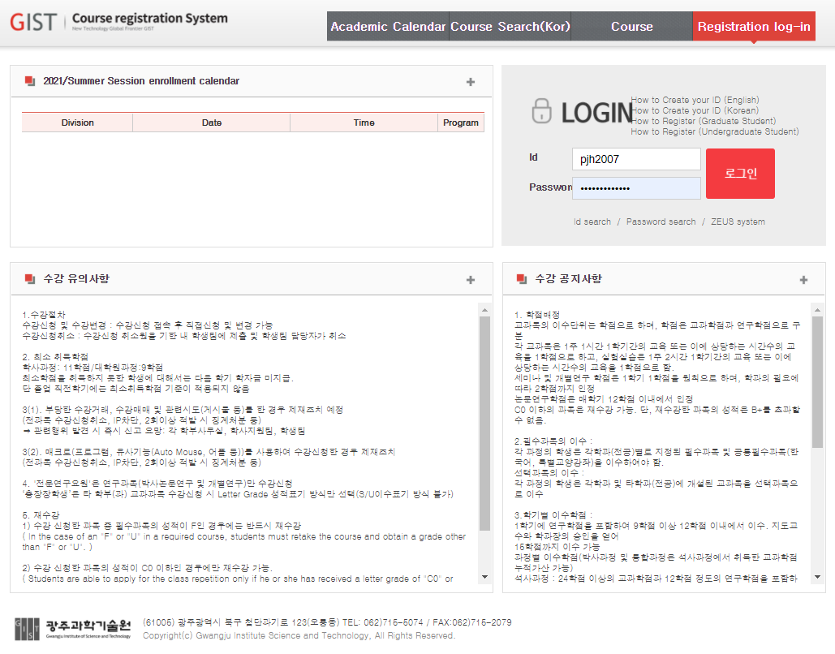
③
④
②
①
- Information on Course Registration Schedule.
- Information on Course Registration Procedure and Precautions.
- Information on Necessary Notice for Course Registration.
- Log in to the Course Registration System using ID and password and then click on the button.
- Id search/Password search
- Use this function to find ID or password.
- ZEUS system
- Go to the ZEUS system login screen.

3.2 Course Registration Information Page
③
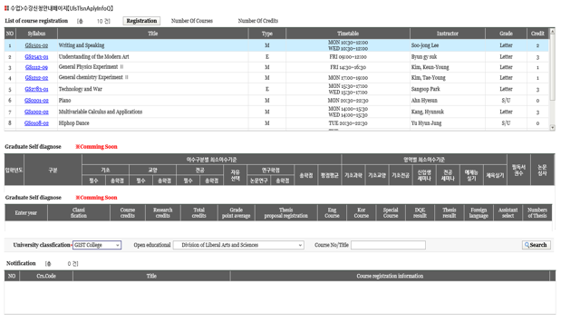
View Syllabus
Move to course registration processing screen
①
②

- Print the course registered.
- Courses: Total number of subjects on the course registered.
- Credits: Total number of credits for the course registered.
3) If the student clicked the course number, the Syllabus content of the selected course is displayed as a pop-up.
4) : Move to the course registration processing (for students) screen.
② This function is currently under construction and will be announced later.
③ Print the information content on the course registered.
- By default, it will print the course that the student is affiliated with.

Course Registration Processing (for students)
④
①
②
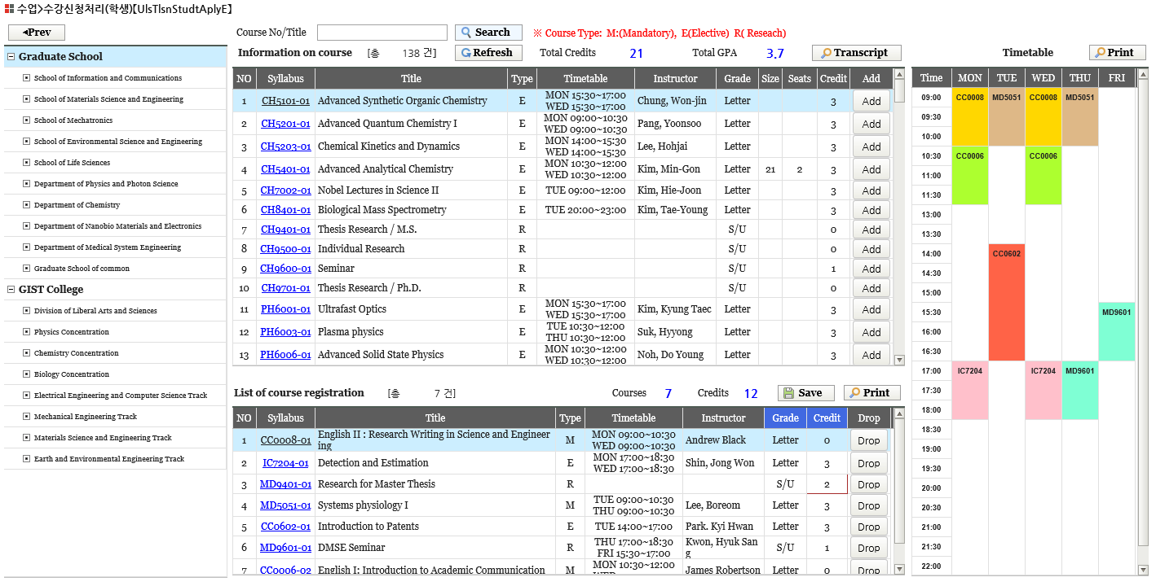
View Syllabus
③

- If the student clicked the department name, they can view the courses from that relevant department.
- The student can view the subjects of the open courses and register for them.
- Course No/Title: Enter the course number or name on the “Information on Course”and click .
- : Review the content on “Information on Course.”
- Total Credits: Total credits completed.
- Total GPA: Total grade point average.
- : Print the content of completed transcripts.
- The student can view the courses they have registered for and cancel subjects.
- : Modify the grade evaluation method of other departments’ subjects.
- : Enter the credits for the grad research dissertation course.
- : The modified grade evaluation method or entered credits are reflected here.
- Courses: Total number of subjects on the course registered.
- Credits: Total number of credits for the course registered.
- : Print the course registration form.

④ The timetable for the courses they have registered for is displayed by color.
1) : Print Timetable.
⑤ : Course registration is done by moving the desired subjects from “Information on Course” to “List of Course Registration."
⑥ : Courses registered in the “List of Course Registration” will be cancelled, and so does the Timetable.

Academic Calendar
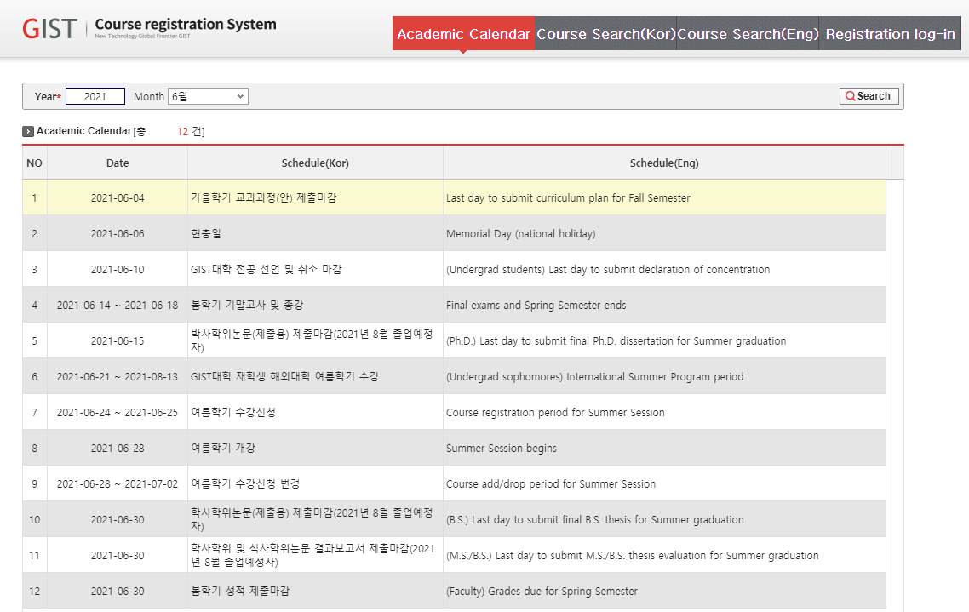

3.5 Course Search
- Print the contents of the academic calendar by month or year.
- If a student wanted to view other schedule, select the year or month and then click the button.

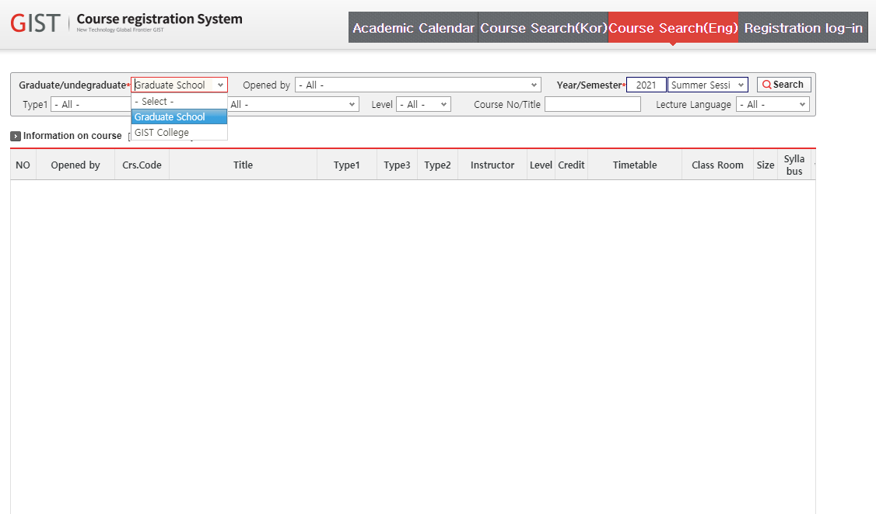

- It shows the content of the open courses.
- If the student wanted to view desired subject, select the subject name or enter the name of the subject and click the button.

