GIST, hyperlipidemia treatment fenofibrate proven effective in preventing heart failure caused by obesity and diabetes
Joint research by Professor Chang-Myung Oh's team from the Department of Biomedical Science and Engineering at GIST, Professor Shinje Moon's team from Hanyang University College of Medicine, Professor Sung Woo Cho's team from Inje University Ilsan Paik Hospital, and Professor Cheol-Young Park's team from Kangbuk Samsung Hospital

- Confirmed the effect of 'Fenofibrate' on suppressing cardiac fibrosis (50%↓) and inflammatory response (60%↓ or more) in obesity and diabetes-related heart failure... Also revealed that it can reduce the rate of hospitalization due to heart failure (10%↓ in hospitalization rate according to analysis of National Health Insurance data)

- "Suggesting a new treatment direction to overcome the limitations of obesity and diabetes-related heart failure treatment... More clearly elucidating the heart protection mechanism through follow-up research"... Published in the international academic journal 《Cardiovascular Diabetology》

▲ (From left) Professor Chang-Myung Oh, master’s student Jiwon Park, and PhD student Hangyul Song

Heart failure, which occurs when the heart muscle is damaged or aged and has problems with its contraction and relaxation functions, is known to rapidly increase in incidence in people over the age of 70. However, there is currently no effective treatment for obesity and diabetes, which are the main causes of heart failure, so the development of fundamental treatments for these diseases is necessary.

A domestic research team has confirmed that ‘Fenofibrate’, a well-known hyperlipidemia treatment, is effective in treating heart disease caused by obesity and diabetes. It is expected to be an important breakthrough in the treatment of heart failure in the future through a different mechanism of action from existing drugs.

The Gwangju Institute of Science and Technology (GIST, President Kichul Lim) announced that the research team led by Professor Chang-Myung Oh of the Department of Biomedical Science and Engineering has discovered the potential of the hyperlipidemia treatment drug ‘Fenofibrate’ to prevent heart failure caused by obesity and diabetes and to protect the heart.

Fenofibrate has been widely used as a hyperlipidemia treatment, but the results of this study confirmed a new function of suppressing inflammation and fat accumulation in the heart. It was also found to be able to reduce the rate of hospitalization due to heart failure, which is expected to suggest a new therapeutic possibility in preventing heart failure related to obesity and diabetes.

The research team confirmed that when fenofibrate was administered to a mouse model of heart failure caused by obesity and diabetes, cardiac fibrosis was reduced by 50% compared to the control group. In addition, the excellent anti-inflammatory effect of fenofibrate was also proven, such as a 60% and 70% decrease in tumor necrosis factor (TNF) and inflammatory cytokine* ‘IL-1β’ in the expression of inflammation-related genes, respectively.

Fenofibrate was administered to a mouse model of heart failure induced by obesity and diabetes for 8 weeks to confirm the effects of suppressing cardiac fibrosis and inflammation. In addition, improvement in cardiac function and suppression of inflammation-related gene expression were observed through echocardiography and gene expression analysis.

As a result of the experiment, in the group administered fenofibrate, cardiac fibrosis was reduced by 50%, and left ventricular ejection fraction (LVEF), which indicates cardiac function, was improved by 15% compared to the control group. In addition, the expression of inflammation-related genes TNF* and IL-1β was reduced by 60% and 70%, respectively, showing a prominent anti-inflammatory effect.

* cytokine: A protein immunomodulator secreted by immune cells. There are various types of cytokines involved in cell proliferation, differentiation, cell death, or wound healing, and many of them are particularly involved in immunity and inflammation.

* TNF (Tumor Necrosis Factor): Tumor necrosis factor is a protein that causes inflammation. If this protein is produced excessively, an inflammatory response occurs in the body, which can cause various autoimmune diseases.

The research team confirmed the cardiac function improvement effect of fenofibrate through a db/db mouse model* and a high-fat diet-induced diabetic mouse model.

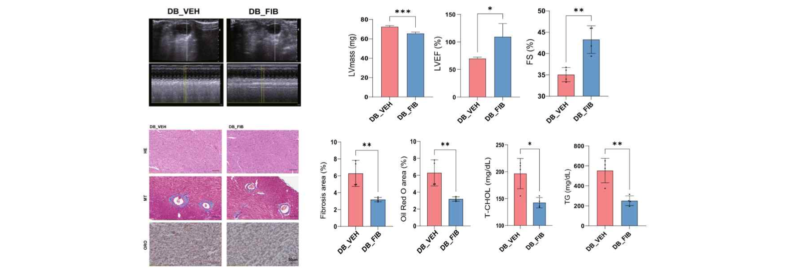▲ Effects of fenofibrate on improving cardiac function and reducing fibrosis and fat accumulation in genetically modified (db/db) mice that induce obesity and diabetes: Compared to the control group, the group treated with fenofibrate showed a decrease in left ventricular mass (LV mass) and an improvement in left ventricular function indices (LVEF, FS). As a result of observing cardiac tissue through staining, it showed a significant decrease in fibrosis and fat accumulation (Oil Red O area (%)).

In cell experiments, after creating a high-fat and high-sugar environment in H9c2 cardiomyocytes, fenofibrate treatment was confirmed to increase cell viability, suppress reactive oxygen species (ROS), and reduce cell death. After fenofibrate treatment, cell viability increased by 45% in a high-fat and high-sugar environment, and reactive oxygen species production was suppressed by 50%.

In addition, the cell death rate was significantly reduced (13.81% → 5.47%), showing a cell protection effect. Western blot analysis for protein detection showed that the expression of proteins related to inflammation and fibrosis was significantly suppressed, and in particular, the expression of TNF and IL-1β was confirmed to be reduced by 60% and 70%, respectively.

Through gene expression analysis, the research team discovered that the PPARα* pathway plays an important role in the cardioprotective mechanism of fenofibrate, suggesting that it may become a new target for future heart failure treatment.

* db/db mouse model: db/db mice are a mouse model used to study obesity and diabetes, and are congenitally insulin resistant, which causes diabetes.

* reactive oxygen species (ROS): Oxygen produced by cells, which can cause cell damage and inflammation if produced excessively.

* apoptosis: A process in which cells naturally die, which can cause tissue damage if excessive.

* PPARα pathway: A pathway that regulates fat metabolism and inflammatory responses within cells, and fenofibrate exhibits cardioprotective effects through this pathway.

Additionally, the research team compared more than 420,000 fenofibrate users with non-users using Korean National Health Insurance data and confirmed that the rate of heart failure hospitalization was reduced by more than 10% in the fenofibrate group.

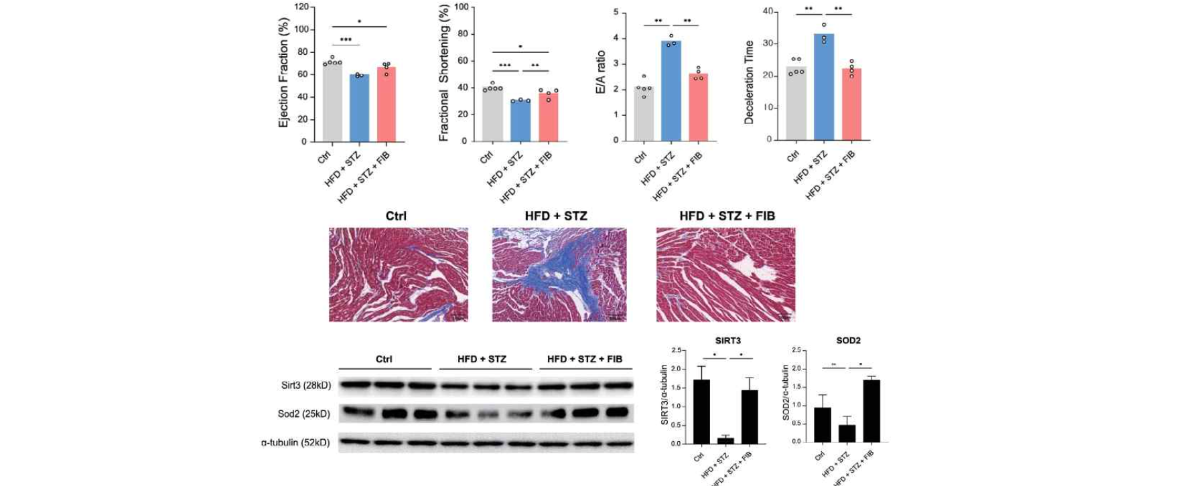▲ Cardioprotective effects of fenofibrate in high-fat diet-streptozotocin-induced diabetic mice: improved cardiac function, suppressed fibrosis, and increased antioxidant protein expression. Compared to the control group, the group treated with fenofibrate showed improved left ventricular function (LVEF, FS) in the heart, and staining results showed reduced cardiac fibrosis. Compared to the control group, the amounts of antioxidant proteins SIRT3 and SOD2 were significantly increased in the fenofibrate-treated group, indicating that fenofibrate helps protect the heart by reducing oxidative stress and through antioxidant action.

Additionally, the research team compared more than 420,000 fenofibrate users with non-users using Korean National Health Insurance data and confirmed that the rate of heart failure hospitalization was reduced by more than 10% in the fenofibrate group.

Professor Chang-Myung Oh said, "This study highlights the potential role of fenofibrate in the treatment of obesity- and diabetes-related heart failure, and suggests a new therapeutic direction that can overcome the limitations of existing treatments. Follow-up studies will further clarify the PPARα pathway activation mechanism and cardioprotective mechanism of fenofibrate, and this study is expected to contribute greatly to the development of future heart failure treatments."

This study was supported by the National Research Foundation of Korea’s Excellent New Researcher program, the Korea Health Industry Development Institute’s ‘KHIDI-AZ Diabetes Research Program’, the Daewoong Foundation’s Research Support Program for Emerging Medical Scientists, and the National Research Council of Science and Technology’s Creative Convergence Research Program. The research was conducted jointly by the GIST Department of Biomedical Science and Engineering Professor Chang-Myung Oh’s team (first authors Jiwon Park, master’s degree, and Hangyul Song, doctoral candidate), Hanyang University College of Medicine Professor Shinje Moon’s team, Inje University Ilsan Paik Hospital Professor Sung Woo Cho’s team, and Kangbuk Samsung Hospital Professor Cheol-Young Park’s team.

The research results were published online on September 16, 2024 in ‘Cardiovascular Diabetology’, an international academic journal ranked in the top 10% in the field of cardiovascular metabolism.



