“Achieving Higher Performance While Using Less Iridium Materials”
GIST and Georgia Institute of Technology Develop Highly Active Iridium Catalyst

- Prof. Park Chan-ho's joint research team achieved 1.5-fold activity with an iridium catalyst applied with tantalum oxide.
- Utilized in polymer electrolyte membrane electrolysis... Expected to reduce the production cost of new and renewable energy such as hydrogen.

▲ Prof. Park Chan-ho (left) of the GIST Graduate School of Energy Convergence and Dr. Baek Chae-gyeong of the Korea Institute of Science and Technology.

GIST (Gwangju Institute of Science and Technology) Graduate School of Energy Convergence Prof. Park Chan-ho and Georgia Institute of Technology Prof. Jang Seung-sun's joint research team developed an iridium catalyst with 1.5 times higher activity than conventional catalysts while reducing iridium usage.

Because iridium is resistant to high temperature, high pressure, corrosion, and is chemically reactive, it is suitable for electrolysis.* It is used as a catalyst in polymer electrolyte membrane electrolysis,** which is widely applied to produce hydrogen using renewable energy. However, it is a precious metal that is rare and expensive to the extent that its reserves are only 1/10th those of platinum, presenting an obstacle to the production of new and renewable energy.

* Electrolysis: A process of separating electrolyte into ions or causing a chemical reaction with electrical energy. When water (electrolyte) is electrolyzed, it is separated into hydrogen ions (H+) and hydroxide ions (OH-), and hydrogen ions become hydrogen molecules (H2) at the anode and hydroxide ions become oxygen molecules (O2) at the cathode.

** Polymer Electrolyte Membrane Electrolysis: Electrolysis is performed using a thin polymer membrane as a separator. This separator distinguishes anodes from cathodes and facilitates the movement of anions and cations while serving as an electrical insulator.

There have been several attempts to develop alloy catalysts or apply metal oxides to reduce the amount of iridium used, but problems such as elution of metals or low electrical conductivity have occurred.
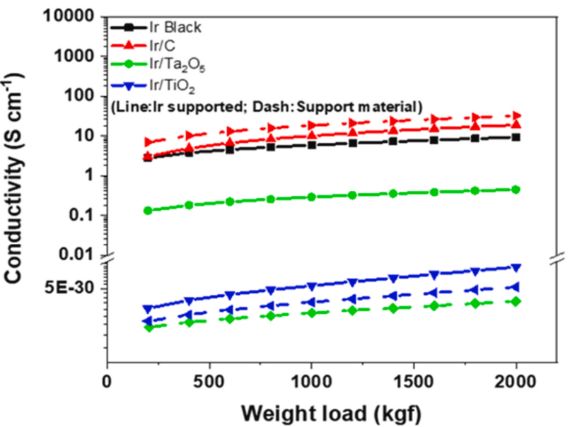
▲ Electrical conductivity of catalyst powder according to pressing force. The higher the value, the higher the electrical conductivity. Iridium/Tantalum Oxide (Ir/Ta2O5) has higher electrical conductivity than Iridium/Titanium Oxide (Ir/TiO2) catalysts.

The research team used a new catalyst made by evenly covering tantalum oxide with a small amount of iridium and significantly improved its performance while reducing the amount of iridium used. Tantalum oxide has a structure with medium-sized pores inside and is a metal oxide with a large surface area per unit weight and excellent performance in fixating catalyst particles.

This catalyst not only showed higher electrical conductivity than iridium catalysts with titanium oxide applied but also reduced the amount of iridium used, which was normally 1 to 2 mg/cm2 in conventional unit cells, to 0.3 mg/cm2. This is equivalent to 15% to 30% of the iridium usage in existing methods.

In particular, the new catalyst showed 1.5 times higher activity in terms of mass activity* than existing iridium catalysts and is expected to be put into good use in polymer electrolyte membrane electrolysis.
▲ X-ray photoemission spectroscopy (XPS) graph of the catalyst (left) and energy diagram of the catalyst (right). The electrical interaction between iridium and tantalum could be determined by the change in position of each peak in the XPS graph, and through calculations, iridium/tantalum oxide (Ir/Ta2O5) was the most advantageous in terms of reaction rate on the energy diagram.

In addition, the research team analyzed the electrical interaction between iridium and tantalum and succeeded in identifying the factors that improved the activity of the catalyst.

* Mass activity: An indicator for evaluating the activity of a catalyst. It indicates how many reactions take place with a unit mass of catalyst per unit time.

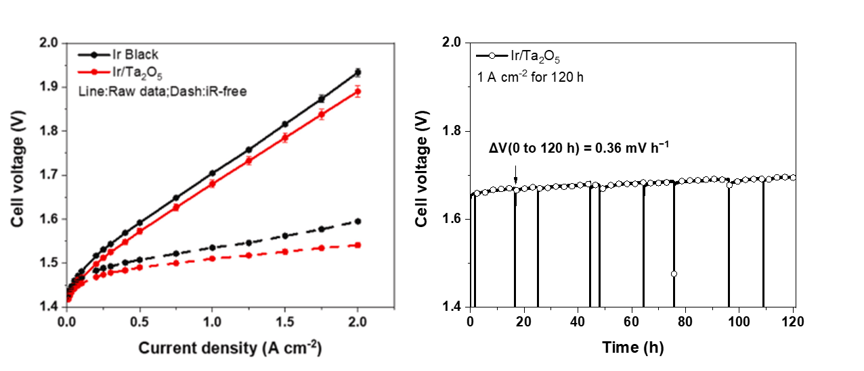
▲ Evaluation of unit cell activity undergoing PEM electrolysis (left) and durability evaluation (right) with catalyst applied. The catalyst showed higher activity than the Iridium Black catalyst that does not contain iridium/tantalum oxide (Ir/Ta2O5). It remained stable even after 120 hours of operation.

GIST Prof. Park Chan-ho stated, “We not only succeeded in developing a catalyst using a new metal oxide that reduces iridium use and improves its performance, we also succeeded in applying it to an actual unit cell.” He went on to say, “It is expected to contribute to the stable production of new and renewable energy such as hydrogen.”

This research, led by Prof. Park and Prof. Jang Seung-sun and participated in by GIST graduate Dr. Baek Chae-gyeong from the Korea Institute of Science and Technology (KIST) and doctoral student Jo Jin-won from the Georgia Institute of Technology, was supported by the Senior Researcher Support Project of the National Research Foundation of Korea. The research results were adopted in the Journal of Power Sources, an international academic journal in the field of electrochemistry, and published online on May 23.

