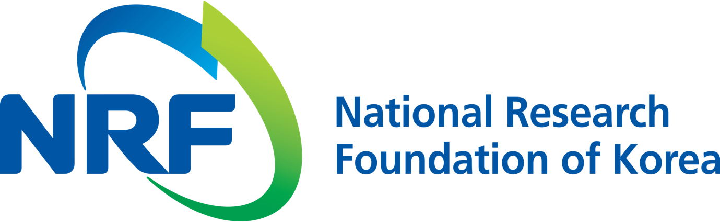

NRF PR Team Kil-soo Park Eun-ji Lee
Department Head Administrator
(+82) 42-869-6116 (+82) 42-869-6116

Contact Person Professors Inchan Kwon or Professor Giyoong Tae
for this Article School of Materials Science and Engineering
(+82) 62-715-2726

Release Date 2019.08.13

Professors Inchan Kwon's and Giyoong Tae's research team develops gold nanoparticle delivery technology for reducing hydrogen peroxide (National Research Foundation of Korea)

□ GIST (President Kiseon Kim) School of Materials Science and Engineering Professors Inchan Kwon's and Giyoong Tae's research team has developed gold nanoparticles that can deliver therapeutic proteins with less side-effects while maintaining effectiveness.

∘ The focus is on the potential application of gold nanoparticles as high value-added substances that can alleviate side effects and enhance the efficacy of biopharmaceuticals.

□ If uric acid* is not naturally excreted by urine, it can cause gout, and uric acid decomposition enzymes are used for treatment. However, it is difficult to effectively remove hydrogen peroxide** produced during decomposition.

* uric acid: a by-product of the metabolism of purine in the liver and discharged through urine

** hydrogen peroxide: A disinfectant that is dangerous to have in the body without being broken down. Catalase, an antioxidant enzyme found in the liver, red blood cells, and kidneys, breaks down hydrogen peroxide into water and oxygen.

∘ Since gold nanoparticles have been spotlighted as scavengers like catalase, an antioxidant enzyme can break down hydrogen peroxide into harmless water and oxygen, the researchers have found that gold nanoparticles can actually remove hydrogen peroxide, a byproduct of uric acid degrading enzymes.

∘ However, if the enzyme and gold nanoparticles are simply mixed and injected, there is a problem because it is difficult to obtain the intended effect as it is diluted in the blood.

□ The researchers demonstrated that they can remove hydrogen peroxide, a byproduct of enzymes, from animal models of gout disease by using polymer nanocarriers that can deliver enzymes and gold nanoparticles at the desired mixing ratio.

∘ By capturing enzymes and gold nanoparticles at desired ratios and delivering them into the body in gold nanoparticles that can be resized by temperature control, the enzyme and gold nanoparticles are not diluted in the blood. Through this process, the concentration of hydrogen peroxide is reduced, while the resulting uric acid decomposition continues for a long time.

□ In mice with high blood uric acid concentration, the nanocarriers were simultaneously collected and injected with uric acid degrading enzyme and gold nanoparticles, and the change in uric acid concentration over time was measured.

∘ The results showed a blood uric acid reduction of about twice as high as in cases where enzymes were injected alone or without inclusion in the nanoparticles.

□ However, further research on the in vivo safety of the nanocarriers and gold nanoparticles is needed before developing practical applications. This research was supported by the National Research Foundation of Korea's Basic Research Project (Basic Research Laboratory Research Director: Professor Giyoong Tae) and was published on July 26, 2019, in the Journal of Controlled Release, an international journal on drug delivery.

∘ Professors Inchan Kwon said, "More applications for the treatment of gout are expected through this research that have better efficacy without worrying about side effects."

⌘

