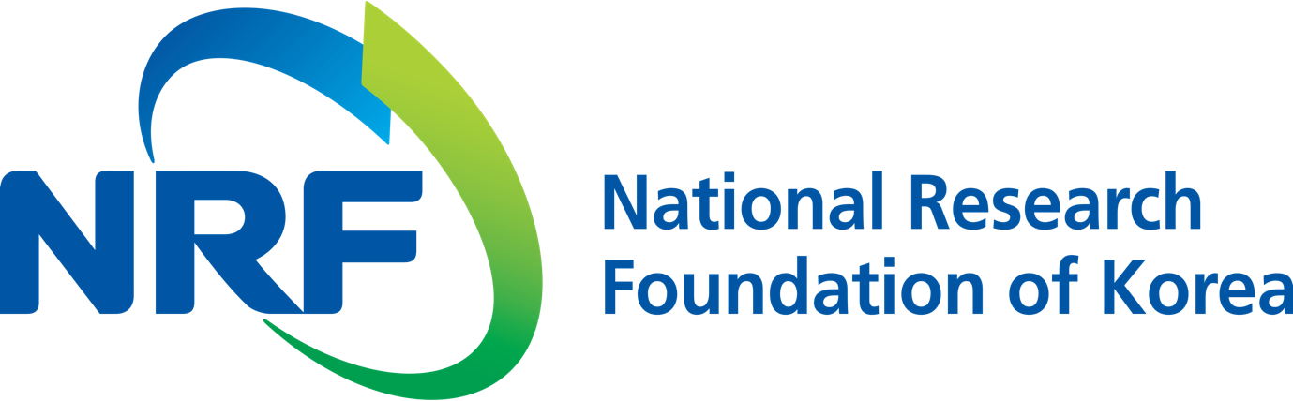

NRF PR Team Han-ki Kim Hyo-jung Jang
Department Head Administrator
(+82) 42-869-6116 (+82) 42-869-6116

Contact Person Professor Kwanghee Lee
for this Article School of Material Science and Engineering
(+82) 62-715-2325

Release Date 2018.08.22

Professor Kwanghee Lee's research team develops new modular structure for high-efficiency perovskite solar cells (National Research Foundation of Korea)

□ The development of technology to improve the module efficiency of perovskite solar cells has attracted attention as the next generation of solar cells. GIST (President Seung Hyeon Moon) Professor Kwanghee Lee of the School of Material Science and Engineering has developed a module structure that improves the efficiency of the perovskite solar cell by using an electrochemical patterning method.

□ Perovskite solar cells are capable of solution process and have high energy conversion efficiency (22.7% as of 2018) of devices, which is attracting attention as a future energy source. However, for the commercialization of perovskite solar cells, it is necessary to manufacture a large-area module with high-efficiency by maximizing the effective area by a precise pattern process.

□ The research team succeeded in creating a new module by confirming that the organic-inorganic composite perovskite has ionic conductivity and forms metallic nano-electrodes at the series connection region. In particular, the perovskite solar cell module developed by the research team has an effective area 94.1% and a module efficiency of 14%.

∘ Using the metal nanoelectrode, the length of the inactive region of the unit cell generated when the module is connected is reduced to 600 μm.

□ Professor Kwanghee Lee said, "This research has developed a new module structure that can improve the low efficiency of current perovskite modules. In the future, the commercialization and industrialization of next-generation solar cells that can replace fossil fuels will be considered a step forward."

□ This research was carried out with support from the Ministry of Science and ICT, the National Research Foundation of Korea, the Ministry of Trade, Industry and Energy and the Korea Energy Evaluation Institute. The results were published on August 17, 2018, in Science Advance.

⌘

