Gwangju Institute of Science and Technology

Official Press Release (https://www.gist.ac.kr/)

Section of Hyo Jung Kim Nayeong Lee
Public Relations Section Chief Senior Administrator
(+82) 62-715-2061 (+82) 62-715-2062

Contact Person Professor Jonghyun Choi
for this Article Artificial Intelligence Graduate School
062-715-2217

Release Date 2020.08.26

Artificial Intelligence Graduate School Professor Jonghyun Choi's team develops a method to explore the structure of binary neural networks

□ GIST (Gwangju Institute of Science and Technology, President Kiseon Kim) Artificial Intelligence Graduate School Professor Jonghyun Choi's team developed a deep learning* algorithm for searching binary network structures that improves the performance degradation that occurs in the process of compressing deep-neural networks for AI deployment.

* deep learning: a generic term for learning by deep-neural networks and is drawing attention as it greatly enhances the performance of AI algorithms

□ The research was awarded a bronze prize at the Samsung Human Tech Paper Award earlier this year and will be presented on August 26, 2020, at the 2020 European Conference on Computer Vision (ECCV), the world's foremost computer vision conference.

∘ This conference, along with the Computer Vision and Pattern Recognition Conference (CVPR) and the International Computer Vision Conference (ICCV), is considered one of the best academic conferences related to image recognition in the AI field. Computer vision is a technology that generates useful information by giving a computer time to analyze images.

□ The proposed network structure search method works only in high-accuracy deep neural networks with floating-point type parameters, but not when searching binary networks. The binary network has the advantage of being remarkably small in capacity with high speed, but finding a network structure with good performance is not an easy task.

∘ This study proposed four element technologies to solve these problems. It was confirmed that the binary network searched by the proposed techniques found a network with a smaller size and higher accuracy than the previously proposed binary network. The code and search models can be downloaded from the project code repository: https://github.com/gistvision/bnas.

□ Artificial Intelligence Graduate School Professor Jonghyun Choi is studying efficient guidance and model structure for visual recognition, and he has published a number of papers in world-class conferences and journals in the field of computer vision. Professor Choi received his Ph.D. in 2015 at the University of Maryland, College Park, and has worked as a researcher at the Allen Institute for AI in Seattle. He joined GIST in 2018 and runs the Computer Vision Lab.

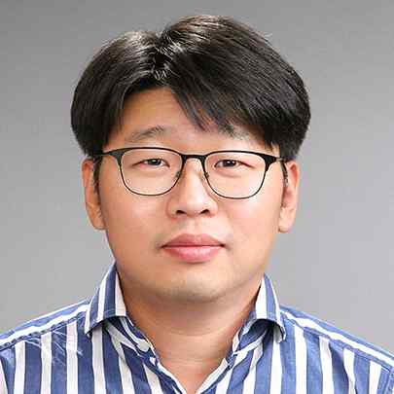
▲ Photo of the research team (from left): Dahyun Kim (EECS master's student, graduated from GIST College in 2020), Kunal Pratap Singh (IIT Roorkee undergrad; GIST Computer Vision Lab intern), and Artificial Intelligence Graduate School Professor Jonghyun Choi

