Number of Paper Citations per Professor −
GIST Ranked 1st in Korea, 5th in World

- 2024 QS World University Rankings, ranked GIST 5th in research capability and 1st in Korea for 16 consecutive years.
- A highly reliable indicator in evaluating research performance... Secret is creating the optimal research-immersive environment.”

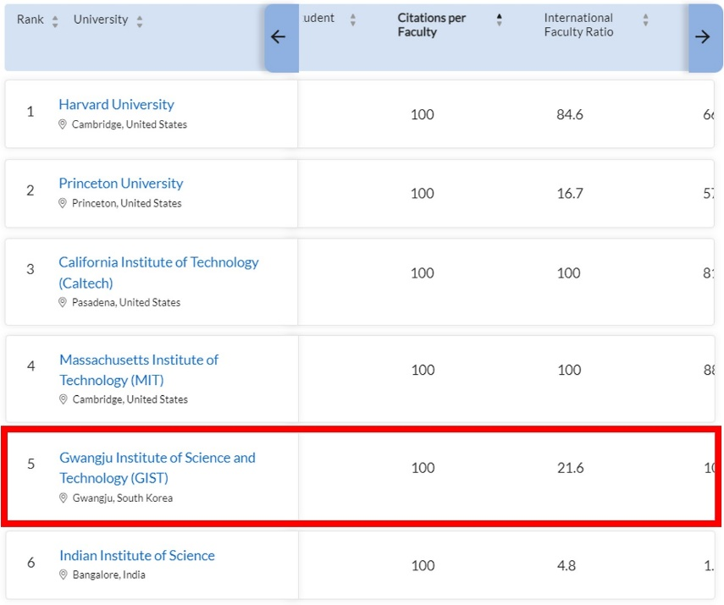
▲ GIST’s ranking in the number of paper citations per professor (1st in Korea, 5th in the world).

GIST (Gwangju Institute of Science and Technology, Acting President Park Raekil) was ranked 1st in Korea and 5th in the world in the category of citations per professor in the QS World University Rankings 2023. QS World University Rankings is a ranking announced in June every year by QS (Quacquarelli Symonds), a global university evaluation agency in the UK. This year, the rankings were announced at 5 a.m. on June 28, Korean Standard Time.

GIST has been ranked No. 1 in Korea for 16 consecutive years since 2008, and has been recognized for its world-class research capabilities by consistently ranking between 2nd and 6th among world universities and maintaining its high position in the world’s top 10.

Number of paper citations per professor is an index that indicates how many papers of a researcher at a given university are cited by other researchers, and is an item that can be used to evaluate both the quantity and quality of research capacity at the university.

This year, in the category of number of papers cited per professor, the ranking was based on the number of citations for papers published by the university during 2017-2021 (5 years) divided by the total number of faculty members during 2017-2022 (6 years).

Unlike indicators such as academic reputation or graduate reputation, which are conducted through surveys, this indicator is considered to be the most reliable evaluation item in that it shows objective data on research performance and its impact on other research.

The reason why GIST, which celebrated its 30th anniversary this year, has been able to maintain world-class research capabilities for 16 years is due to its administrative philosophy of internationalization and integration since its establishment and efforts to create an optimal environment for immersion in research.

GIST actively supports joint research with world-class researchers from world-class institutes such as Caltech and MIT in the US, and encourages collaborative and integrative research through research groups composed of researchers from various fields by breaking down the barriers between research fields and disciplines.

In addition, it offers a stable residential environment suitable for research for its faculty and students so that they can stay on campus and focus on research without worrying about housing, and various incentives and rewards for those who produce excellent results.

In this year's category of research paper citations per professor, not only GIST but also most of the research-oriented science and technology-specialized universities received excellent evaluations. This highlights the importance of strategic support at the national level for science and technology and future talent development in enhancing research competitiveness of universities.

As for domestic universities, Daegu Gyeongbuk Institute of Science and Technology (DGIST) ranked 7th in the world following GIST, while Ulsan National Institute of Science and Technology (UNIST), Pohang University of Science and Technology (POSTECH), and Korea Advanced Institute of Science and Technology (KAIST) placed 25th, 29th, and 35th in the world, respectively. Harvard University took first place in the world, and Princeton University, Caltech, and MIT ranked second through fourth.

Acting President Park Raekil stated, "GIST has once again proved that GIST is the university with the best research capabilities in Korea by achieving the top spot in the number of citations per professor for 16 consecutive years," and that “we will become an institution that grows together with the region and the country through proper education and research.”

