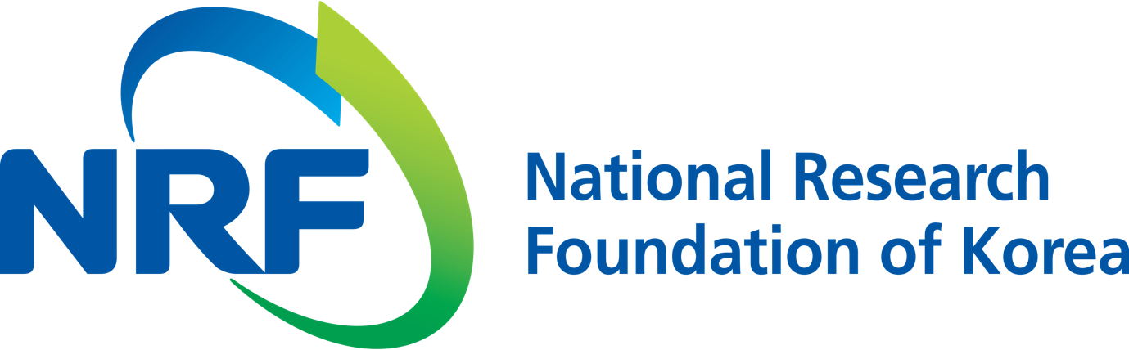

**NRF PR Team** Han-ki Kim Hyo-jung Jang

Department Head Administrator

(+82) 42-869-6116 (+82) 42-869-6116

**Contact Person** Professor Chung-Hee Cho

**for this Article** School of Life Sciences

(+82) 62-715-2490

**Release Date** 2018.07.23

**Professor Chung-Hee Cho's research team discovers head-to-tail protein for sperm (National Research Foundation of Korea)**

□ A key principle has been discovered at the molecular level for the formation of mammalian sperm, including humans. GIST (President Seung Hyeon Moon) Professor Chung-Hee Cho and graduate student Ji-hye Kim team have identified sperm specific proteins that connect and stabilize the head and tail of sperm during the formation process.

□ Sperm can move using the movement of its tail. Sperm specific proteins are involved in the unique developmental process that can be seen only in germ cells, including the formation of the tail. Studies on sperm-specific proteins are still insufficient, but they are very important to understand male reproductive phenomena, sperm functionality, and fertility.

□ The researchers reported the role of the sperm specific protein, SPATC1L, in spermatogenesis. This protein is present at the junction between the head and tail of the mouse sperm, and it regulates other proteins to maintain the structure of the linkage. In mice lacking this protein, the head and tail of all sperm are separated and become completely infertile.

□ Professor Chung-Hee Cho said, "Through this research, we have shown that the specific protein, which exists only in the neck of sperm, connects the head and tail of sperm. This will help us in understanding and diagnosing the cause of male infertility and is expected to be the foundation for the development of fertility drugs."

□ This research was supported by the Basic Research Project of the National Research Foundation of Korea (Ministry of Science and ICT). The results were published in *EMBO Reports*, a worldwide academic journal, on July 19, 2018.

⌘