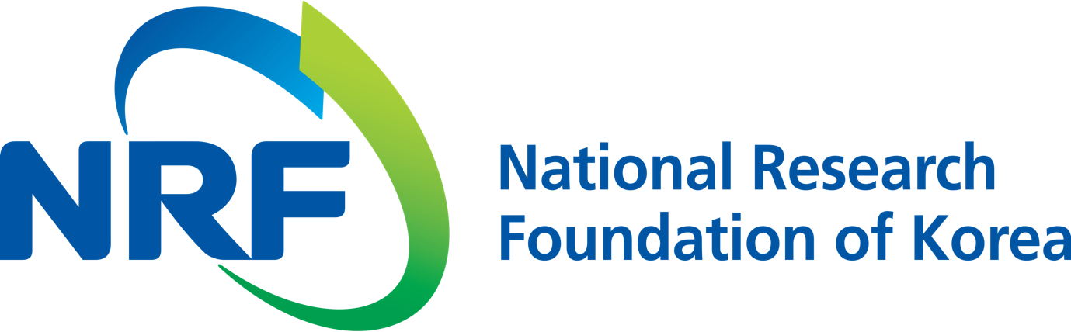

**NRF PR Team** Han-ki Kim Hyo-jung Jang

Department Head Administrator

(+82) 42-869-6116 (+82) 42-869-6116

**Contact Person** Professor Jongho Lee

**for this Article** School of Mechanical Engineering

(+82) 62-715-2757

**Release Date** 2018.07.31

**Professor Jongho Lee's research team develops a self-deforming film that can bend or stretch by itself (National Research Foundation of Korea)**

□ According to the National Research Foundation of Korea (President Jung-hye Noh), GIST (President Seung Hyeon Moon) Professor Jongho Lee of the School of Mechanical Engineering has developed a a self-deforming film that can bend or stretch by itself, making it possible to develop flexible electronic devices.

□ Recently, research on flexible electronic devices is actively underway. However, studies so far have not been conducted to actively transform electronics themselves, taking into account only passive variations caused by external forces.

□ The research team made a self-deforming film by attaching thin, electricity-operated memory alloys to film with regular spacing blocks. The film is very thin with a thickness of about 250 micrometers, which minimizes variations on electronic equipment when combined with a flexible electronic device.

∘ The shape memory alloy used is characterized by shrinkage when heat is applied. It is possible to use both the characteristics of the shape memory alloy and the elasticity of the film to perform bending and bi-directional stretching.

∘ Also, the degree of bending can be controlled by the applied current. Depending on the arrangement of blocks holding the alloy and the design elements of the film substrate, different shapes can be made.

□ Professor Jongho Lee said, "The result of this study are of great significance because it suggests new possibilities of flexible electronic devices. Our method can be applied to various active electronic devices and soft robots, such as a display whose shape changes depending on content or situation or solar cells that can open or move by itself."

□ This research was supported by the National Research Foundation of Korea, the GIST Research Institute, and the GIST-Caltech Project. Their paper was published on July 23, 2018, in *Soft Robotics*, which is the best international journal on robotics.

⌘