More Accurate Predictions of Ultra-fine Dust for Korea!
GIST Develops an Air Quality Forecasting System

- GIST Professor Song Cheol-han, of the International Joint Research Team develops a modeling system of Korean atmospheric chemistry.
- Reflects East Asian characteristics and creates optimal conditions... 24% higher accuracy than the European Centre for Medium-Range Weather Forecasting.

▲ (From left) GIST Department of Earth and Environmental Engineering Professor Song Cheol-han (left) and doctoral student Yu Jin-hyeok.

Many countries are operating air quality forecasting systems* because of ultra-fine dust, which is emerging as a serious environmental issue worldwide, as it can cause significant social and economic losses, such as premature death even with short-term exposure.

In Korea, ultra-fine dust forecasting has been carried out by the National Institute of Environmental Research under the Ministry of Environment since 2014, but they are facing difficulty in making very accurate predictions.

Real-time CAMS (Copernicus Atmosphere Monitoring and Modeling Service) of the European Centre for Medium-Range Weather Forecasting (ECMWF) and GEOS-CF (Goddard Earth Observing System Composition Forecasting) of the National Aeronautics and Space Administration (NASA) are representative air quality forecast data.

GIST’s (Gwangju Institute of Science and Technology, Acting President Park Raekil) Department of Earth and Environmental Engineering Professor Song Cheol-han’s joint research team has been developing the Korean Air Chemistry Modeling System (K_ACheMS) since 2019 to improve the accuracy of ultra-fine dust forecasting in Korea.

This system applied the Korean model, CMAQ-GIST, which reflects the characteristics of East Asia, to the US Environmental Protection Agency's model (CMAQ, Community Multiscale Air Quality), which is widely used for ultra-fine dust and air quality modeling worldwide.

In this study, the accuracy of short-term predictions for 1 to 3 days was greatly enhanced by improving the initial condition of the atmospheric chemistry model through the data assimilation technique.

The research team developed a system that generates optimal initial conditions by combining the ultra-fine dust concentration data obtained from the Korean geostationary orbit satellite, ground-bases air quality observation networks, and the Korean model, CMAQ-GIST.

In general, the initial conditions of atmospheric chemistry models are set based on climate data, yielding large uncertainty, However, in this system, real-time observation data are applied through data assimilation, allowing current air quality information to be reflected in the initial conditions.

Real-time prediction performed under optimal initial conditions showed a 24% higher accuracy than the predictions by the European Centre for Medium-Range Weather Forecasting, known as the world’s best in performance.

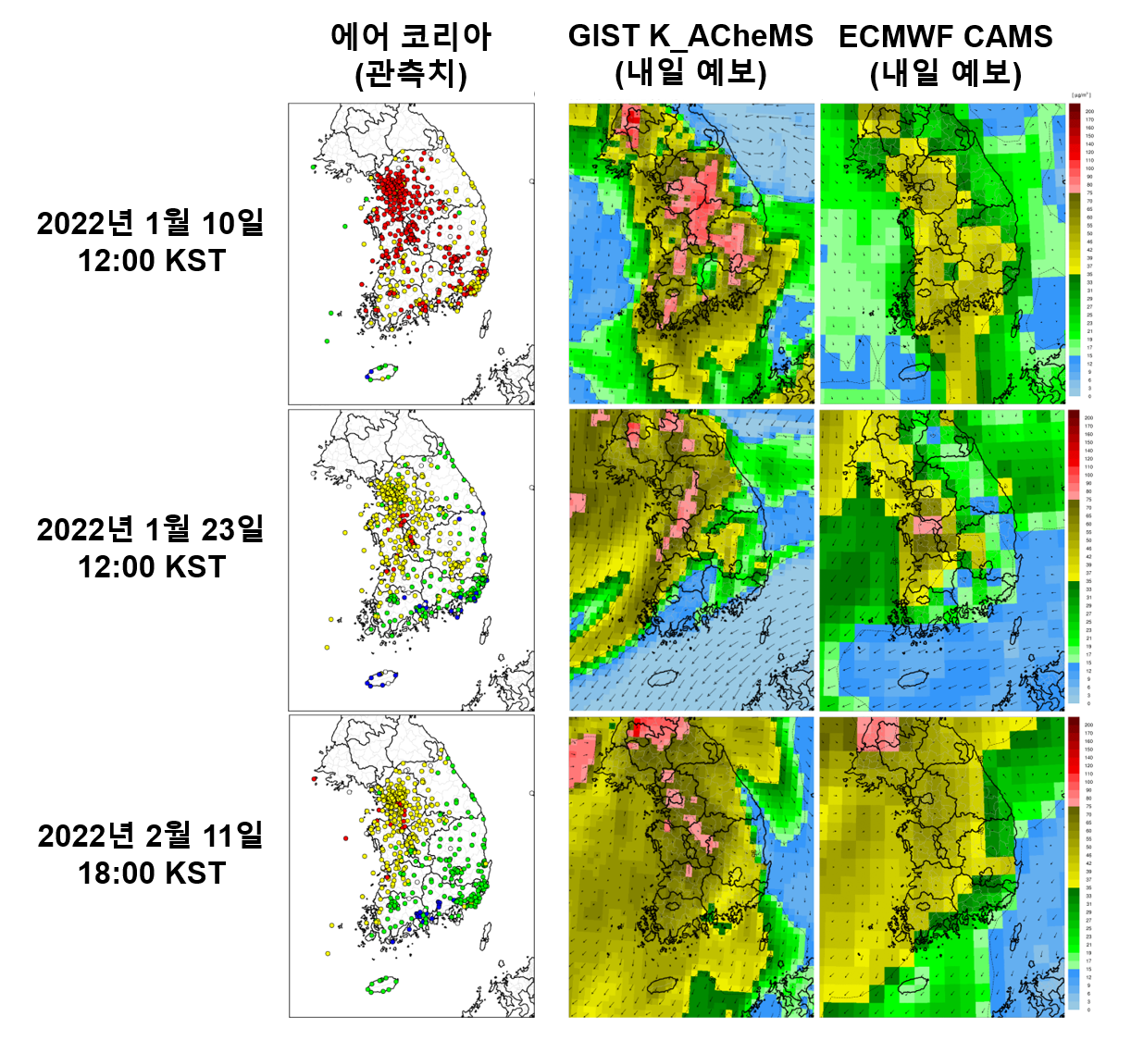
▲ Spatial distribution of PM2.5 observed by Air Korea (left), PM2.5 predicted by K_ACheMS (center), and near-real-time CMAS PM2.5 (right) by ECMWF. Blue, green, yellow, and red in the figure indicate good, normal, bad, and very bad levels of PM2.5, respectively, based on Korean environmental standards. K_ACheMS very successfully predicted the three largest cases of high concentrations of ultra-fine dust (PM2.5) that occurred in January-February 2022.

The research team has been conducting real-time air quality forecasts with this system since January of last year and has been disclosing them on the GIST website. (https://kachems.gist.ac.kr)

This system has predicted ultra-fine dust much more accurately than the European Centre for Medium-Range Weather Forecasting in three cases of high concentrations of ultra-fine dust cases that have occurred since last year.

Professor Song Cheol-han stated, “We are concentrating our research efforts to obtain a synergistic effect by combining the AI system currently under development with the Korean air quality model.” He went on by emphasizing, “We hope this evolves into the best air quality modeling system that leads the world in ultra-fine dust and air quality prediction.”

This research, led by Prof. Song and conducted by doctorat program student Yu Jin-hyeok, was participated in by Dr. Lee So-jin (The Seoul Institute), Song Chang-geun (UNIST), Dr. Lim Jeong-ho, Dr. Vincent-Henri Peuch (European Centre for Medium-Range Weather Forecasting), UCLA Prof. Pablo E. Saide (UCLA, USA), Prof. Gregory R. Carmichael (University of Iowa), Prof. Kim Jun (Yonsei University), Prof. Woo Jeong-heon (Konkuk University), and Ryu Seong-hyeon (CEO of Mirae Climate Co., Ltd.). This research project received support from the National Research Foundation of Korea's Ultra-fine Dust Response Technology Development Project in association with Northeast Asia.

The research results were published on May 23 in npj Climate and Atmospheric Science, a sister journal of Nature, an internationally renowned academic journal in the field of atmospheric science and meteorology.

