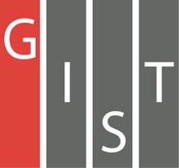
Gwangju Institute of Science and Technology

Official Press Release (https://www.gist.ac.kr/)

Section of Hyo Jung Kim Nayeong Lee
Public Affairs Section Chief Senior Administrator
(+82) 62-715-2061 (+82) 62-715-2062

Contact Person Chaired Professor Hyugbaeg Im
for this Article GIST College
(+82) 62-715-3635

Release Date 2012.12.11

Chaired Professor Hyugbaeg Im's participation in a book as a co-author was selected as excellent academic book by Sejong Books in 2019

□ GIST (President Kiseon Kim) College Chaired Professor Hyugbaeg Im's participation in the book 'Candlelight Vigils and Multiple Movements' as a co-author was selected in 2019 as excellent academic book by Sejong Books (formerly Academic Books by the Ministry of Culture, Sports and Tourism).

∘ 'Sejong Books' is a project by the Ministry of Culture, Sports and Tourism and organized by the Korea Publication Industry Promotion Agency, which selects excellent books every year to promote the publishing of academic fields and to promote a knowledge-based society, and distributes them to more than 850 public libraries across the country. The '2019 Sejong Books' Academic Division considered academic book published in Korea from July of last year to June of this year. Among the 10,277 books reviewed in 10 fields that have high academic value and can contribute to improving the nation's reading culture, 400 were selected as excellent books.

□ A total of nine people, including GIST College Chaired Professor Hyugbaeg Im and Catholic University of Daegu Professor of Political Science and Diplomacy Woo-young Jang participated as co-authors, and the academic analysis of historical candlelight vigils based on the concept of multitude social movements was highly regarded and selected as excellent academic book.

∘ Chaired Professor Hyugbaeg Im is a leading Korean democracy theorist who won a number of academic awards and honors, including the Korea Academy of Sciences Award (2015), the Korea Political Science Association Award (2010), and the International Conference of Asian Scientists (ICAS) Award for Excellence in Literature (2018). He received his Ph.D. in political science from the University of Chicago and was a professor of political science at Ewha Womans University and Korea University and was the dean of the Graduate School of Policy. He also worked as a director of political reform for the Presidential Transition Committee in 2003.

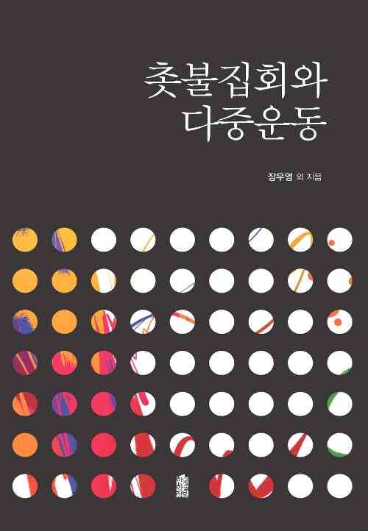
Authors ▲ GIST Chaired Professor Hyugbaeg Im ▲ Bum-soo Kim (Professor of Digital Social Science Center at Yonsei University) ▲ Myo-yeon Do (Research fellow at the Institute for Unification Studies at Yeungnam University) ▲ Chang-gu Byun (Professor of Political Science and Diplomacy at Catholic University of Daegu) ▲ Kyung-jae Song (Professor of Research at Kyung Hee University's Institute for Human Social Reconstruction) ▲ Hyun-chul Lee (Professor of Political Science at Konkuk University) ▲ Woo-young Jang (Professor of Political Science and Diplomacy at the Catholic University of Daegu) ▲ Hee-jung Cho (Responsible Research Institute of Social Sciences at Sogang University) ▲ Jae-kwon Cha (Professor of Political Science and Diplomacy at Pukyong National University)

