Lim Kichul Former President of KISTEP,
Appointed 9th President of GIST

- Served as Blue House Science and Technology Secretary, and Vice President of Science and Technology Policy Institute... Appointed by the board of directors on Tuesday, July 4..

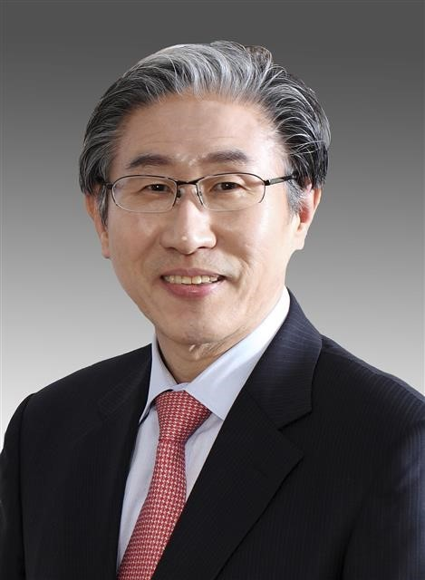
▲ Lim Kichul, former president of the Korea Institute of Science and Technology Evaluation and Planning, is appointed as the 9th president of GIST.

GIST (Gwangju Institute of Science and Technology) appoints Lim Kichul (age 68, born 1955), former director of the Korea Institute of Science and Technology Evaluation and Planning (KISTEP), as its ninth president.

The GIST board of directors held a board meeting in the afternoon of July 4 (Tuesday) and appointed Lim Kichul as the ninth president of GIST.

Newly appointed president Lim Kichul graduated from the Department of Industrial Chemistry at Seoul National University and received a master's and doctoral degree in engineering from the university's graduate school.

Lim served as the head of the Planning and Coordination Office and as vice president of the Science and Technology Policy Institute (STEPI). He served as the Science and Technology Secretary at the Blue House President's Office during the Lee Myung-bak administration. Since then, he has served as a standing member of the National Science and Technology Committee, the eighth president of the Korea Institute of Science and Technology Evaluation and Planning, vice president of the Korea Federation of Science and Technology Societies (KOFST), and as a collaboratingprofessor at the Graduate School of Management of Technology at Korea University.

The ninth president of GIST, who was appointed at the board of directors’ meeting on this day (July 4), is appointed through the approval of the Minister of Education and the approval of the Minister of Science and ICT. The term of office of the new president is four years from the date of approval by the Minister of Science and ICT.

