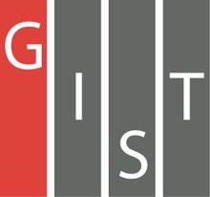
Gwangju Institute of Science and Technology

Official Press Release (https://www.gist.ac.kr/)

Section of Hyo Jung Kim Nayeong Lee
Public Affairs Section Chief Senior Administrator
(+82) 62-715-2061 (+82) 62-715-2062

Contact Person Professor Jae-Suk Lee
for this Article School of Materials Science and Engineering
(+82) 62-715-2306

Release Date 2019.10.21

Professor Jae-Suk Lee is selected as the first
Invited Fellow of the Polymer Society of Korea

□ GIST (President Kiseon Kim) School of Materials Science and Engineering Professor Jae-Suk Lee was selected as the first "Invited Fellow" at a conference of the Polymer Society of Korea held on Jeju from October 9 to 12, 2019, in recognition of his contributions and achievements in the development of polymer science and technology.

∘ The Polymer Society of Korea, one of the major national societies with about 3,000 members, is contributing to the development of new materials industry, which has recently gained importance.

∘ The fellowship system is widely used in foreign countries, but it is rare to select fellowships in domestic societies. However, the trend is gradually increasing for the development of domestic societies and the encouragement of fellowship members.

□ Professor Lee has contributed significantly to research in polymer science and technology, especially "polymer synthesis," and has published 230 research papers.

∘ In particular, he was the first in the world to discover properties for the polymerization of polyisocyanate, and 40 papers on polyisocyanate were published as a result of his continuous research.

□ Professor Jae-Suk Lee said, "I am very happy to be chosen as the first fellow of the Polymer Society of Korea. I think this is the result of continuous research in one field. Hopefully, Korea will create a research atmosphere where a person can focus on only one field of study."

□ Professor Jae-Suk Lee received the 1st LG Chem Polymer Academic Award from the Polymer Society of Korea in 2013 and has been an active member of the Korea Academy of Science and Technology since 2016.

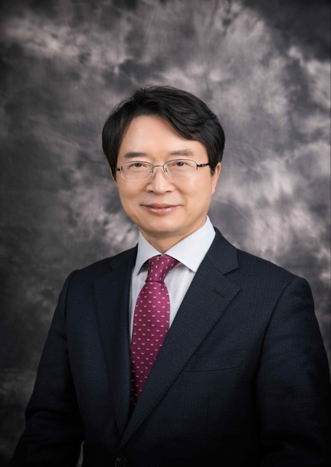
▲ [Photo 1] Professor Jae-Suk Lee of the
School of Materials Science and Engineering at GIST

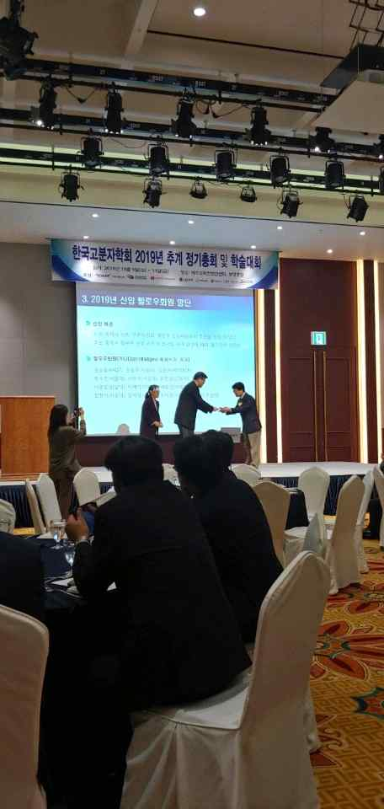
▲ [Photo 2] Presentation of the First Fellowship membership
certificate at the Polymer Society of Korea conference on Jeju

