Edited Volume by Professor Kim Geon-woo,
Publication of “The Present and Future of AI Governance”

- Who, what, and how to regulate artificial intelligence... Finding a solution from various angles.

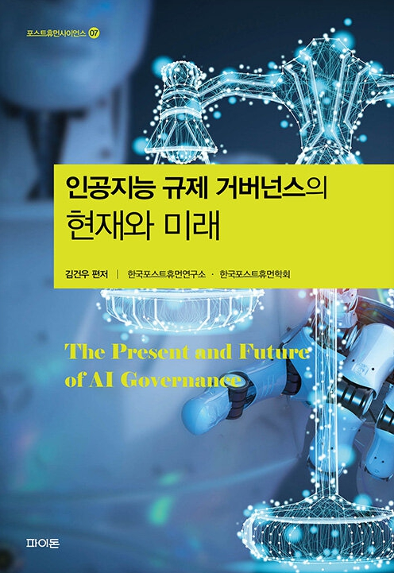
▲ The cover of “The Present and Future of AI Governance.

GIST (Gwangju Institute of Science and Technology, Acting President Park Rae-gil) Division of Liberal Arts and Sciences professor Kim Geon-woo’s compilation “The Present and Future of AI Governance” has been published.

This book presents a desirable path for coexistence between humanity and artificial intelligence, dealing with general and comprehensive discussions on who, what, and how to regulate artificial intelligence technology from ethical and legal perspectives.

In particular, it provides an opportunity to examine where we are currently standing in the coordinate space of three axes: AI technology, society, and institution, and to think about where we should be heading the future. All the contributors to this book present their own problem awareness, diagnosis, and solutions in relation to these problems.

Prof. Kim Geon-woo stared, “Governance is a framework for establishing social order and solving social problems by engaging in real issues through political and social means.” He added, “This book will be helpful in governance from a flexible and integrated perspective beyond the existing method.”

Prof. Kim graduated from the Department of Physics at Seoul National University, received a master’s degree in the philosophy of science from the History of Science and Philosophy of Science Interdisciplinary Program at Seoul National University’s Graduate School, and a PhD in legal philosophy from Seoul National University’s Graduate School of Law. He is currently a professor at GIST in the Division of Liberal Arts and Sciences.

In particular, he is interested in examining the foundation of law from various aspects of legal philosophy and in exploring ethical, legal, and social issues associated with advanced technology. Recently, he has been concentrating on research planning that seeks a postmodern basis for normative studies in general from a holistic perspective that transcends the distinction between humanity, society, and nature by synthesizing these two fields.

He has written a number of papers on related topics and translated Frederick Shower’s “How to Think Like a Lawyer.”

