Gwangju Institute of Science and Technology

Official Press Release (https://www.gist.ac.kr/)

Section of Hyo Jung Kim Nayeong Lee
Public Relations Section Chief Senior Administrator
(+82) 62-715-2061 (+82) 62-715-2062

Contact Person Wiju Sung, Administrator
for this Article International Environmental Research Institute
(+82) 62-715-3366

Release Date 2020.06.03

GIST undergraduate student co-authors a GIST-UN University book chapter about internship activities

□ GIST (Gwangju Institute of Science and Technology, President Kiseon Kim) College undergraduate student participated in a book containing the contents of her participation in the 'GIST-UN University (GIST-UNU) Internship Program' with the International Environmental Research Institute (Director Kyoung-Woong Kim, IERI) that was published by Springer *, a well-known science and technology publisher.

* Springer is a prominent publisher founded in Germany in 1842, specializing in scientific and technological journals and books, especially Nature, the world's leading scientific journal.

∘ The GIST-UNU internship program is a program supported by the IERI for GIST undergraduate students to promote cooperation with UN Universities and international organizations. Since 2016, three GIST undergraduates have been interns at the U.N. University of Canada, the Institute of Water, Environment and Health (UNU-INWEH) *, and expanded to the German UNU-FLORES * in the second phase.

* UNU-INWEH: United Nations University-Institute for Water, Environment and Health

** UNU-FLORES: United Nations University-Integrated Management of Material Fluxes and of Resources

□ Sujin Shin of the School of Earth Sciences and Environmental Engineering studied the relationship between water, food security and migration under the guidance of Dr. Nidhi Nagabhatla at UNU-INWEH, from January-July 2019 during the fourth year of her undergraduate studies.

∘ During the internship period, Sujin Shin participated as a co-author in a chapter of the book "Water and Food Security Crisis Influencing Human Mobility Patterns: A Comprehensive Overview." In addition, it proceeded with the overall work of the data, including a conceptual layout proposal that presents the main scope of the water-food crisis and explains the interrelationships. In particular, in the case of the Democratic Republic of Congo, the causes and phenomena of the water-food crisis were analyzed, and, through this, community resilience was suggested as an adaptation strategy.

∘ Currently, Sujin Shin is enrolled in the GIST master's program and conducting research on the 'behavior of antibiotic resistant genes under solar oxidizers' that can contribute to understanding and predicting antibiotic resistant propagation through water systems in the water treatment laboratory of School of Earth Sciences and Environmental Engineering Professor Lee Yoon-ho.

□ IERI Director Kyoung-Woong Kim said, "The goal of the GIST-UNU internship program is to help young people who will lead the future change the world and adapt to new times. In the future, we will spare no effort to continue various activities to solve global environmental problems through cooperation with UN Universities and other international organizations located around the world."

∘ Meanwhile, since GIST IERI was founded in 2001 with the goal of establishing a UN University research institute, GIST-UNU has been operating a joint program of sustainability and academic technology from 2004 to 2018 and continues to make great contributions and related activities to international R&D collaborations to tackle environmental problems in developing countries, foster environmental experts and strengthen capabilities. Since 2014, it has engaged in international development cooperation activities in the water sector through the Korea-United Nations Development Plan (UNDP) project that are actively progressing. Since 2016, it has been actively participating in international climate technology cooperation and climate change response through the United Nations Framework Convention on Climate Change (UNFCCC) technology mechanism.

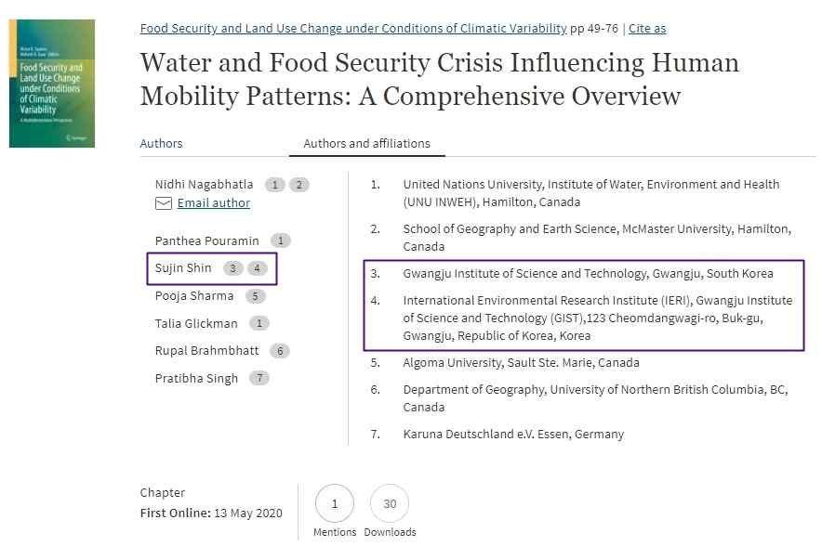
▲ [Photo 1] Water and Food Security Crisis Influencing
Human Mobility Patterns: A Comprehensive Overview

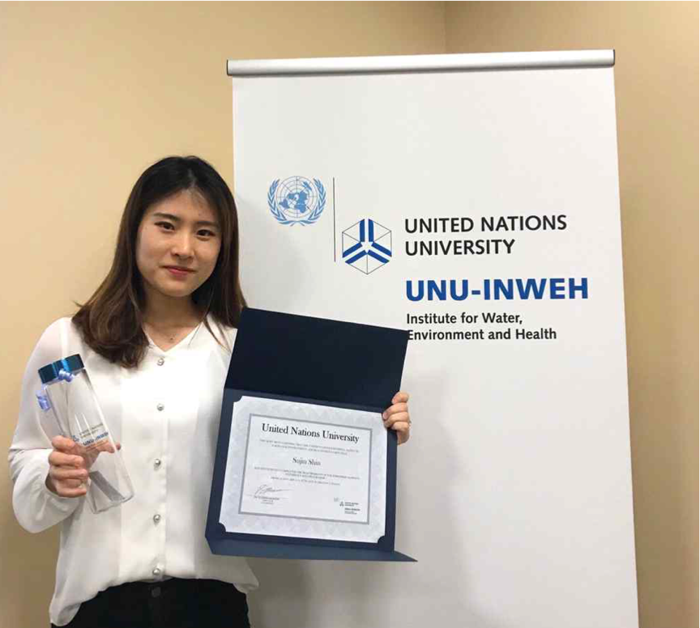
▲ [Photo 2] School of Earth Sciences and Environmental Engineering student Sujin Shin

