Gwangju Institute of Science and Technology

Official Press Release (https://www.gist.ac.kr/)

Section of Hyo Jung Kim Nayeong Lee
Public Affairs Section Chief Senior Administrator
(+82) 62-715-2061 (+82) 62-715-2062

Contact Person Professor Keun-Young Kim
for this Article Department of Physics and Photon Sciences
(+82) 62-715-3648

Release Date 2019.11.21

Korean students participate in paper introduced by the world-renowned scientific journal 'MIT Technology Review'

□ GIST (President Kiseon Kim) undergraduate senior Sang-hyun Oh who is majoring in physics participated in a paper that was by the world-renowned scientific journal 'MIT Technology Review.' *

* MIT Technology Review: started in 1899 as a magazine to introduces new science and technology to the general public, science and engineering researchers, policy makers, and financial professionals, and it won the Utne Reader's Best Independent Press Award for Science and Technology in 2011.

* https://www.technologyreview.com/s/614704/

□ The paper "Boosting Vector Calculus with the Graphical Notation" was written under the guidance of Department of Physics and Photon Sciences Professor Keun-Young Kim, Joon-Hwi Kim who is a third-year physics major at Seoul National University, and Sang-hyun Oh who is a fourth-year physics major at GIST College.

∘ It was ublished on November 3, 2019, in arXiv *, an online repository of physics papers, and it was featured in the MIT Technology Review article "How to turn the complex mathematics of vector calculus into simple pictures."

* https://arxiv.org/abs/1911.00892 arXiv is a place to inform physicists around the world about the contents of the paper before it is formally published in the journal. The paper will soon be published in the American Journal of Physics, the most prestigious journal in physics education.

□ The authors demonstrated the excellence of graphical notation through various problems dealing with vector calculus and undergraduate physics and put them in a paper for reference/educational purposes. They also explain the location and importance of this study by introducing the whole subject, including other graphical notations used in physics (Penrose Graphical Notation, Birdtracks, Feynman Diagram, etc.).

□ In this paper, the authors developed a method that makes it easier to understand vector calculus, which is essential for science and engineering students, through graphs rather than equations. This is a similar idea to what Richard Fineman (Richard P. Feynman, 1965 Nobel Prize winner) developed as an easy way to comprehend the interactions of complex elementary particles through formulas.

∘ The method developed in this paper is expected to make it easier for many students to understand and use vector calculus as well as broaden their understanding of the various graphical notations * used in physics.

* Graphic notation refers to the notation method using a graph composed of a node and a line. In traditional subscript notation, the components of vectors and tensors are represented as subscripts, but in graphical notation, lines are used instead of subscripts, so it is easy to grasp the overall structure of the equation.

□ Professor Keun-Young Kim said, "This study has excellent themes and contents, but it is also one of the best examples of collaborative research in which two students, Sang-hyun Oh and Joon-Hwi Kim, came up with ideas and led the research. It is especially unusual for undergraduate students to conduct and successfully complete all aspects of the research."

□ GIST College student Sang-hyun Oh said, "Thanks to the free atmosphere of GIST and the various educational programs designed to foster creative talents, it was possible to study with interest and write a paper about relatively unknown graphical notation rather than traditional subscript notation."

□ Seoul National University student Joon-Hwi Kim said, "Since childhood, I've enjoyed mathematical physics and was inspired by a book on graphical notation that in read in my third year of high school. In this project, I had a pleasant experience exchanging synergies with Sang-hyun Oh and sharing values about education."

□ GIST College student Sang-hyun Oh is currently spending the semester at Caltech as an exchange student and is conducting a study on "analytical simulation of satellite galaxy formation according to space re-ionization" under the guidance of Professor Philip Hopkins.

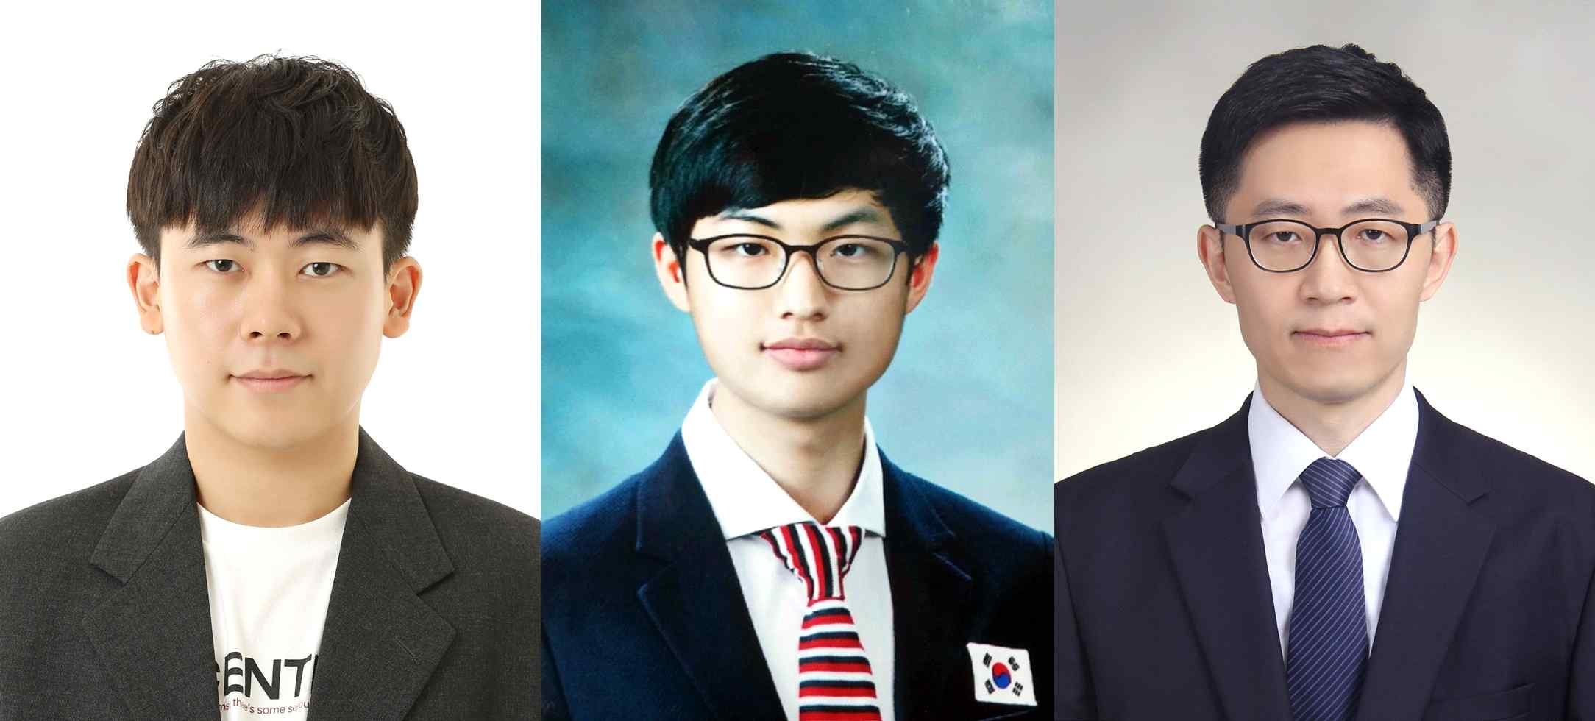
Photo: Seoul National University student Joon-Hwi Kim, GIST College student Sang-hyun Oh, and GIST Professor Keun-Young Kim

