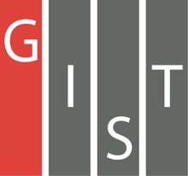

**Gwangju Institute of Science and Technology**

**Official Press Release (https://www.gist.ac.kr/)**

**Section of** Hyo Jung Kim Nayeong Lee

**Public Relations** Section Chief Senior Administrator

(+82) 62-715-2061 (+82) 62-715-2062

**Release Date** 2020.10.15

**GIST graduate Dr. ChaBum Lee won the Best**

**Paper Award from the American Society**

**of Mechanical Engineers**

□ GIST (Gwangju Institute of Science and Technology, President Kiseon Kim) School of Mechanical Engineering graduate Dr. ChaBum Lee (2012 Ph.D., Advisor: Professor Sun Kyu Lee) was named the winner of the "2020 Blackall Machine Tool and Gage Award" in the field of production technology by the American Society of Mechanical Engineers.

∘ This award was created in 1954 by Frederick S. Blackall, Jr., a Fellow and the 70th President of the American Society of Mechanical Engineers (ASME). The winners are determined each December by members of the American Society of Mechanical Engineers (ASME) Production Sector Organizing Committees for significant contribution to the research of production/design, control/measurement, or manufacturing technology. Winners will be presented with a prize of USD $1,000 and a plaque at the ASME Annual Conference scheduled in June 2021.

□ Dr. ChaBum Lee researched Kinfe-edge interferometry that can measure the wear and condition of cutting tool tips in real time (paper: Precision Cutting Tool Wear Monitoring Method by Knife-Edge Diffraction Interferometry).

∘ This measurement technique can measure not only tool wear but also the roughness of a semiconductor photomask edge, and this technology that can quantitatively measure whether the tip of a propeller is corroded from macroscopic to nanometer scale. This paper was presented at the Mechanical Science and Engineering Conference (MSEC) hosted by the American Society of Mechanical Engineering (ASME) in 2018.

□ Dr. ChaBum Lee, who is currently an assistant professor at Texas A&M University, said, "It is a great honor to win this award, and it is a great inspiration and motivation for the research that I am currently conducting. This field is currently being conducted by only a few researchers in the United States, and I hope that it will be an opportunity for more people to be interested about it in the future."

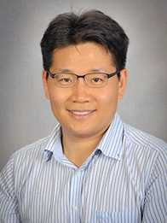

▲ Dr. ChaBum Lee (currently an assistant

professor at Texas A&M University)