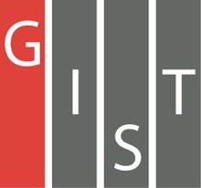

**Gwangju Institute of Science and Technology**

**Official Press Release (https://www.gist.ac.kr/)**

**Section of** Hyo Jung Kim Nayeong Lee

**Public Relations** Section Chief Senior Administrator

(+82) 62-715-2061 (+82) 62-715-2062

**Contact Person** Jung-gon Kim, Administrator

**for this Article** GIST Business Incubator

062-715-2595

**Release Date** 2020.11.25

**GIST technology startup company "Genome & Company" to be listed on KOSDAQ in December**

□ GIST (Gwangju Institute of Science and Technology, President Kiseon Kim) professor's startup company, Genome & Company (Department of Biomedical Science and Engineering Professor Hansoo Park and Ji-soo Bae are joint-representatives), is expected to be listed on the KOSDAQ next month after passing the preliminary examination for listing on the KOSDAQ.

∘ Genome & Company, which ranks first in the KONEX market capitalization, is a company that develops medicines using microbiome (intestinal microorganisms) based on antibody research and genetic technology. One of the major products, "GEN-001," completed patent registration in Korea in August 2019 and signed a license contract to transfer technologies throughout East Asia (Korea, China, Japan) in cooperation with LG Chem in December of the same year.

∘ In August of this year, Genome & Company succeeded in attracting 20 billion won worth of new investment from KDB Industrial Bank of Korea in the form of a free IPO format (equity investment before listing) and plans to move from the KONEX to KOSDAQ market.

□ Genome & Company, a technology start-up scouting company, is expected to grow further thanks to the active support activities of the GIST Business Incubator (Director Sung-keun Ki), which organized the "2020 Start-up Business Support Package Project" of the Ministry of SMEs and Startups.

∘ The "2020 Start-up Business Support Package Project" will be operated as a two-track program for companies selected by scouts as a technology start-up and a global linkage project that collaborates with Microsoft.

∘ The pick-up program supports 30 outstanding start-up companies related to AI with a total project cost of 6.15 billion won, while the technology start-up scouts receive 300 million won to select and support Genome & Company NI, Green System, and KS Optical.

□ KS Optical Co., Ltd. (CEO Geun-sik Kim) is a company that develops and supplies medical, bio-material, and pharmaceutical material to markets overseas due to the global reputation of its technology. In accordance with the strong investment support program of the GIST Business Incubator, it is attracting investment from leading domestic investment companies and attracting investment worth 60 billion won from abroad.

∘ Green System Co., Ltd. (CEO Yong-young Shin) has original technology for completely biodegradable natural plastic materials and produces 100% biodegradable eco-friendly plastic bags, disposable straws, and containers. Negotiations for the delivery of eco-friendly materials products are currently underway from Korea's leading retailers such as E-Mart and Lotte Corporation, and 1.8 billion won worth of investment has been confirmed through an investment consortium of the corporate support center, and 3 billion won worth of investment is being attracted.

□ GIST Business Incubator Director Sung-keun Ki said, "GIST has formed a consortium with leading domestic investment companies and is conducting various specialized programs that can solve the difficulties in securing the technology and funds required by start-ups in the leap period. In connection with this, we are doing our best to provide opportunities for companies to grow to the next level by increasing the success rate of investment attraction through corporate-tailored investment attraction activities."

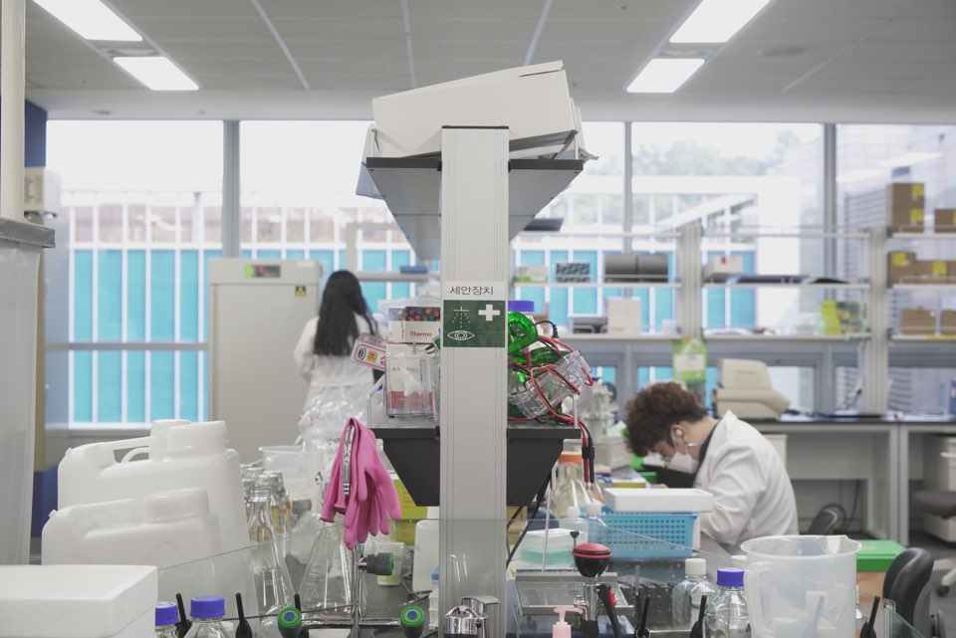

▲ Genome & Company to be listed on KOSDAQ in December