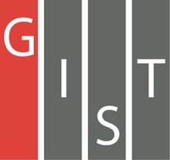

**Gwangju Institute of Science and Technology**

**Official Press Release (https://www.gist.ac.kr/)**

**Section of** Hyo Jung Kim Nayeong Lee

**Public Affairs** Section Chief Senior Administrator

(+82) 62-715-2061 (+82) 62-715-2062

**Contact Person** Section of Public Affairs

**for this Article** (+82) 62-715-2061~3

**Release Date** 2019.12.19

**Four GIST College students majoring in EECS**

**receive the 2019 NET Challenge Camp Award**

□ Gwangju Institute of Science and Technology (GIST, President Kiseon Kim) — 4 GIST College students majoring in electrical engineering and computer science (EECS) received the 2019 NET Challenge Camp Award from the Ministry of Science and ICT in the student team category.

∘ This competition is to support the development and commercialization of innovative ideas in the field of network applications and is sponsored by the Ministry of Science and ICT, the National Information Society Agency, and the KOREN Research Cooperation Forum. The awards ceremony was recently held at the Pangyo Gyeonggi Creative Economy Innovation Center.

□ 'NET Challenge Camp 2019' was launched in April with 15 student teams contributing new ICT technology ideas and services that can be commercialized in network applications. Four teams from companies were selected to evaluate the student's implementation process and results over a period of about five months.

□ GIST third year students Song-mi Oh (team leader), Ju-hyun Nam, Jong-myung Lee, and Sun-gyu Kim are majoring in EECS and created the team 'Detective KOREN' under School of Electrical Engineering and Computer Science Professor JongWon Kim to participate in the competition.

∘ The students of the 'Detective KOREN' team learned about the 'NET Challenge Camp' from student who participated last year, and they came up with ideas by taking Professor JongWon Kim's 'Computer System Theory and Experiment' course, which was offered for the first time this semester. They later prepared for the competition under the guidance of Professor JongWon Kim's Networked Intelligence Lab.

□ The 'Detective KOREN' team implemented a 'solution for finding missing elderly persons suffering from dementia by using CCTV networks for public transportation' by utilizing edge computing (distributed computing technology). The idea is to quickly search public CCTV information with edge computing, which has enhanced search efficiency and economic feasibility.

∘ Through this solution, if a photo of a missing person suffering from dementia is submitted to the police along with a report with the location and time of the disappearance, the police can find missing persons among those caught on public transportation CCTV around the missing area, greatly reducing the number of police personnel and the time that has been previously required to find the person.

□ 'Detective KOREN' team leader Song-mi Oh said, "In the future, this service can be easily expanded not only to find elderly people with dementia but also to search for missing children, which will be easier when future public transportation CCTV information utilizes 5G mobile communication-based wireless networking."

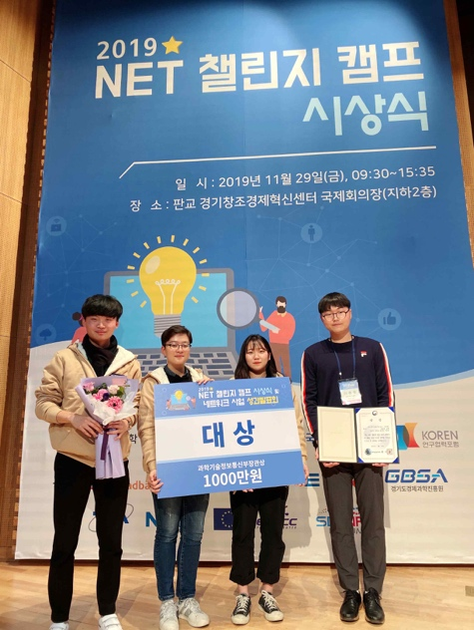

▲ GIST College team 'Detective KOREN'

receive the 2019 NET Challenge Camp Award