

**Gwangju Institute of Science and Technology**

**Official Press Release (https://www.gist.ac.kr/)**

**Section of** Hyo Jung Kim Nayeong Lee

**Public Relations** Section Chief Senior Administrator

(+82) 62-715-2061 (+82) 62-715-2062

**Contact Person** Professor Inchan Kwon

**for this Article** School of Materials Science and Engineering

062-715-2312

**Release Date** 2020.12.03

**Professor Inchan Kwon was honored by Minister of Education for his distinguished service to**

**industry-academic cooperation**

□ GIST (Gwangju Institute of Science and Technology, President Kiseon Kim) School of Materials Science and Engineering Professor Inchan Kwon was selected as a person of merit for industry-university cooperation and received a commendation from the Minister of Education. The awards ceremony was held on December 2, 2020, at the Industry-Academic Cooperation Expo.

□ Professor Inchan Kwon participated as a technology advisor and Chief Technology Officer (CTO) in starting a pharmaceutical company to promote the commercialization of technology. The commendation recognizes his contribution to industry-academic cooperation by transferring a number new bio drug development techniques that he has accumulated over the years.

∘ He has been a technical advisor since the foundation of ProAppTech Co., Ltd., and has recently played a major role in commercializing the technology in the enterprise while participating as the Chief Technology Officer (CTO). In addition, efforts to commercialize the technology contributed directly to the creation of new jobs through the revitalization of start-ups.

□ Professor Kwon transferred the biobetter technology of manufacturing gout treatment and diabetes treatment to a pharmaceutical company. For the commercialization of new drug technologies, joint research was conducted with ProAppTech Co., Ltd., the Ministry of Science and ICT's Technology Transfer Commercialization Project, and the Ministry of SME and Startups' Industry-Academic Cooperation Project.

∘ ProAppTech Co., Ltd., attracted 5 billion won worth of Series A investment this year to conduct global pre-clinical tests of gout treatment technology that has been transferred.

□ The biobetter technology transferred to ProApptech Co., Ltd., can be applied not only to gout but also to various diseases such as diabetes and arthritis, resulting in several technology transfers. In particular, it contributed to coexistence between universities and companies by providing a framework for developing innovative new drugs by receiving competitive technologies from schools.

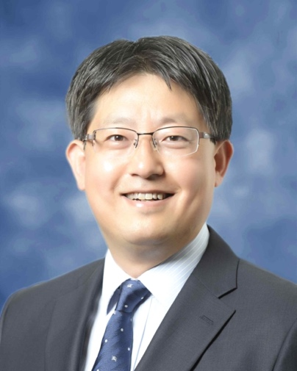

▲ GIST School of Materials Science and

Engineering Professor Inchan Kwon