

**Gwangju Institute of Science and Technology**

**Official Press Release (https://www.gist.ac.kr/)**

**Section of** Hyo Jung Kim Nayeong Lee

**Public Relations** Section Chief Senior Administrator

(+82) 62-715-2061 (+82) 62-715-2062

**Contact Person** Professor Sanggyu Kang

**for this Article** School of Mechanical Engineering

062-715-3240

**Release Date** 2020.12.02

**Professor Sanggyu Kang's team won the encouragement award at the 2020 Campus**

**Patent Universiade**

□ GIST (Gwangju Institute of Science and Technology, President Kiseon Kim) School of Mechanical Engineering Professor Sanggyu Kang's team received the encouragement award for the patent analysis of solid electrolyte materials for lithium secondary batteries at the '2020 Campus Patent Universiade.'

∘ The Campus Patent Universiade, which celebrates its 13th anniversary this year, is hosted by the Korean Intellectual Property Office and organized by the Korea Invention Promotion Association, the National Academy of Engineering of Korea, and the Korea Federation of Science and Technology Societies. It is a prestigious conference sponsored by over 30 companies, including large corporations. This competition is held every year for the purpose of providing creative ideas from universities to industries by encouraging practical patent education based on the use of big patent data at universities and by nurturing intellectual property specialists required by companies.

□ School of Mechanical Engineering Professor Sanggyu Kang formed a patent team by recruiting undergraduates Tae-gon Kim and Jae-young Bae from the School of Mechanical Engineering and Jong-yoon Jeong from the Department of Chemistry. The team chose 'solid electrolyte material for lithium secondary batteries' among the topics presented in the competition. Professor Sanggyu Kang guided the students with in-depth step-by-step patent analysis process.

∘ For patent analysis, a patent search database called KIPRIS was used, and patents published or registered in Korea, the United States, Japan, Europe, and China were investigated. To include as many patents as possible on the subject and obtain raw data with less noise, an optimal search formula was used with various operators.

∘ In addition, the research team analyzed technology classification and technology development according to major sources (leading companies) based on the determined raw data and derived blank technologies and core technologies through O/S matrix analysis. Based on the analysis results, a strategy for securing patents including technology development strategy and design avoidance was presented.

□ Student Jong-yoon Jeong said, "Even though there was no background knowledge related to patents, I was able to learn about patents through the guidance of the professor and cooperation with the team members, and through this competition, I became very interested in the energy field. Participation in this competition will be of great help in conducting future research."

∘ Student Tae-gon Kim said, "It was a very meaningful experience to be able to get closer to patents by analyzing and organizing patent literature that I had not been exposed to before."

□ Professor Sanggyu Kang, who was in charge of the guidance, said, "I'm glad that the students I taught were able to get good results in the competition, and I plan to recruit undergraduate and graduate students every year to compete in the Campus Patent Universiade."

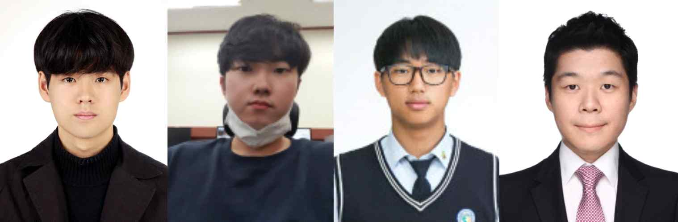

▲ [From left] 2020 Campus Patent Universiade encouragement award recipients Jong-yoon Jeong, Tae-gon Kim, and Jae-young Bae (Advisor Professor Sanggyu Kang)