Gwangju Institute of Science and Technology

Official Press Release (https://www.gist.ac.kr/)

Section of Hyo Jung Kim Nayeong Lee
Public Relations Section Chief Senior Administrator
(+82) 62-715-2061 (+82) 62-715-2062

Contact Person Section of Public Relations
for this Article (+82) 62-715-2061~2063

Release Date 2020.04.09

GIST College student pursing a future in astrophysics is accepted by nine overseas Ph.D. programs at prestigious universities

□ "From GIST, my final dream that I want to fulfill is to become a professor of astrophysics and perform research in the field of astrophysics, such as black holes and astrophysical high-energy phenomena."

□ Gwangju Institute of Science and Technology (GIST, President Kiseon Kim) Hyerin Cho (physics major, advisor Department of Physics and Photon Sciences Professor Keun-Young Kim) graduated from GIST College this past February and has been accepted by nine overseas Ph.D. programs at prestigious universities, including Harvard University, Caltech, Princeton University, Toronto University in Canada, and Curtin University in Australia.

∘ Princeton University in particular offered Hyerin Cho the Martin Schwarzchild Special Fellowship, which is awarded to one student a year who is most likely to become a theoretical astrophysicist.

∘ After deliberating which prestigious Ph.D. program she should choose, Hyerin Cho decided to attend Harvard University because it has the most opportunities to study new research fields. She is scheduled to start her Ph.D. program in September unless her visa is delayed due to the COVID-19 pandemic.

□ Hyerin Cho commented that her various research experiences at GIST, her experience in publishing papers, and the meticulous guidance and recommendations offered by her advisor Professor Keun-Young Kim highlighted her research potential and allowed her to gain admission into those universities.

∘ According to Hyerin Cho, the best thing about studying at GIST was the close relation with her professors. "Even when I had doubts about majoring in physics, or whether I should pursue theoretical or experimental physics, or whether I should study physics overseas, I was able to talk with many professors and get their guidance."

□ GIST student Hyerin Cho said, "While majoring in physics at GIST College, the fact that I was able to participate in an international joint research project at a foreign university and publish a paper as a co-author in Science and subsequently in Astrophysical Journal Letters made me a very competitive applicant for prestigious Ph.D. programs. GIST College's various international exchange programs helped me develop my research abilities while interacting with the world's leading researchers in the field."

∘ Through GIST College's international exchange program with Caltech, Hyerin Cho conducted research in the field of high energy theoretical astrophysics and participated in the Halo exploration study by using fast radio burst (FRB) signals as a member of the Australian CRAFT team, which involved in-depth study of observational astrophysics with local teams.

□ In October 2019, Hyerin Cho participated in a paper as a co-author that was published in Science, and she published a follow-up paper as the first author in the SCI journal Astrophysical Journal Letters in March 2020. She received the Future Talent Award, the Excellent Paper Award, and graduated Cum Laude at the February graduation ceremony, which was postponed due to the COVID-19 pandemic.

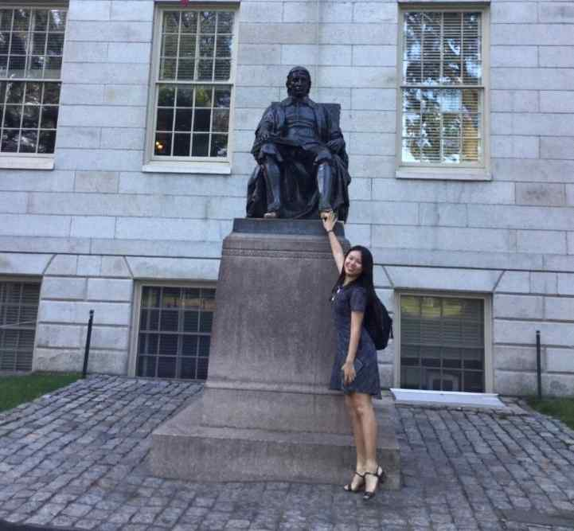
▲ Hyerin Cho takes a commemorative photo in front
of the statue of John Harvard at Harvard University

