Gwangju Institute of Science and Technology

Official Press Release (https://www.gist.ac.kr/)

Section of Hyo Jung Kim Nayeong Lee
Public Relations Section Chief Senior Administrator
(+82) 62-715-2061 (+82) 62-715-2062

Contact Person Kyung-hwa Kim / Chang-hoon Choi
for this Article Sections of Academic Affairs / General Affairs
(+82) 62-715-2042/2103

Release Date 2020.04.22

2020 Science and Information Day awards given by the Ministry of Science and ICT for the promotion of GIST science and technology

□ On the occasion of the 53rd Science Day (April 21) and the 65th Information and Communication Day (April 22), two GIST (President Kiseon Kim) professors and two staff members were selected as winners of the Minister of Science and ICT Promotion Award from the government for their contribution to the creation of excellent research results and the promotion of science and technology, including School of Life Sciences Professor Chunghee Cho.

∘ School of Life Sciences Professor Chunghee Cho, School of Materials Science and Engineering Professor Ji Young Jo, Section of Financing Section Chief Young-il Joo, and Section of General Affairs Administrator Chang-hoon Choi received ministerial awards.

□ Professor Chunghee Cho has been recognized as a leading researcher in this field both at home and abroad by publishing world-class research results, including a total of 80 papers (SCI papers 74 so far, SCI papers 66 after the appointment of JIST, and 37 as corresponding author).

∘ Professor Ji Young Jo has been at the forefront of researching thin film properties and has developed new materials for steel, piezoelectric and thermoelectric materials, which are important axis of solid physics, and has developed new materials through convergence research that goes beyond interdisciplinary material engineering, chemistry, and environmental engineering.

∘ Section Chief Young-il Joo improved administrative transparency by nurturing national R&D personnel and by establishing a recruiting system to attract outstanding students and to discover science-gifted students through the connection of science gifted students and university education and has contributed to the development of institutions through the readjustment of the financial accounting system.

∘ Administrator Chang-hoon Choi contributed to the establishment of an institution's mid- and long-term development plan, created an institution evaluation report system, improved the institution's development task evaluation system, and was credited with providing active administrative support for the establishment of a foundation for various annual cooperation and smooth research.

□ The Ministry of Science and ICT commemorates Science Day on April 21st of every year and has discovered and rewarded people of merit who contributed to the development of science and technology to promote the pride, honor, and morale of scientists and engineers. In 2020, the 53rd Science and ICT Day Commemoration Ceremony was presented to only 8 representative winners and was broadcast live online to prevent the spread of COVID-19.

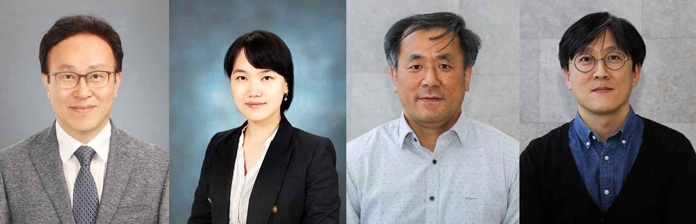
[Photos] From left: Professor Chunghee Cho, Professor Ji Young Jo,
Section Chief Young-il Joo, and Administrator Chang-hoon Choi

