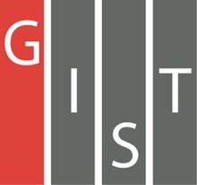
Gwangju Institute of Science and Technology

Official Press Release (https://www.gist.ac.kr/)

Section of Hyo Jung Kim Nayeong Lee
Public Affairs Section Chief Senior Administrator
(+82) 62-715-2061 (+82) 62-715-2062

Contact Person Se-mi Park, Administrator
for this Article GIST PRESS
(+82) 62-715-2960

Release Date 2019.11.28

A book published by GIST PRESS with Chaired Professor Sung-Ju Park as the lead author was selected in 2019 by Sejong Books as an
excellent academic book

□ GIST (President Kiseon Kim) School of Material Science and Engineering Chaired Professor Sung-Ju Park's book 'Advanced topics in LED technology' was selected as an excellent academic book this year by Sejong Books (formerly Academic Books by the Ministry of Culture, Sports and Tourism).

∘ 'Sejong Books' is a project by the Ministry of Culture, Sports and Tourism and organized by the Korea Publication Industry Promotion Agency, which selects excellent books every year to promote the publishing of academic fields and to promote a knowledge-based society, and distributes them to more than 850 public libraries across the country. The '2019 Sejong Books' Academic Division considered academic book published in Korea from July of last year to June of this year. Among the 10,277 books reviewed in 10 fields that have high academic value and can contribute to improving the nation's reading culture, 400 were selected as excellent books.

□ In addition to Chaired Professor Sung-Ju Park, eight researchers from GIST participated as co-authors in writing 'Advanced topics in LED technology,' which describes the overall knowledge of LED technology and the new applications and technologies that are emerging.

∘ Chaired Professor Sung-Ju Park, the lead author of the book has published 327 SCI international papers in the field of LED and optoelectronic devices using nitride semiconductors, silicon semiconductors, and oxide semiconductors. He continues to study photovoltaic devices such as LEDs.

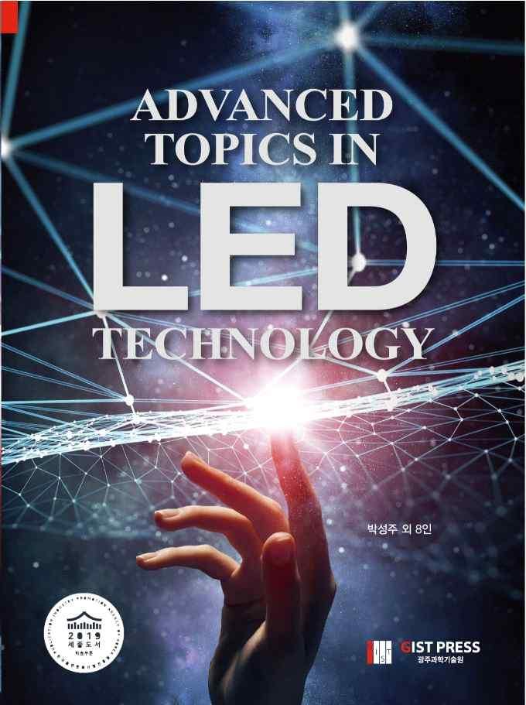

Author's affiliation at the time of publication

▲ GIST School of Material Science and Engineering Chaired Professor Sung-Ju Park

▲ Na-young Kim (SK Hynix senior researcher)

▲ Byung-hyuk Kim (Advanced Radiological Institute of the Korea Atomic Energy Research Institute postdoctoral researchers)

▲ Sang-Jo Kim (GIST School of Material Science and Engineering Ph.D. program)

▲ Se-mi Oh (University of Michigan postdoctoral researcher)

