Gwangju Institute of Science and Technology

Official Press Release (https://www.gist.ac.kr/)

Section of Hyo Jung Kim Nayeong Lee
Public Relations Section Chief Senior Administrator
(+82) 62-715-2061 (+82) 62-715-2062

Contact Person Professor Kwanghee Lee
for this Article School of Material Science and Engineering
(+82) 62-715-2325

Release Date 2020.03.24

Professor Kwanghee Lee proposes national challenge for the "Development of Transparent Window Film-Type Solar Cells for Zero Energy Buildings"

□ Transparent solar cells produced by the printing process can be attached as films to building windows as well as to car windows, raising expectations as a future (next generation) energy source that can efficiently produce electricity without limitation on the installation site.

□ Gwangju Institute of Science and Technology (GIST, President Kiseon Kim) School of Material Science and Engineering Professor Kwanghee Lee will develop window film-type transparent solar cell devices and modules for zero energy buildings.

∘ Research on film-type transparent solar cells, one of the challenges in the field of next-generation solar cells designated by Korea, is focused only on achieving high transmittance in the visible light range with high efficiency and translucence.

∘ However, if window film functions are added to existing film-type transparent solar cells and applied to buildings or automotive glass windows, it is expected that not only energy-supporting functions but also UV protection and insulation will be able to increase competitiveness of film-type solar cells.

□ This research project aims to develop innovative future eco-friendly energy materials that did not exist before that can satisfy the function of transparent solar cells capable of photovoltaic power generation and the function of a window (or tinting) film that can save on cooling and heating power consumption.

∘ The researchers also plan to develop a 100cm² sized module through a low-cost printing process based on flexible transparent electrodes and organic materials capable of solution process and will conduct fundamental research on the transparent solar cell structure of window thin-films, including top and bottom transparent electrodes and components.

□ The "development of windows-film-type solar cell devices and modules" project proposed GIST Professor Kwanghee Lee is considered a national challenge, so help from industries with core materials and large-area printing process technologies and experience is essential.

∘ Therefore, the plan is to conduct joint industrial and industrial research with MSWAY, which has specialized technologies in this field, in particular, to jointly develop a large area printing process technology, which is a necessary core material, as well as a large-scale flexible transparent electrode board function.

∘ This research project was selected to receive support for the mid-sized (type 2) sector of the National Research Foundation of Korea and will be implemented over the next five years from March 2020 to February 2025.

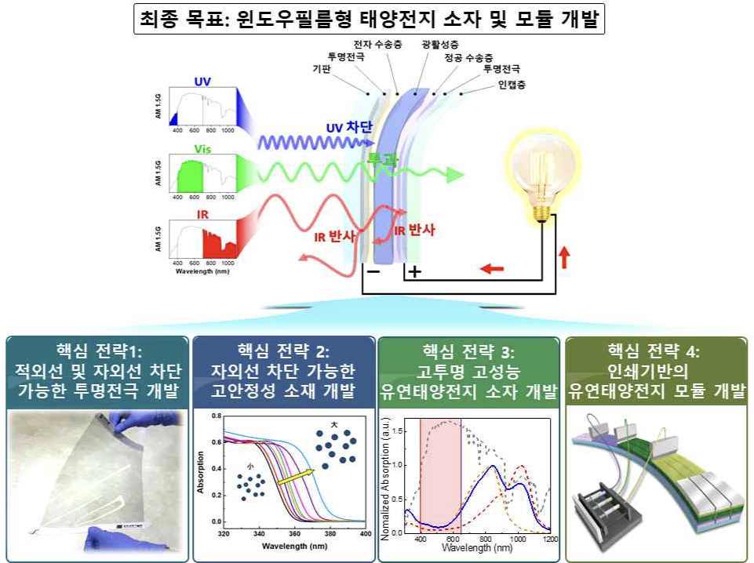
<Four key technology development strategies to achieve the final goal of this study>

