Prof. Sung Chan Jun holds a special lecture on ‘3rd generation electronic medicine’

- GIST Academy, held the <March Breakfast Forum> on the 27th (Mon)... Presenting future healthcare such as electronic medicine

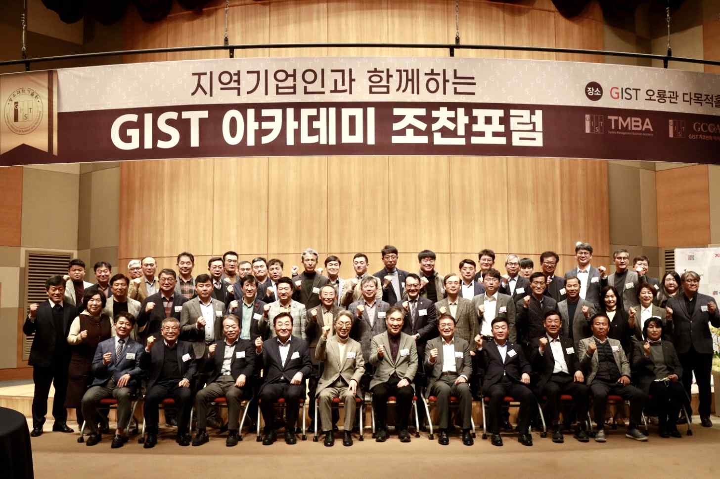
▲ GIST Academy is holding the March Breakfast Forum at Oryong Hall and took commemorative photos.

GIST Academy (Gwangju Institute of Science and Technology, Acting President Raekol Park) held the 'Healthcare in the Digital Era: Third-Generation Medicine Electronic Medicine (Electroceuticals)' was the theme of the March Breakfast Forum.

School of Electrical Engineering And Computer Science Professor Sung Chan Jun served as a speaker at the forum, presented the third-generation treatment digital treatment* and electronic medicine* as healthcare technologies emerging in the digital age.

Digital therapies cost less to develop and have very low toxicity compared to existing drugs, and electronic drugs are expected to grow in the future as drugs that can be applied to ADHD, Parkinson's disease, and malignant brain tumors have received FDA approval.

* digital therapeutics: Refers to software medical devices used to prevent, manage, and treat disorders or diseases based on scientific and clinical evidence.

* electronic medicine: Refers to medical devices that treat diseases through electromagnetic stimulation such as electricity, magnetic fields, and ultrasonic waves.

Professor Jun introduced the treatment case and use technology of 'electrical brain stimulation', a method of artificially activating the brain and treating brain diseases by applying electrical stimulation to a specific brain area among electronic medicines. It explained that neurons can be activated up to 11 times without opening the skull.

Professor Jun concluded the lecture by presenting the possibility of future technology development of digital therapeutics and electronic medicines using brain stimulation.

GIST Academy operates the Techno Management Business Academy (opened in 2010) and Climate Change Academy (opened in 2016) as non-degree courses. The GIST Academy Breakfast Forum is held on the last Monday of every month, inviting experts from various fields as lecturers to alumni and executives of local companies.

GIST Academy supports executives in each field to deeply understand the changes in the business environment and global management strategies through lectures by the best experts in Korea, form a wide human network, and contribute to the vitalization of the local economy and industry-university cooperation.

