GIST signs an agreement with Samsung Electronics to establish a ‘Semiconductor Engineering Department’ to nurture semiconductor experts

- A total of 150 students will be selected for 5 years from 2024... All scholarship students will be given the opportunity to work at Samsung Electronics
- Planning to discover and support educational programs to nurture technical personnel specializing in semiconductor processes

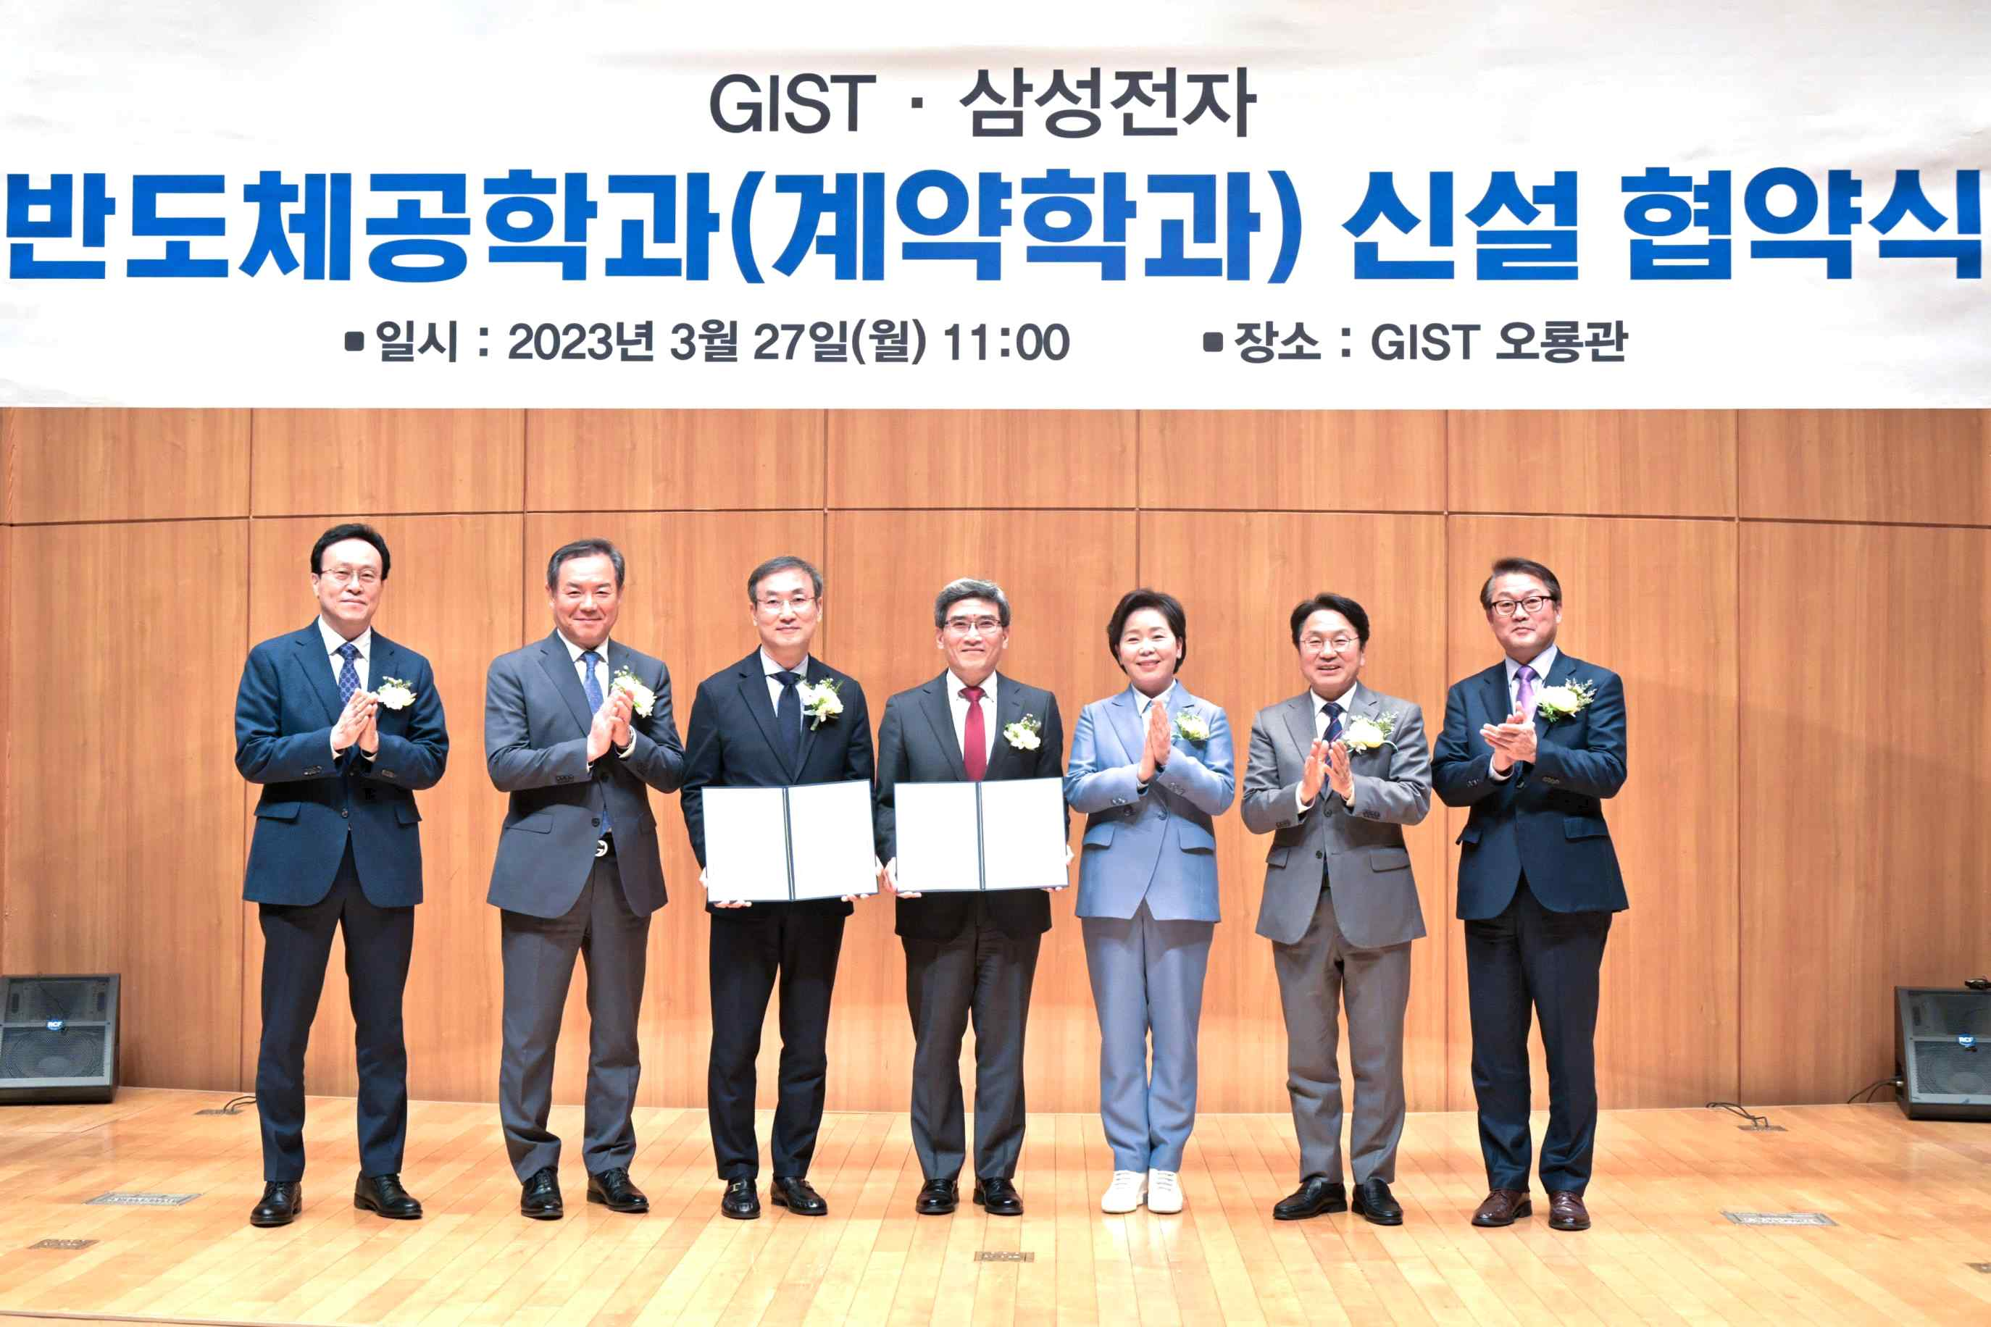
▲ GIST and Samsung Electronics Co., Ltd. are taking a group photo after signing a business agreement. (From left) GIST College Dean Chunghee Cho, National Assembly member Hyung-seok Lee, GIST acting president Raekil Park, Samsung Electronics President Jae-hyeok Song, National Assembly member Hyang-ja Yang, Gwangju Metropolitan City Mayor Ki-jung Kang, and Samsung Electronics Director Seung-hee Park.

GIST (Gwangju Institute of Science and Technology, Acting President Raekil Park) has decided to establish a Semiconductor Engineering Department to nurture technical personnel specializing in semiconductor processes with Samsung Electronics Co., Ltd. (hereinafter referred to as Samsung Electronics).

The signing ceremony was held on March 27 (Mon) at 11:00 am at GIST Ohryonggwan with the participation of key officials such as GIST Acting President Raekil Park, GIST College Dean Chunghee Cho, National Assembly member Hyang-ja Yang, Research Director Chang-Duk Jun, Samsung Electronics President Jae-hyeok Song, Director Seung-hee Park, Gwangju Metropolitan City Mayor Ki-jung Kang, National Assembly member Hyung-seok Lee, and National Assembly member Hyang-ja Yang.

Through this agreement with Samsung Electronics, GIST will ▴ establish and operat the Department of Semiconductor Engineering to nurture experts in the semiconductor process ▴ discover, operate, and support various educational programs related to the cultivation of experts in the semiconductor process ▴ organize and operate the Department of Semiconductor Engineering Steering Committee, etc.

GIST plans to select a total of 150 students, 30 each year from 2024 to 2028, as integrated master's degree students in semiconductor engineering science.

Selected students will complete 7 semesters of the bachelor's course and 3 semesters of the master's course. Students who are selected as double scholarship students will be hired by Samsung Electronics and are trained as experts in semiconductor processing.

Meanwhile, on this day, DGIST and UNIST also signed an agreement with Samsung Electronics for the establishment of a new employment conditional contract department at each school.

As a result, the number of schools that have newly established and operated employment-conditional contract departments with Samsung Electronics has increased to a total of seven schools, including Sungkyunkwan University, Yonsei University, KAIST, and POSTECH, followed by three science and technology institutes (GIST, DGIST, and UNIST).

It is very important to secure national competitiveness related to semiconductors due to the recent reorganization of the international semiconductor business. In particular, semiconductors are currently not only a core industry in Korea, but also a future high-tech industry that will lead future industries such as AI, autonomous driving, and robots.

To this end, it is important to continuously improve the level of integration and high performance of semiconductor devices, and it is the time when key talents who can overcome the problems of high level of integration and high performance of semiconductor devices that are experiencing difficulties and lead the development of semiconductor integrated process technology are absolutely needed. Minister of Science and ICT Lee Jong-ho also expressed the importance of ‘preparing a government-wide semiconductor talent training system’ last year.

GIST, which has produced an average of 8 technology startups per year for the past 5 years, plans to play a role as a technology startup hub in Honam in the semiconductor field by nurturing experts specializing in semiconductors in the region according to the establishment of the Department of Semiconductor Engineering.

GIST Acting President Raekil Park said, "It is hoped that this agreement will be of great help to the balanced regional development of Korea's semiconductor industry and the cultivation of creative talents. We will contribute to revitalizing the local economy by actively cooperating so that GIST's excellent educational and research resources and Samsung Electronics' world-class technology can create synergy."



