“Developing a compound eye imitation semiconductor for Supervision AI” GIST, selected as a regional innovation mega project host

- Total project cost of KRW 6.9 billion, cooperation with Korea University of Energy, Korea Photonics Technology Institute, Nepes, Korea Alps, etc.
- Expected to drive the mining and AI industries, which are strategic industries in Gwangju, at the same time... adding vitality to the local economy

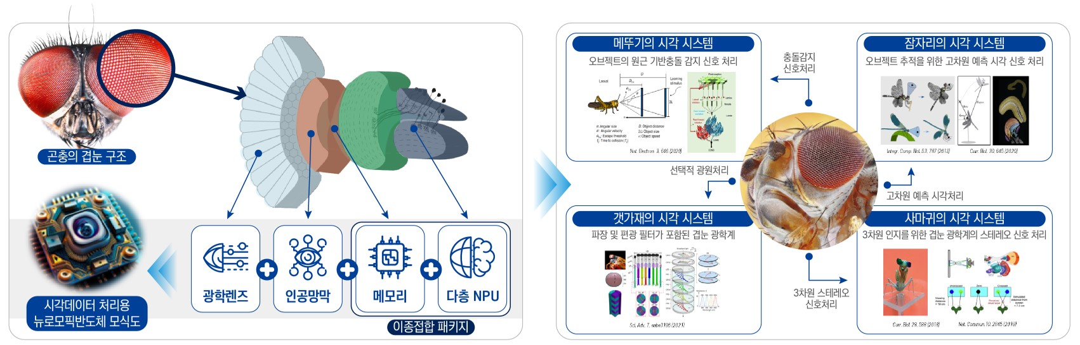▲ Structure diagram of compound eye-mimicking neuromorphic semiconductor for Supervision AI

GIST (Gwangju Institute of Science and Technology, Acting President Raekil Park) has been selected as the leading institution for the regional innovation mega project under the Ministry of Science and ICT under the theme of ‘Compound Eye Imitation Neuromorphic Semiconductor for Supervision AI’.

The total project cost of 6.875 billion won (5.5 billion won from the government, 1.375 billion won from the local government) will be invested, and it will be operated as a pilot project for 3 years, and it is expected that the project will be possible for up to 10 years including the pilot project period.

GIST promoted the project in the form of ‘ultra-wide cooperation’ with Gwangju and Jeonnam for successful project execution. Korea University of Energy Engineering, Korea Photonics Technology Institute, Nepes Co., Ltd., Korea Alps Co., Ltd., Pion Korea Co., Ltd. will cooperate.

After going through a demand survey response of the Ministry of Science and Technology, advance planning, patent trend analysis, etc., GIST reflected the contents of expert consulting by the Ministry of Science and ICT and the R&D Special Zone Promotion Foundation, a professional organization for the project, to was selected to create a "double-eyed imitation neuromorphic semiconductors for supervision AI" as a key theme for regional innovation.

In last year's demand survey, GIST proposed a 'visual intelligence semiconductor' as the theme by connecting the mining and artificial intelligence industries. The subject was derived through an analysis of Gwangju and Jeonnam capabilities, domestic and international environments, and discussions with innovation agents across the country.

In this project, in order to overcome both the limitations of the existing human optic nerve and the von Neumann structure, it plans to design and develop a neuromorphic semiconductor with low power and high computational ability by imitating the primitive optic nerve network of insects and plans to proceed based on the know-how accumulated through the existing mining industry, such as lens design, compound semiconductor process, and image sensor technology.

The ultimate goal of this project is to lead the mining industry and artificial intelligence industry at the same time by combining the existing strategic industries of Gwangju, the mining industry and artificial intelligence industry, and Jeonnam blue technology* industry.

* blue technology: Technology that borrows the principles of nature or is inspired by nature

In particular, GIST-Samsung Electronics' Semiconductor Contract Department and Ministry of Science and ICT-Gwang Ju-Kwang City are promoting GIST's visual intelligence semiconductor advanced process fab construction, which will start this year. It is expected that synergy will be created in connection with the domestic AI semiconductor demonstration center facilities of the Artificial Intelligence Industry Convergence Agency (AICA).

School of Electrical Engineering and Computer Science Professor Young Min Song , who is in charge of research for this project, said, "Through this project, R&D projects related to ‘AI Semiconductor’, the first pledge for coexistence in Gwangju and Jeonnam, were selected. We will do our best to ensure that this project does not stop at simple research and development, but becomes an opportunity to add vitality to the local industry together with participating organizations, partner organizations, and companies."

