"AI Era, Discussing the Justice of Art" GIST Academy, <April Breakfast Forum>

- <April Breakfast Forum> held on the 24th (Mon)... Special Lecture by Prof. Woon-Seung Yeo at Ewha Womans University

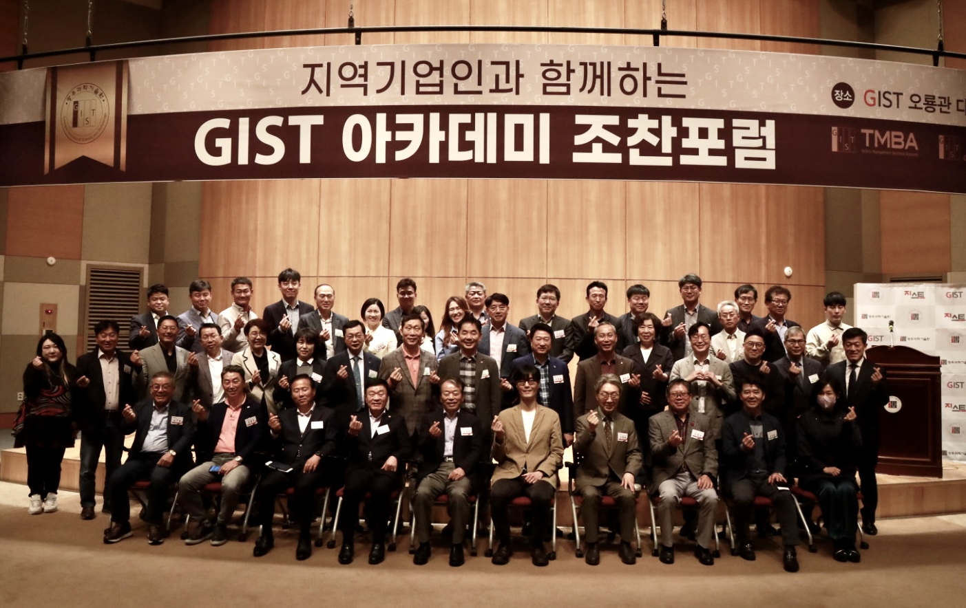▲ The GIST Academy is taking commemorative photos after holding the April Breakfast Forum

GIST (Gwangju Institute of Science and Technology, Acting President Raekil Park Rae-gil) Academy held a breakfast forum on April 24th (Mon) at Oryong Hall on the theme of 'Technology-Based Art Creation: Past, Present, and Future' with 60 representatives from Gwangju and Jeonnam region attending.

Woon-Seung Yeo, a professor at the Department of Convergence Contents at Ewha Womans University, who was a speaker at the forum, explained that in the face of the 4th Industrial Revolution, technologies such as artificial intelligence (AI) have gone beyond simple tools to carry out creative tasks that were considered unique to humans.

‘Art creation’, which has long been thought of as a creative activity only for humans, can also be made possible by applying AI technology without active human intervention. Furthermore, the possibility that humans, who were the subjects of art creation, are now excluded from the process is being proved.

Professor Yeo raised the question of how to define art in the future if the existence of human beings in art creation can be replaced by AI today, when art is no longer a human domain, which aroused the interest of participants. He also concluded the lecture by emphasizing the need to redefine art and redefine the status and role of artists by grasping the core of new changes, saying that "preparation for a completely unknown future" is the point.

The GIST Academy operates the Technology Management Academy (opened in 2010) and the Climate Change Academy (opened in 2016) as non-degree courses. The GIST Academy Breakfast Forum is held on the last Monday of every month, inviting experts from various fields as lecturers to alumni and local corporate executives.

The GIST Academy supports executives in each field to deeply understand the changes in the business environment and global management strategies through lectures by the best experts in Korea, form a wide human network, and contribute to the revitalization of the local economy and industry-university cooperation.

