GIST holds the 24th Earth and Environmental Science Olympiad

- Provide laboratory experience, experiments, and practical training opportunities to college students interested in earth and environmental engineering... Expected to cultivate excellent talent in the environmental field
- Minjeong Kim, GIST School of Earth Sciences and Environmental Engineering, received the Minister of Environment Award

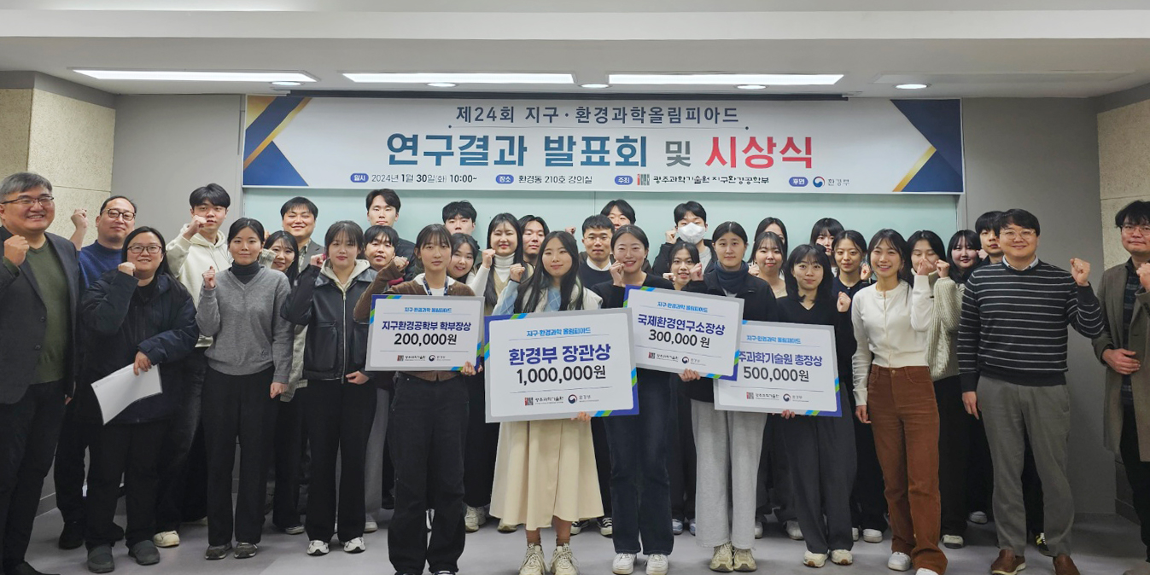▲ A group photo is being taken at the awards ceremony after the 24th Earth and Environmental Science Olympiad.

The Gwangju Institute of Science and Technology (GIST, President Kichul Lim) announced that the School of Earth Sciences and Environmental Engineering (Dean Yunho Lee) held the ‘24th Earth and Environmental Science Olympiad Presentation and Awards Ceremony’.

This event, hosted by GIST's School of Earth Sciences and Environmental Engineering and sponsored by the Ministry of Environment, has been held every year since 2001 to provide laboratory experience, experiments, and practice opportunities to college students interested in earth and environmental engineering and to foster outstanding talent in the environmental field. This year, it was held at the GIST School of Earth Sciences and Environmental Engineering Building from Wednesday, January 3 to Wednesday, January 31, with 28 university students from all over the country participating.

Participating students stayed at GIST for four weeks and conducted research under the guidance of a lab professor related to their individual research topic. With the help of researchers in GIST's School of Earth Sciences and Environmental Engineering, they learned how to use experimental equipment.

Presentations on a total of 28 research topics were held from 10 a.m. to 4 p.m. on Tuesday, January 30th. By combining the written evaluation (reports and presentation materials) and presentation results, a total of 4 people were honored with awards, including the Minister of Environment Award.

▴ The Minister of Environment Award (prize of 1 million won) went to Minjeong Kim from the GIST School of Earth Sciences and Environmental Engineering (Project name: Investigation of methylmercury emission sources through correlation analysis between wet deposition and air pollutants in Gwangju). ▴ The President's Award (KRW 500,000) went to Jeong-Eun Lee of the Department of Earth and Environmental Sciences at Chonnam National University (Project name: Monovalent and divalent cation substitution and chemical composition analysis of purified natural Bentonite (BDL, GTC4, WRK)). ▴T he International Environmental Director’s Award (KRW 300,000) went to Heejeong Park, Department of Chemistry, Dongguk University (Project name: Study of redox cycle characteristics of solid oxide fuel cells). ▴ The Earth and Environmental Engineering Department Director's Award (KRW 200,000) was awarded to Yuna Song (Project name: DFT experimental research to improve the performance of Ru-based NH3 decomposition catalyst) from the Department of Chemical Engineering at Yeungnam University.

Minjeong Kim, a student from the GIST School of Earth Sciences and Environmental Engineering, received the Minister of Environment Award and said, "I am most grateful to Professor Seunghee Han, who generously provided me with encouragement and advice as well as basic guidance on research while interning in the trace metal biogeochemistry laboratory for four weeks. In the future, I will grow into an environmental expert who can contribute to the country and society."

Dean Yunho Lee said, "Student interest in earth and environmental engineering is increasing every year. Attitudes and levels of conducting research are also evolving, so I hope that many excellent talents will be produced in the earth and environment fields."



