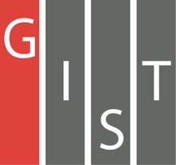
Gwangju Institute of Science and Technology

Official Press Release (https://www.gist.ac.kr/)

Section of Mi-Yeon Kim Nayeong Lee
Public Affairs Section Chief Senior Administrator
(+82) 62-715-2020 (+82) 62-715-2024

Contact Person Yonghyeok Choi
Regarding Article Administrator, Section of Public Affairs
(+82) 62-715-2025

Release Date 2018.06.15

GIST and KIST sign MoU
to develop national science and technology and
to enhance the research abilities of both institutions

□ GIST (President Seung Hyeon Moon) and the Korean Institute of Science and Technology (KIST, President Byung Gwon Lee) signed a memorandum of understanding (MoU) on June 12, 2018, to develop national science and technology and to enhance the research abilities of both institutions through mutual cooperation.

∘ The main focus of the MoU are: △ development and implementation of joint research projects △ finding new areas of research for the future △ exchange research and educational materials and access to equipment and facilities △ exchange of personnel and technical information.

□ President Seung Hyeon Moon said, “I hope that this agreement with KIST will serve as a leap forward for future science and technology leadership as well as convergence of talented people by integrating the core competencies of both institutions.”

⌘

