Gwangju Institute of Science and Technology

Official Press Release (https://www.gist.ac.kr/)

Section of Mi-Yeon Kim Nayeong Lee
Public Affairs Section Chief Senior Administrator
(+82) 62-715-2020 (+82) 62-715-2024

Contact Person Seo-Young Kang, Adminstrator
for this Article International Environmental Research Institute
(+82) 62-715-3393

Release Date 2018.07.05

GIST IERI participates in the Asia-Pacific Forum
and introduces the achievements of the UNDP project

□ GIST (President Seung Hyeon Moon) – The International Environmental Research Institute (IERI, Director In Seop Chang) participated in the South-South Cooperation Forum held in Bangkok, Thailand, from June 27 to 29, 2018, and introduced the "GIST Hope Water Purifier," a gravity type membrane-based powerless water purification system.

□ This regional forum, organized by the United Nations Economic and Social Commission for Asia and the Pacific (UN ESCAP), was held in commemoration of the 40th anniversary of the Buenos Aires Action Plan (1978). Kaveh Zahedi, Deputy Secretary General of the UN ESCAP, Jorge Chediek, Secretary General of UNOSSC *, Vice Minister of Foreign Affairs, Virasakdi Futrakul, and more than 100 experts attended the meeting.

* United Nations Office for South-South Cooperation

∘ This forum was held in the form of a multilateral panel discussion on the principles of South-South cooperation, institutionalization, innovative and effective approaches, and strengthening of cooperation. The experts' opinions were used to discuss key issues and cooperation of South-South cooperation to support developing countries. It was a place to look back.

∘ The South-South Cooperation Forum was organized to provide multilateral panel discussions to find innovative and effective institutional solutions while strengthening cooperation in supporting developing countries.

□ GIST IERI, which conducts water quality measurement and management training for developing countries such as Indonesia and Cambodia through 'K-UNDP * cooperation project,' participated in the exhibition and received a good evaluations by demonstrating 'GIST Hope Water Purifier,' which is a gravity type membrane-based powerless water purification system to help provide drinking water in developing countries.

* United Nations Development Programme

□ GIST IERI through the UNU-GIST Joint Program provides clean drinking water to developing countries where it is difficult to find drinking water due to climate change or natural disasters such as heavy rains, floods and droughts. GIST Hope Water Purifier, which was selected as the best water purifier, will be continuously distributed.

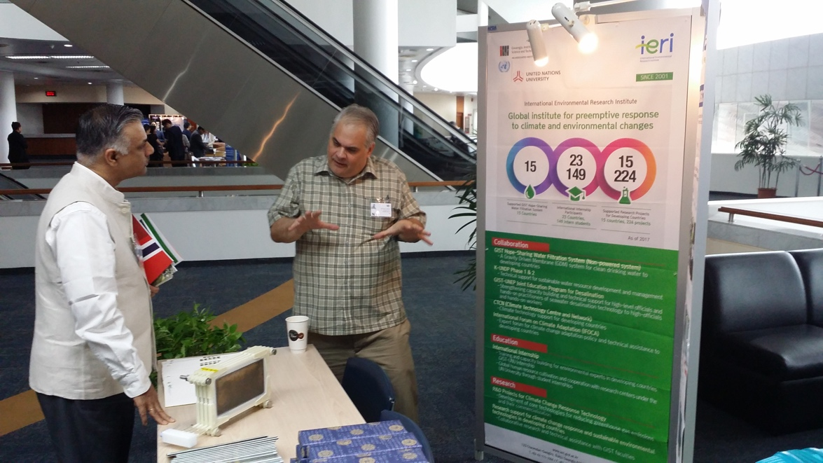
▲ Dr. Kenneth Walter Widmer of IERI introduces the GIST water purifier.

