GIST Oryong Art Hall,
Holding Its 3rd Invitational Exhibition “Imagining Infinity”

- Song Yoo-mi Invitational Exhibition ... 40 abstract paintings on display through August 26.

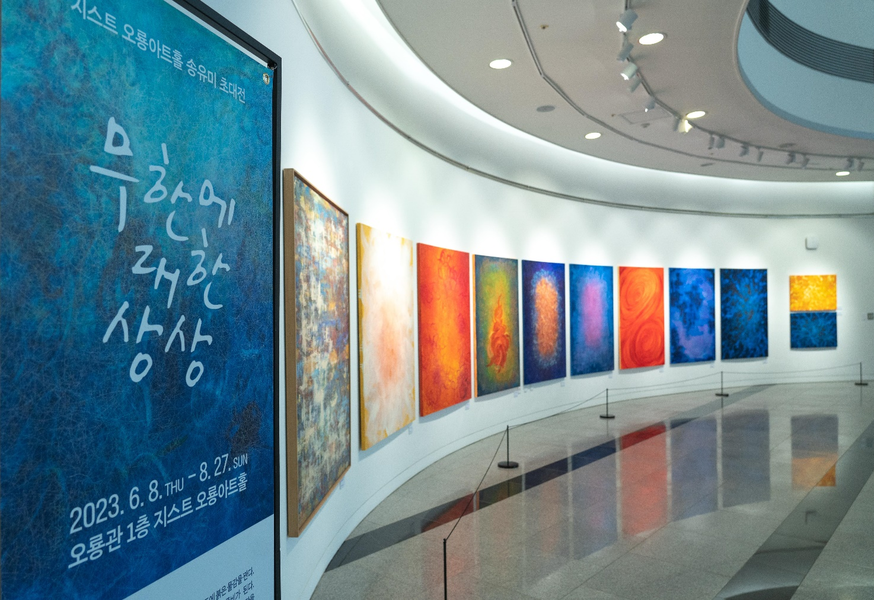
▲ The 3rd Invitational Exhibition, “Imagining Infinity,” is being held at the Oryong Art Hall at GIST.

GIST’s (Gwangju Institute of Science and Technology, Park Rae-gil, Acting President) Oryong Art Hall is holding its third exhibition this year, “Imagining Infinity,” an invitational exhibition by artist Song Yu-mi.

Oryong Art Hall, as a space in operation to communicate with the local community and provide citizens with events to enjoy culture and the arts, opened in December of last year, starting with the first invitational exhibition, “Rise as Islands, Bloom as Flowers” by artist Kim Hyeokjeong, and blooming as a flower.

This invitational exhibition displays 40 abstract paintings that capture the abstraction of repeating lines. The artist repeatedly drew infinite lines to express dialectically developing history in the form of an endless spiral.

In these works, thin lines are overlapped and tangled like strands of hair or threaded blood vessels, and the overlapping of these lines is infinitely repeated to create space on the flat surface and add depth to the work.

Art critic Lim Woo-gi stated, "In the overlapping of countless spirals in Song Yu-mi's paintings, there is hidden a fundamental image depicting a life cycle that circulates, is born, and then disappears. You can feel the energy coming from the ‘act of painting’ as well as from the painting.”

Artist Song Yumi was selected as a finalist at the London Art Biennale (Chelsea, London) and a representative artist at the Agora Gallery (Chelsea, New York), and has participated in the group exhibition “Interconnection and Intuition,” held at Agora Gallery. She is an artist who has recently made her name known in Europe.

Artist Song stated, “I am happy to be exhibiting as an invited artist for the Oryong Art Hall Invitational Exhibition. An artist's painting expands from the moment the artist puts down their brush, so I expect citizens and GIST researchers to further expand the depth of these paintings.”

This invitational exhibition, which opened on June 8, will be held through August 26 in the Oryong Art Hall of GIST’s Oryong-gwan.

