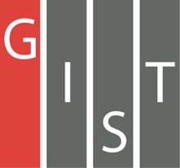

**Gwangju Institute of Science and Technology**

**Official Press Release (https://www.gist.ac.kr/)**

**Section of** Hyo Jung Kim Nayeong Lee

**Public Relations** Section Chief Senior Administrator

(+82) 62-715-2061 (+82) 62-715-2062

**Contact Person** Seung-jae Lee, Section Chief

**for this Article** GIST AI Graduate School

062-715-6351

**Release Date** 2020.07.28

**GIST AI Graduate School hosts**

**2020 AI Summer School**

□ GIST (Gwangju Institute of Science and Technology, President Kiseon Kim) AI Graduate School (Dean JongWon Kim) hosted an on/offline 2020 AI Summer School program for both freshmen and current students of the GIST AI Graduate School.

∘ The 2020 AI Summer School is part of the "AI Graduate School Axel Summer Camp (7.6.~8.14.)" program and hosted with NVIDIA, a global leader in graphic processing units (GPU), which signed a business agreement with GIST at the end of last year, and includes the "The NVIDIA Deep Learning Institute (DLI) Workshop (7.7.)" and the "GIST-ETRI (Electronics and Telecommunications Research Institute, Director Myung-jun Kim) AI Workshop (7.8.)." GIST AI Graduate School operates "AXEL Camp" during every semester vacation for intensive training and improved skills for new and current students.

□ This event was conducted with a mix of on/offline classes to prevent the spread of COVID-19, so only a limited number of students were able to attend the event. About 50 GIST AI graduate students participated online, and about 30 students attended offline.

∘ Seoul National University's AI Committee Chairman Yang-hee Choi, Professor Yu Kang, Professor Bo-hyung Han, Professor Gun-hee Kim, KAIST Professor Sang-wan Lee, Professor Se-young Yoon, Korea Electronics Technology Institute (KETI) Dr. Joo-hong Yoon, and Dr. Min-kyu Park were invited as lecturers to provide students with a very special opportunity to experience specialized education at the AI Graduate School, such as mentoring and lectures by experts in machine learning and computer vision.

□ Prior to the 2020 AI Summer School, ▲ hands-on training was conducted on the basics of deep learning for computer vision at the GIST-NVIDIA DLI workshop and ▲ ETRI's roadmap for AI technology development and the current status and examples of R&D on voice, language, and visual intelligence were presented at the GIST-ETRI AI Workshop. GIST had the opportunity to promote research exchanges between the two institutions through the introduction of GIST's role in the Gwangju AI city project and its research on auditory and visual intelligence.

□ GIST AI Graduate School Dean JongWon Kim said, "The AI Graduate School's 2020 AI Summer School has provided a great opportunity to bring together scholars in the field of artificial intelligence and for students to understand AI research and trends. GIST AI Graduate School will contribute to balanced regional development and job creation by fostering specialized AI convergence specialists suitable for the region."

□ Meanwhile, the GIST AI Graduate School, which opened in March of this year, approaches in-depth study of AI SW/HW based on empirical data and infrastructure to cultivate global AI innovative specialists. It is operated as a combined master's and doctorate course that performs field-oriented research and technology demonstration. In particular, in order to lead the industry-oriented innovation that leads to education, research, and entrepreneurship, it is focused on creating synergy with the AI Industrial Convergence Complex in Gwangju, focusing on three major areas of healthcare, automotive, and energy, which are the main industries in Gwangju. It is planning to carry out education and research on convergence (AI for X) focusing on synergy with the 'AI Industrial Convergence Complex.'

∘ GIST AI Graduate School's spring recruitment for its 2021 academic year is from October 8 to October 21, 2020.

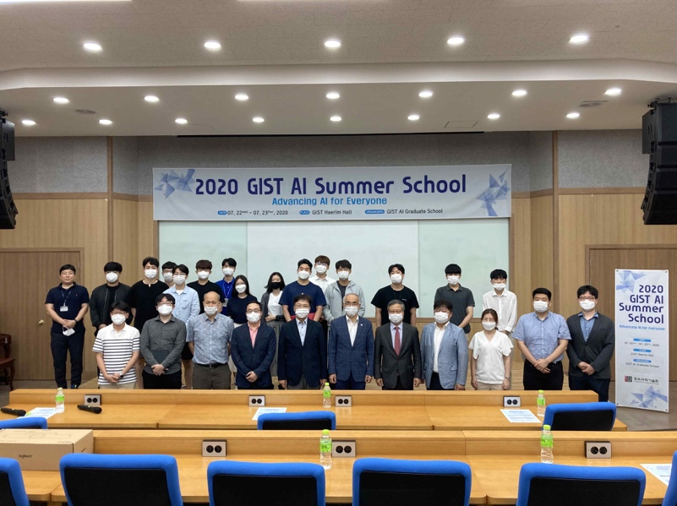

[Photo 1] 2020 AI Summer School group photo at the GIST AI Graduate School (7.22-7.23)

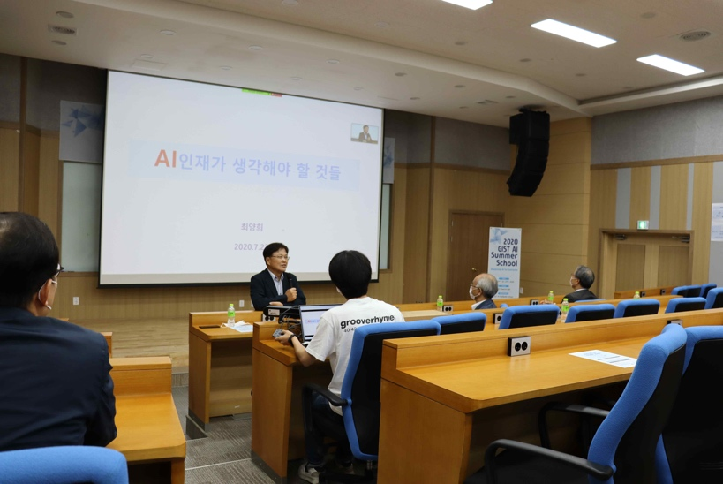

[Photo 2] 2020 AI Summer School special lecture at the GIST AI Graduate School (7.22)

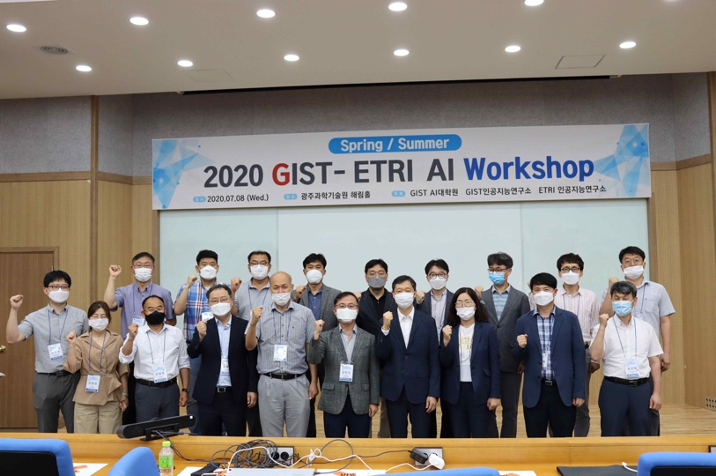

[Photo 3] GIST-ETRI AI Workshop (7.8)