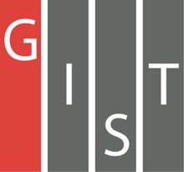
Gwangju Institute of Science and Technology

Official Press Release (https://www.gist.ac.kr/)

Section of Hyo Jung Kim Nayeong Lee
Public Relations Section Chief Senior Administrator
(+82) 62-715-2061 (+82) 62-715-2062

Contact Person Professor Sung-Gyoo Park
for this Article School of Life Sciences
062-715-2511

Release Date 2020.08.27

GIST holds an online workshop on
research for rare diseases in 2020

□ GIST (Gwangju Institute of Science and Technology, President Kiseon Kim) hosted the "Undiagnosed Rare Disease Functional Core Workshop" (DirectorProfessor Sung-Gyoo Park, GIST School of Life Sciences) was held online on August 26, 2020.

∘ This workshop topic was on "Rare Disease Research Status and Basic Research" and was prepared for the purpose of presenting a future-oriented research direction for the study of undiagnosed rare diseases under the supervision of the undiagnosed rare disease functional core and clinical core supported by the Centers for Disease Control and Prevention (Director Eun-kyung Jung).

□ The event was conducted online using video conferencing solutions from 2 pm to 6 pm, and current status analysis and opinions were exchanged, focusing on recent trends in undiagnosed rare diseases and ongoing research results.

∘ The program for this workshop was largely based on the research contents of the undiagnosed rare disease functional core following the presentation of the status of pediatric and adult undiagnosed clinical cores. ▲ For the first part of the workshop, Professor Jong-Hee Chae (Seoul National University Hospital), who leads the research on undiagnosed rare diseases, and Professor Jong-Hyun Ahn (Seoul Samsung Hospital) presented the clinical core of undiagnosed rare diseases in adults.

∘ ▲ For the second part of the workshop, presentation were given based on the research results of the functional core of undiagnosed rare diseases: the fruit fly model for the functional core group (GIST Professor Young-Joon Kim), zebra fish model (Kangwon National University Professor Yoon Ki), induced stem cell model (Seoul National University Professor Hyuk-jin Cha), molecular model (Seoul National University Professor Hee-jung Choi), and research on mouse and molecular mechanisms (GIST Professor Sung-Gyoo Park and POSTECH Professor Seung-Tae Baek).

∘ Finally, the overall event ended with discussions on the future-oriented development direction of research on undiagnosed rare diseases, cooperation between clinical and functional cores, and international cooperation.

□ Korea Centers for Disease Control and Prevention Director Yoon-jin Ahn who organized the program for this workshop said, "In the future, a lot of effort and support will be needed for the development of the undiagnosed program." Seoul National University Hospital Jong-hee Chae said, "In the future, the nation's undiagnosed rare disease diagnosis and research programs will be expanded to provide a foundation for the treatment of patients with rare diseases."

∘ GIST Professor Sung-Gyoo Park who is in charge of functional core said, "Through active cooperation with the clinical core of undiagnosed rare diseases, we will endeavor to meet the unmet needs in clinical practice."

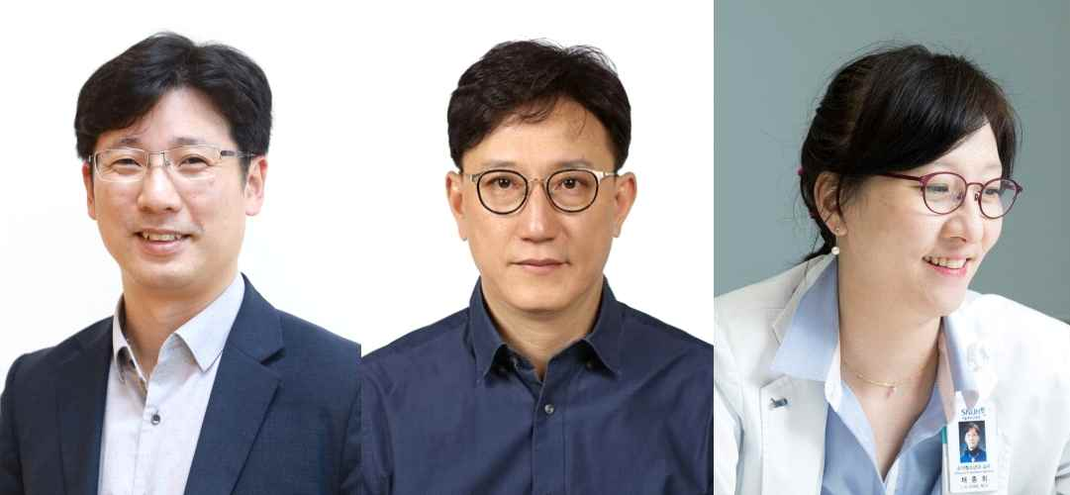
▲ Photo 1 (from left): GIST School of Life Sciences Professor Sung-Gyoo, Department of Pediatrics, Seoul Samsung Hospital Professor Jin-hwan Cho, and Department of Pediatrics, Seoul National University Hospital ProfessorJong-hee Chae

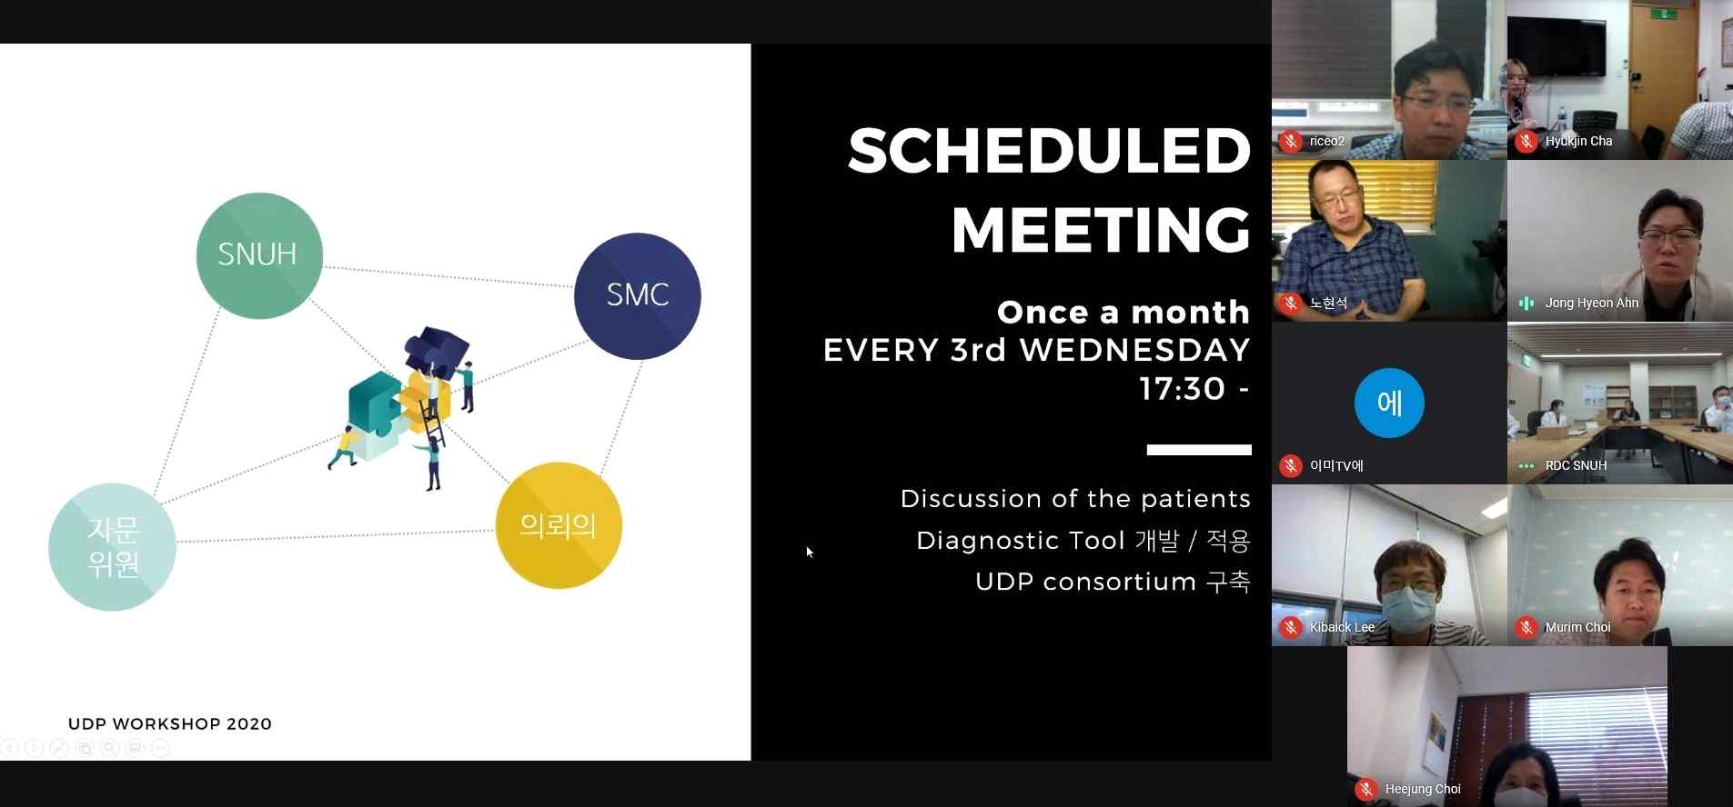
▲ Photo 2: Undiagnosed Rare Disease Functional Core Workshop

