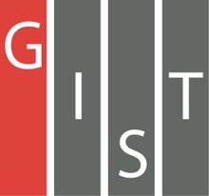
Gwangju Institute of Science and Technology

Official Press Release (https://www.gist.ac.kr/)

Section of Mi-Yeon Kim Nayeong Lee
Public Affairs Section Chief Senior Administrator
(+82) 62-715-2020 (+82) 62-715-2024

Contact Person Sangmin Choi, Administrator
for this Article Artificial Intelligence Research Institute
(+82) 62-715-5203

Release Date 2019.05.28

GIST to host regional meeting to report on the status of the Artificial Intelligence-based Industrial Convergence Complex Project

□ GIST (President Kiseon Kim) will organize a regional report on the "Artificial Intelligence-based Industrial Convergence Complex Project" *, which was jointly organized by Gwangju Metropolitan City and the National IT Industry Promotion Agency (NIPA) on May 30 at 2:00 pm in Oryong Hall.

∘ The Artificial Intelligence-based Industrial Convergence Complex Project * (a total of 406 billion won for 5 years) was reviewed and approved at a Cabinet meeting on January 29, 2019, as a project to be exempted from a preliminary feasibility study.

* This project is a self-contained artificial intelligence-based start-up complex in Gwangju's special high-tech R&D district with a total investment of 400 billion won (including government expenses, local expenses, and private investors) over the next five years.

□ This event will report on the status of Artificial Intelligence-based Industrial Convergence Complex Project to businesses, academia, government officials, and citizens. Any interested local residents can attend. The session will be held by Artificial Intelligence Research Institute Director Hyuk Lim (School of Electrical Engineering and Computer Science professor) who is the official in charge of reporting the current status and development of the project.

□ To prepare the event as a venue for strengthening cooperation among local communities in order to successfully carry out the "Artificial Intelligence-based Industrial Convergence Complex Project, GIST plans to gather 150 local residents as well as industry, academic, and government officials from across the country who are interested in the project to freely share constructive ideas on the project's success.

□ In addition, GIST will continue to hold networking events to revitalize local industries as well as the major industries of Gwangju, such as automobiles, energy, and healthcare while explaining the latest trends related to business and artificial intelligence.

□ GIST Artificial Intelligence Research Institute Director Hyuk Lim said, "Through this report, we hope to promote the Artificial Intelligence-based Industrial Convergence Complex Project and strengthen cooperation among industry, academia, government, and local communities for the successful execution of this project."

※ For more information on events, please refer to the GIST homepage bulletin board

※ Inquiries: GIST Institute of Artificial Intelligence 062-715-5203

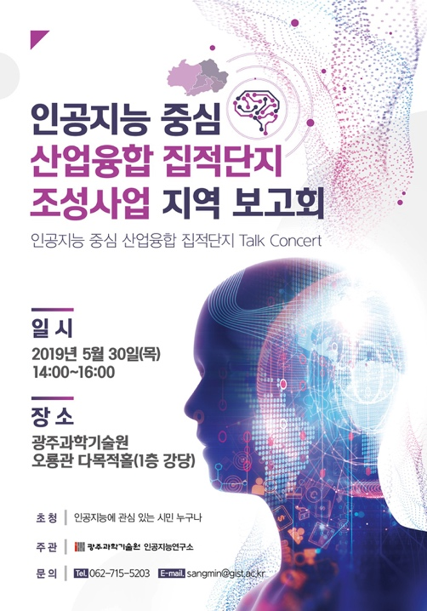
Poster

