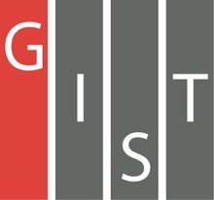

**Gwangju Institute of Science and Technology**

**Official Press Release (https://www.gist.ac.kr/)**

**Section of** Hyo Jung Kim Nayeong Lee

**Public Affairs** Section Chief Senior Administrator

(+82) 62-715-2061 (+82) 62-715-2062

**Contact Person** Section of Public Relations

**for this Article** (+82) 62-715-2062

**Release Date** 2019.09.25

**President Kiseon Kim introduces the future vision**

**of Gwangju AI Cluster at the 20th World**

**Knowledge Forum**

□ GIST President Kiseon Kim at the 20th World Knowledge Forum [Gwangju·GIST Special Session] held in Seoul on September 27, 2019, introduced the future vision for the Gwangju AI Cluster under the theme of "AI Success Equation: Innovation and Clustering."

∘ The main session, which was hosted by Yonsei University Professor Won-soo Kim, was held at 1:30 pm on September 27, 2109, at the Shilla Hotel in Seoul where Gwangju Mayor Yong-sup Lee gave congratulatory remarks and GIST President Kiseon Kim served as the chair. Foxconn Group Vice Chairman Jay Lee and Southern Compass co-founder Trisha Wang participated as panelists.

□ The World Knowledge Forum, which marks its 20th anniversary this year, will be held at Shilla Hotel and Jangchung Gymnasium in Seoul under the theme of "The Knowledge Revolution for Humanity 5.0" for three days from September 25 to 27, 2019. This year's key speakers include YouTube co-founder Steven Chen, Yahoo co-founder Jerry Yang, the Director of Alibaba, and Qualcomm Global Business President Jim Cathey. Global leader of the 4th Industrial Revolution, including Vitaly Rick Buterine, founder of the Etherium, also attended the event.

∘ The World Knowledge Forum is the largest in Asia, with about 100 sessions, and is expected to attract approximately 3,500 people, including speakers and participants. Major speakers include former US President George W. Bush, former US Secretary of State Colin Powell, former US Secretary of State Hillary Clinton, and former French President Nicolas Sarkozy.

□ GIST President Kiseon Kim who chaired the Gwangju·GIST Special Session said, "Gwangju and GIST are putting all their energy into creating a 'Gwangju AI Cluster' complex to create new growth engines for the future and to develop core technologies. Gwangju will grow as Korea's representative AI city by building world-class artificial intelligence research capabilities and infrastructure."

□ GIST, along with Gwangju Metropolitan City, is promoting the 'Industrial Intelligence-based Industrial Convergence Complex Project,' with a total project cost of KRW 416 billion for five years from 2020 to 2024, focusing on creating synergy and securing AI growth engines centered on healthcare, automotive, and energy.

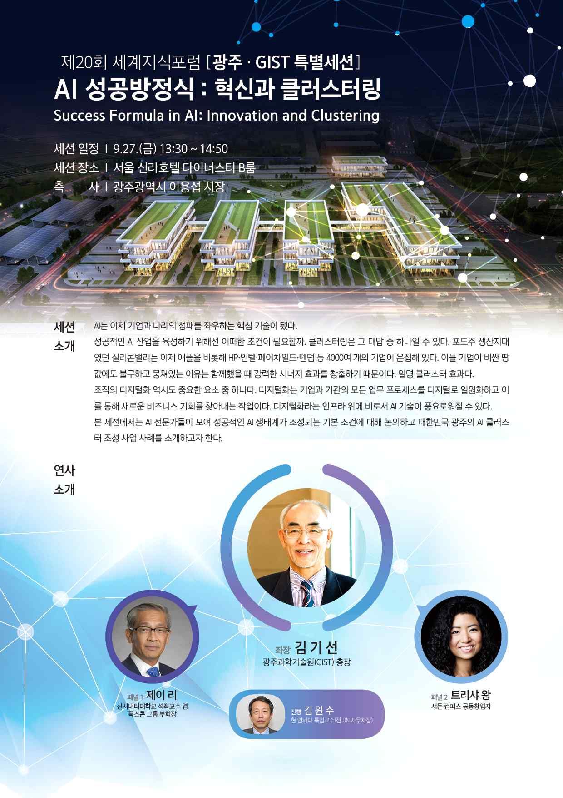

▲ Gwangju·GIST Special Session Poster