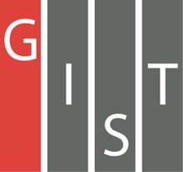

**Gwangju Institute of Science and Technology**

**Official Press Release (https://www.gist.ac.kr/)**

**Section of** Hyo Jung Kim Nayeong Lee

**Public Affairs** Section Chief Senior Administrator

(+82) 62-715-2061 (+82) 62-715-2062

**Contact Person** Juhee Kang, Administrator

**for this Article** Section of Public Affairs

(+82) 62-715-2065

**Release Date** 2019.11.20

**'2019 GIST Culture Night' is a place for multicultural exchange where everyone becomes united**

□ GIST (President Kiseon Kim) hosted the '2019 GIST Culture Night,' a festival for foreigners of various nationalities, on November 15, 2019.

∘ Since 2005, this event has been held every year for to create consensus and unity among GIST members by understanding different cultures. This year, more than 450 people including GIST members and local residents participated in the event to experience and share various unique cultures from around the world.

□ Since its inception, GIST has been globally competitive by offering English courses in all subjects and by conducting research collaborations with world-class universities such as Caltech. Currently, GIST has an international campus with foreign members who make up 10% of our student body from 30 countries around the world.

∘ At this event, seven teams of GIST foreign students and researchers held country booths (USA, Bangladesh, India, Nepal, Philippines, Pakistan, Vietnam), traditional games, food, performances, and a traditional fashion fashion show. Other traditional Korean games such as tuho and yutnori were provided along with popcorn and cotton candy to visitors.

□ Office of International and Public Affairs Dean Sung-Gyoo Park said, "Through the event, we hope that members of GIST will understand the diversity of different cultures and will help foreigners adjust to Korean life. GIST plans to strengthen its research capabilities on the global stage, while promoting various cultural events for communication and exchange."

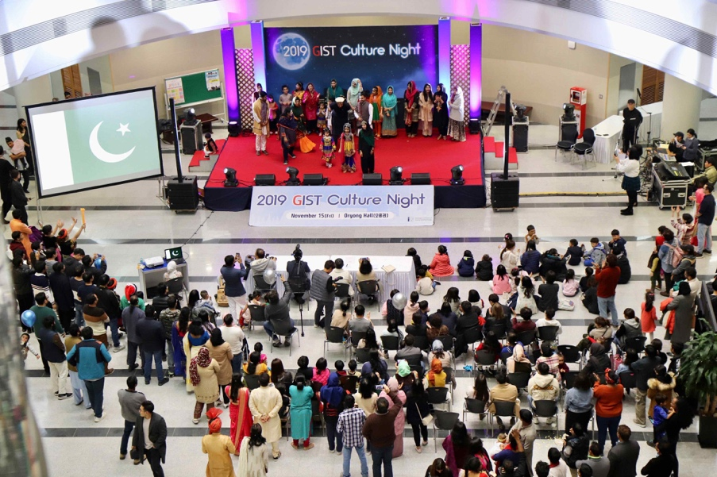

▲ [Photo 1] 2019 GIST Cultural Night Traditional Fashion Show

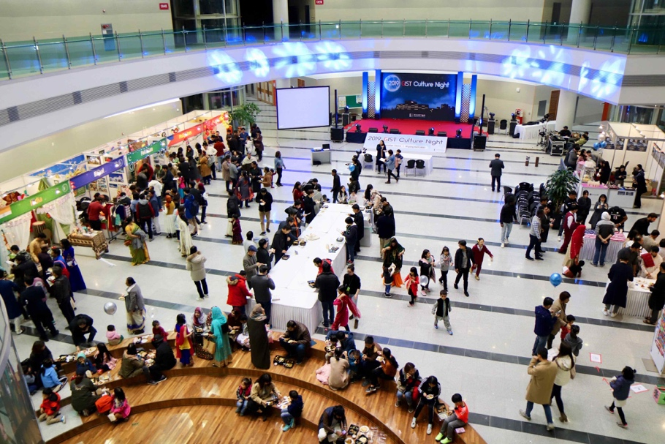

▲ [Photo 2] 2019 GIST Cultural Night Booth Exhibitions