

**Gwangju Institute of Science and Technology**

**Official Press Release (https://www.gist.ac.kr/)**

**Section of** Hyo Jung Kim Nayeong Lee

**Public Affairs** Section Chief Senior Administrator

(+82) 62-715-2061 (+82) 62-715-2062

**Contact Person** Professor Jae-Suk Lee

**for this Article** School of Materials Science and Engineering

(+82) 62-715-2306

**Release Date** 2019.11.21

**GIST Nobel Grubbs Center for Polymers and Catalysis completes the "2019 GIST Grubbs**

**Center Seminar" at Caltech**

□ GIST (President Kiseon Kim) Nobel Grubbs Center for Polymers and Catalysis (Director Robert H. Grubbs, Assistant Director Jae-Suk Lee) hosted the "2019 GIST Grubbs Center Seminar at Caltech" on November 11, 2019, at the California Institute of Technology.

∘ The GIST Nobel Grubbs Center for Polymers and Catalysis was established in January 2016 to create a leading research environment through joint research collaboration with Professor Grubs of Caltech, the 2005 Nobel laureate in chemistry, to secure world-class research capabilities and competitive technologies.

□ The seminar provided a venue for Professor Jae-Suk Lee and Professor Sukwon Hong to visit Caltech to share their research results with Professor Robert Grubbs and Professor Brian Stoltz.

∘ Recently, the research results of Professor Jae-Suk Lee's research team, supported by the Nobel Grubbs Center for Polymers and Catalysis, have been published in Macromolecules by the American Chemical Society and in Polymer Chemistry by the Royal Society of England, the leading journal in the field of polymers, and the research conducted by Professor Sukwon Hong's research team has been published in the international journal Organometallics.

□ Professor Jae-Suk Lee and Professor Sukwon Hong said, "We will continue to work closely with Caltech to secure world-class technology. In addition to active human exchanges, we will expand our network and contribute to the further development of the GIST Nobel Center."

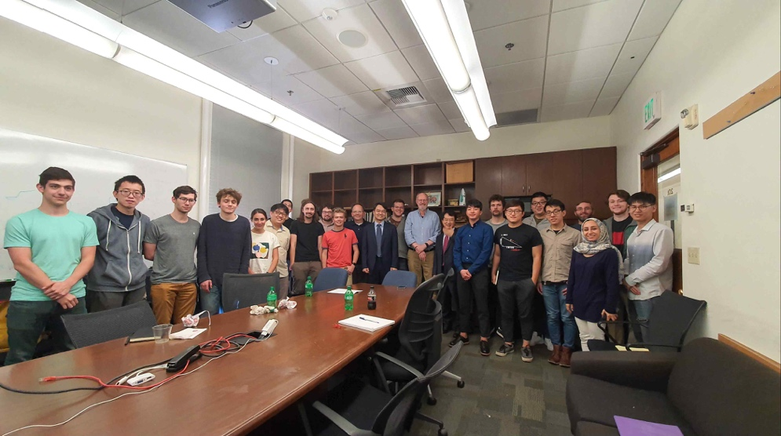

▲ [Photo 1] Commemorative photo taken after completion of the seminar at Caltech by the Nobel Grubbs Center for Polymers and Catalysis

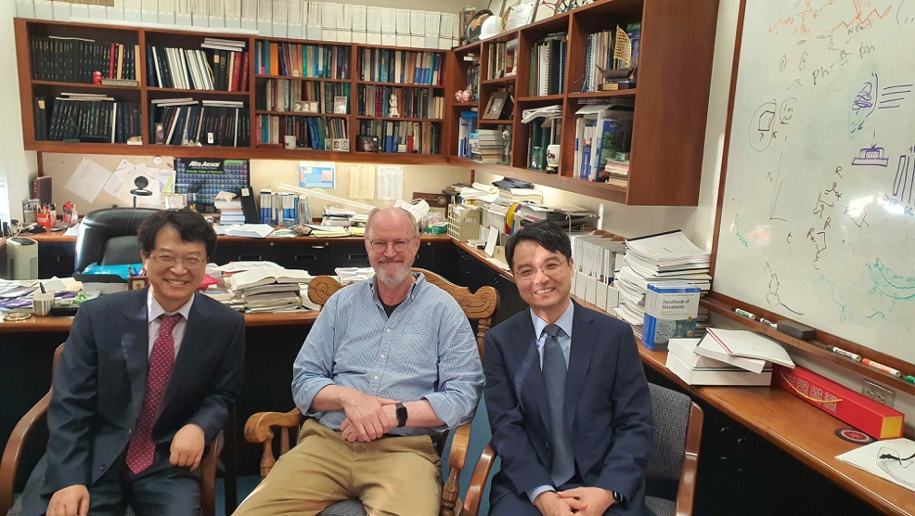

▲ [Photo 2] Commemorative photo taken after completion of the seminar at Caltech by the Nobel Grubbs Center for Polymers and Catalysis (from left) Professor Jae-Suk Lee, Professor Robert H. Grubbs, and Professor Sukwon Hong

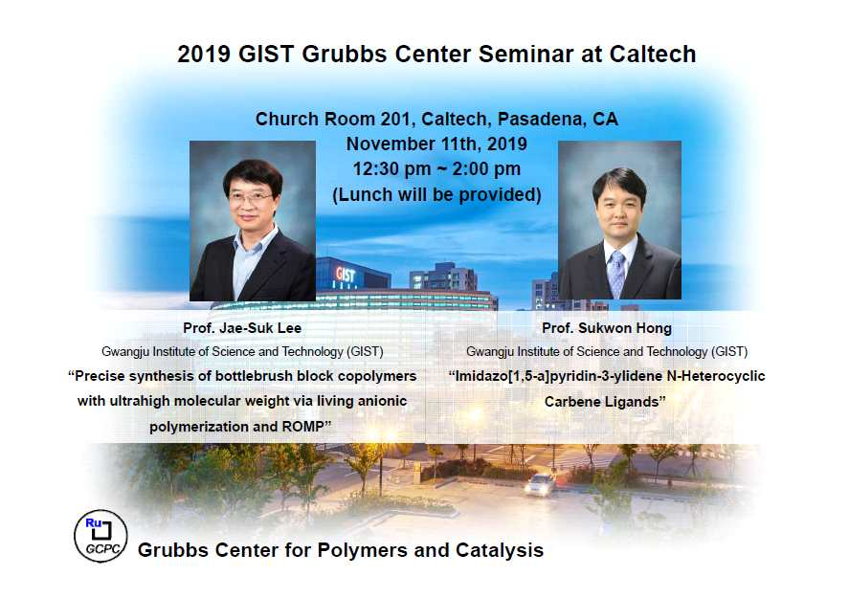

▲ [Photo 3] 2019 GIST Grubbs Seminar poster