

**Gwangju Institute of Science and Technology**

**Official Press Release (https://www.gist.ac.kr/)**

**Section of** Hyo Jung Kim Nayeong Lee

**Public Affairs** Section Chief Senior Administrator

(+82) 62-715-2061 (+82) 62-715-2062

**Contact Person** Mina Choi, Administrator

**for this Article** GIST Academy

(+82) 62-715-2622

**Release Date** 2019.11.20

**GIST Techno Management Business Academy hosts 9th Completion Ceremony**

□ GIST (President Kiseon Kim) Techno Management Business Academy (Director Jong-In Song) held its 9th Completion Ceremony along with a ceremony for the donation of 15 million won by the 9th class of the graduation students on November 19, 2019, at Oryong Hall.

∘ About 70 participants attended the event, including Vice President Jong-In Song, the graduating students, and GIST staff members. A total of 42 students completed the 27 week curriculum, with Dongyang Metal Chairman Jeong-soon Park, the 9th president of the student alumni association, and Young-sim Roh, the chairman of Green Engineer Ring, respectively, being awarded the President's Award and GTMBA Director's Award respectively.

□ Vice President Jong-In Song said, "I hope that you will become respected entrepreneurs who will lead the future of the community and the Republic of Korea by fully utilizing the knowledge and human network acquired through GTMBA. Always be proud of being a GTMBA alumni, and strive for continued communication, exchange, and cooperation with GIST and industries."

□ 9th alumni association president Jeong-soon Park said, "The 42 graduates will strive to design and promote a better future for the local economy and enterprise by utilizing the high level of knowledge and diverse information provided by the GTMBA curriculum. We wanted to make a class donation in the hope that GIST will stand tall as a global science and engineering research institute in the region."

□ GTMBA is currently recruiting new students for the 10th term in 2020. The course runs for one year, starting in March and running until November.

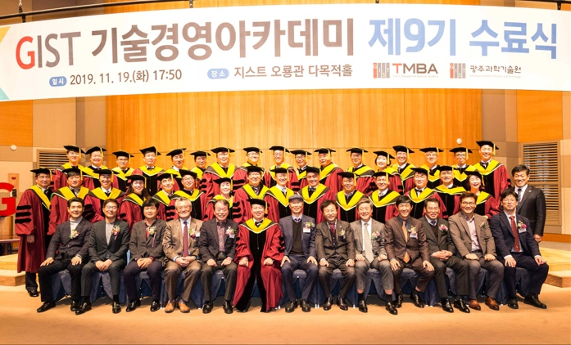

▲ [Photo 1] Commemorative Photo for GIST Techno Management

Business Academy's 9th Completion Ceremony

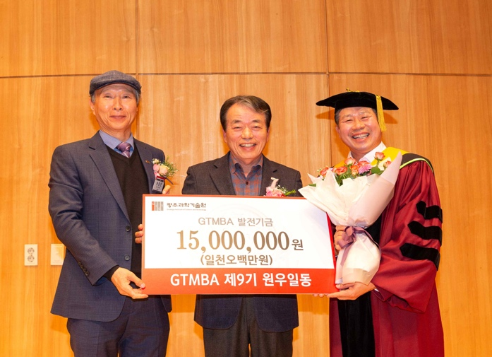

▲ [Photo 2] GTMBA 9th alumni association president Jeong-soon Park

(CEO, Dongyang Metal Co., Ltd.) at the donation ceremony