

**Gwangju Institute of Science and Technology**

**Official Press Release (https://www.gist.ac.kr/)**

**Section of** Hyo Jung Kim Nayeong Lee

**Public Relations** Section Chief Senior Administrator

(+82) 62-715-2061 (+82) 62-715-2062

**Contact Person** Seok-ho Lee, Administrator

**for this Article** Section of Planning

(+82) 62-715-2977

**Release Date** 2020.06.11

**Minister Young-sun Park of the Ministry of SMEs and Startups visits GIST, saying "Active support for start-ups such as AI and healthcare in Gwangju"**

□ Minister Young-sun Park of the Ministry of SMEs and Startups visited GIST (Gwangju Institute of Science and Technology, President Kiseon Kim) on the afternoon of June 10 and held an on-site meeting to revitalize youth start-ups with a total of 40 people attending, including GIST President Kiseon Kim, Gwangju SMEs and Startups Director Hyun-jo Lee, and undergraduate entrepreneurship start-up students.

∘ This round-table conference was prepared to share the practical difficulties that students face preparing for start-ups or during the initial commercialization process for their entrepreneurship ideas and to seek solutions together.

□ About 10 student (preparatory) start-ups attended the on-site meeting held at the GIST Startup Promotion Center. Cloudstone (CEO Min-joon Kin, undergraduate chemistry major), which developed which developed a special delivery app service for one-person orders, had a time to introduce the company's business model and operational status.

∘ To prevent the spread of COVID-19, a thermal camera, hand sanitizers, and mask were provided on site.

□ At the meeting, Minister Park said, "I know that student start-ups like you have a lot of difficulties in realizing their dreams. Don't give up until the end, and pursue your dreams with the hope that if you knock on the door, it will open. As GIST is actively supporting AI start-up experts and with the Gwangju Artificial Intelligence Complex being created, we will support more young people to create start-ups in various fields such as AI and health care."

□ President Kiseon Kim said, "Starting this year, GIST AI Research Institute is actively promoting 'AI start-up development project' to discover AI needs, educate preliminary start-up teams in AI, and discover business ideas. We will try to secure new growth engines for the local community by fostering AI start-up teams focusing on Gwangju's main industries such as automobiles, energy, healthcare and cultural contents."

□ Meanwhile, before the meeting, Minister Park boarded a vehicle equipped with LiDAR (Light Detection and Ranging) * , which was produced by SOS LAB, a GIST student start-up company (CEO Ji-sung Jung, a Ph.D. student in the School of Mechanical Engineering, took a leave of absence). The test-drive monitored road data collected in real time at GIST's campus.

* LiDAR sensors are used as a key technology for self-driving cars and combine them with other sensors in the vehicle to provide accurate judgment on situations that occur when driving.

∘ SOS Lab recently succeeded in attracting 9.8 billion won worth of Series A+ investment, starting with the lead investment of the Korea Development Bank of Korea (KDB) lead investment. This is an additional investment following the investment (6.8 billion won) received from Mando, a global auto parts manufacturer, in 2018, and the accumulated investment so far amounts to about 17 billion won. CEO Ji-sung Jung said, "By 2021, we will commercialize vehicle LiDAR, and we will contribute to creating a world where technology can take responsibility for human safety by developing durable LiDAR at low cost."

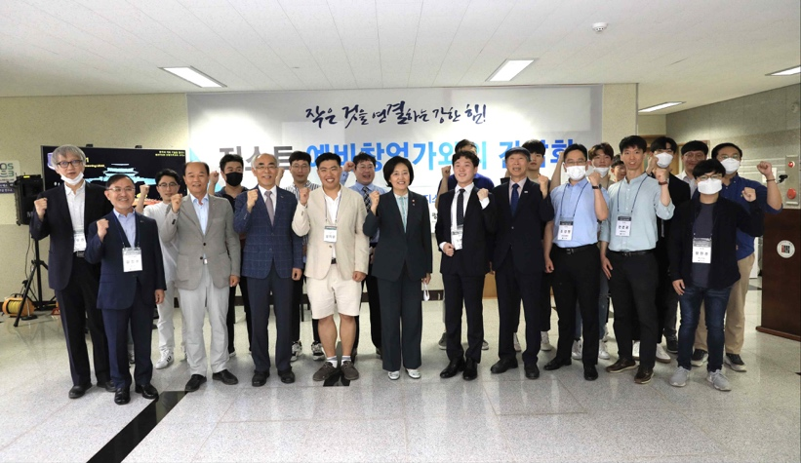

[Picture 1] Group photo for on-site meeting to promote youth

start-ups with the Ministry of SMEs and Startups

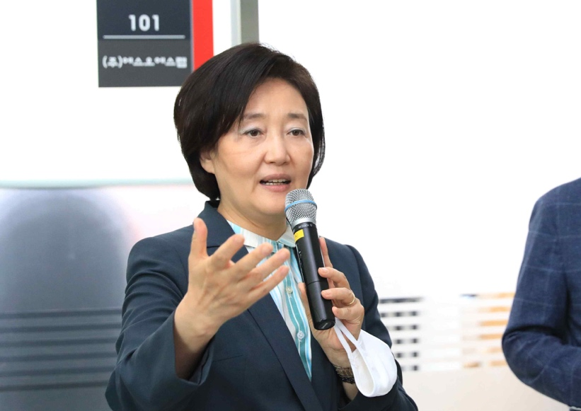

[Picture 2] Young-sun Park, Minister of SMEs and Startups at GIST to promote youth start-ups

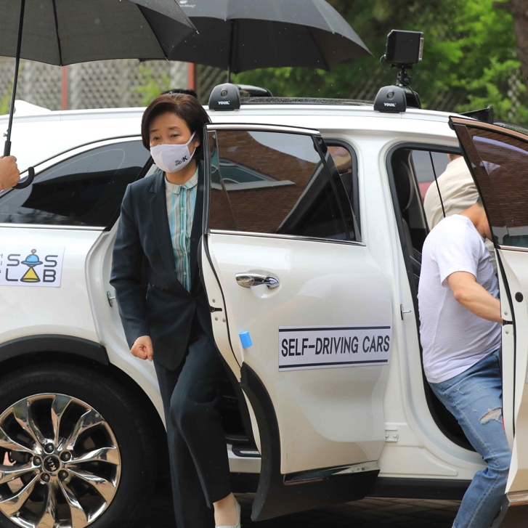

[Picture 3] Test drive of 'LiDAR Sensor' vehicle made by SOS Lab,

a GIST student start-up company with the Ministry of SMEs and Startups