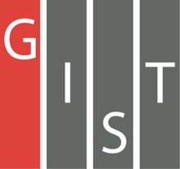

**Gwangju Institute of Science and Technology**

**Official Press Release (https://www.gist.ac.kr/)**

**Section of** Hyo Jung Kim Nayeong Lee

**Public Relations** Section Chief Senior Administrator

(+82) 62-715-2061 (+82) 62-715-2062

**Contact Person** Soo Jung Park, Administrator

**for this Article** Section of Public Affairs

(+82) 62-715-2022

**Release Date** 2020.03.19

**GIST and Hungary's ELTE University sign a**

**mutual agreement to foster global specialists**

□ Gwangju Institute of Science and Technology (GIST, President Kiseon Kim) and Hungary's Eötvös Loránd University (ELTE) signed a student exchange agreement to foster global specialists.

∘ ELTE University in Hungary opened in 1635 and is the best national university in Hungary with a history of 376 years and has 30,000 students in eight departments. It has a deep relationship with Korea by officially opening and operating a Korean language department in 2009, and, in 2019, it hosted a Korean speaking contest and a Korean cultural experience event to mark the 10th anniversary of the opening of a Korean language department.

□ ELTE University has been conducting joint research with Gist through the European Union's Erasmus Mundus TEAM program * since 2018 to build human resources exchange and network in the field of information and communication technology, and an inter-agency agreement was signed as a springboard.

* TEAM: Technologies for information and communication, Europe – east Asia Mobilities

□ GIST President Kiseon Kim said, "We hope that this agreement will serve as an important opportunity to bring together the core competencies of education and research at both institutions and that it will also have a positive effect on promoting cooperative exchanges between Korea and Hungary."

□ Based on the conclusion of the agreement, GIST and ELTE University plan further cooperation in various fields, including exchange student programs and exchange of credits, as well as holding joint academic workshops and promoting joint research.

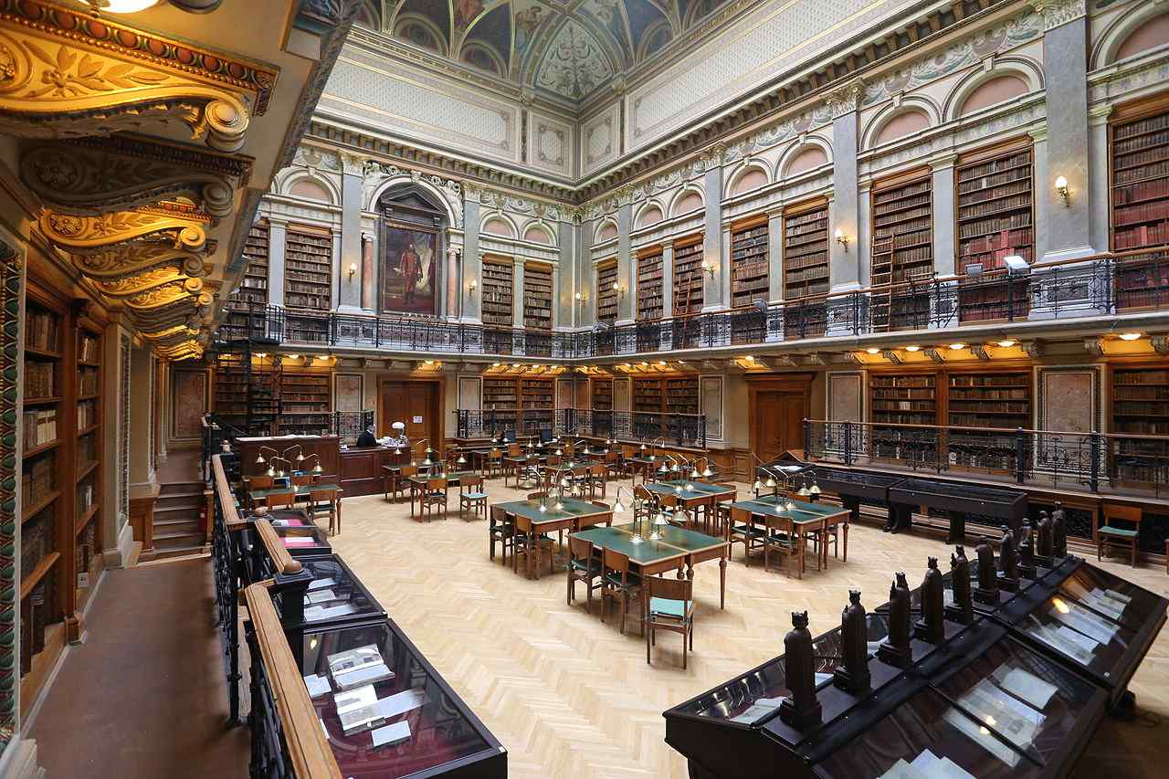

▲ ELTE University's library <credit: Wikipedia>