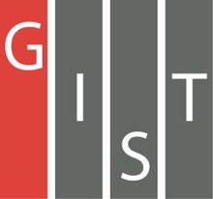

**Gwangju Institute of Science and Technology**

**Official Press Release (https://www.gist.ac.kr/)**

**Section of** Mi-Yeon Kim Nayeong Lee

**Public Affairs** Section Chief Senior Administrator

(+82) 62-715-2020 (+82) 62-715-2024

**Contact Person** Soo Jung Park, Administrator

**for this Article** Section of International Cooperation

(+82) 62-715-2062

**Release Date** 2018.07.18

**GIST signs MoU with Sorbonne Université, France**

□ GIST (President Seung Hyeon Moon) signed an MoU for personnel exchanges and joint research cooperation with Sorbonne Université (President Jean Chambaz) * in Paris, France on June 8, 2018.

* To date, Sorbonne Université has produced 32 Nobel Prize winners and Fields Medal winners. In particular, Marie Skłodowska Curie, a two-time Nobel Prize winner, earned a Ph.D. from the Sorbonne and later served as professor at the Sorbonne Université.

□ GIST Professors in the Department of Physics and Photo Science started to work with the research team of Jean-Jacques Gallets, Fabrice Bournel, Jean Francois) at the Laboratoire de Chimie Physiqes Matiere et Rayonnement at Sorbonne University in Paris, France in 2015.

∘ In 2015, the University of Sorbonne was building a special experimental device called the "S-phase Photoemission Spectrometer" at the Paris Soleil Synchrotron Radiation Accelerator Laboratory, and Professor Bongjin Mun's research team contacted Sorbonne Université Group to conduct research on application of photoelectron spectroscopy, which established the foundation for collaborative research.

∘ The joint research theme is "Challenging research on the real-time observation of the physical/chemical reaction characteristics of the material surface/interface using synchrotron X-ray" and plays an important role in the development of next generation catalytic materials and future materials for energy.

□ In September 2015, the GIST team visited the Sorbonne, and in 2016 Professor Francois Rochet of the Sorbonne visited the GIST. In April 2017, Professor Jean-Jacques Gallets and Fabrice Bournel from the Sorbonne Université participated in the Operando Science Workshop held at the GIST. In addition, from 2016 to 2017, the GIST team visited the Sorbonne more than four times to use experimental equipment and conducted joint experiments and research.

□ The joint research team of both universities has published joint research results at many international conferences and published two papers in the international SCI journal: "Chemical states of surface oxygen during CO oxidation on Pt (110) surface revealed by ambient pressure XPS" in the Journal of Physics: Condensed Matter (2017) and "Lattice mismatch-driven surface segregation and formation of reactive interfacial sites on Pt3Ni (111) bimetal surfaces" in Science Advances (2018).

□ GIST President Seung Hyeon Moon said, "I hope that this agreement will be an important opportunity to garner the core competencies of the two institutions and will lead to the creation of more excellent research results in the future and that it will also positively affect further cooperative exchanges between Korea and France."

□ GIST and Sorbonne plans to further promote various cooperation activities including exchange student programs and joint workshops based on this MoU.

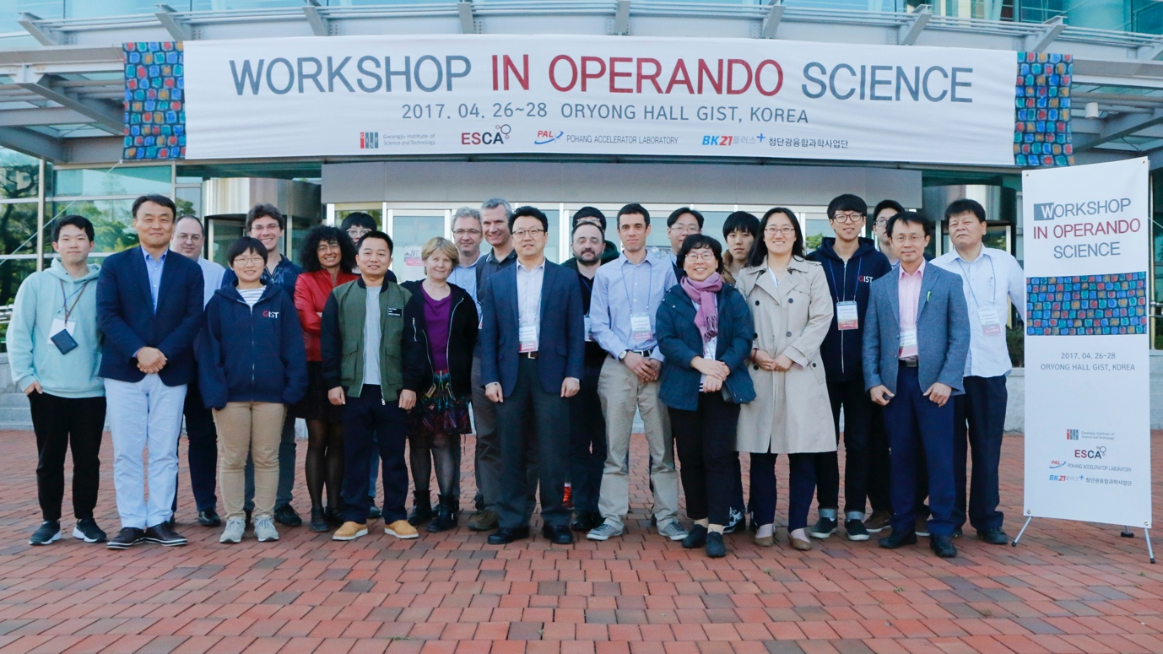

▲ Professor from Sorbonne Université participated in the Operando Science Workshop

held at GIST in April last year to promote joint research and cooperation.