

**Gwangju Institute of Science and Technology**

**Official Press Release (https://www.gist.ac.kr/)**

**Section of** Hyo Jung Kim Nayeong Lee

**Public Relations** Section Chief Senior Administrator

(+82) 62-715-2061 (+82) 62-715-2062

**Contact Person** Kyung-jin Cho, Administrator

**for this Article** GIST Business Incubator

062-715-2596

**Release Date** 2020.09.20

**GIST Angel Club signs an investment**

**contract with Cloudstone Co., Ltd.**

□ GIST (Gwangju Institute of Science and Technology, President Kiseon Kim) Angel Club (Chairman Woo-jin Park, Director of the Science and Technology Applied Research Group) signed an investment contract worth 50 million won with Cloudstone Co., Ltd.

∘ The GIST Angel Club was formed on April 29 of this year to revitalize angel investment for start-ups founded with GIST's promising technology. Seventeen members of GIST, venture capitalists, accountants, lawyers, and professional consultants are participating.

□ The Angel Club continues to hold online investment promotion briefing sessions to prevent the spread of COVID-19, and Cloudstone Co., Ltd., became the first company to have attracted investment from the GIST Angel Club.

∘ Cloudstone Co., Ltd., is a promising start-up company founded last year by CEO Min-joon Kim, who is a chemistry major at GIST, that operates "Delivery Geek," a delivery service company specializing in deliveries for one person. Due to the lack of delivery fees and minimum order amount, it is receiving great response from university merchants and students, and it is currently actively serving Seoul National University and other universities in the Seoul metropolitan area

□ Angel Club Chairman Woo-jin Park said, "In the future, we will continue to carry out various activities to boost investment so that GIST start-ups with high potential for growth can grow at an early date."

∘ Instead of a one-time investment, the GIST Angel Club plans to support sustainable growth for the company as a partner by offering continuous consulting, mentoring, and technical guidance of angels in related fields.

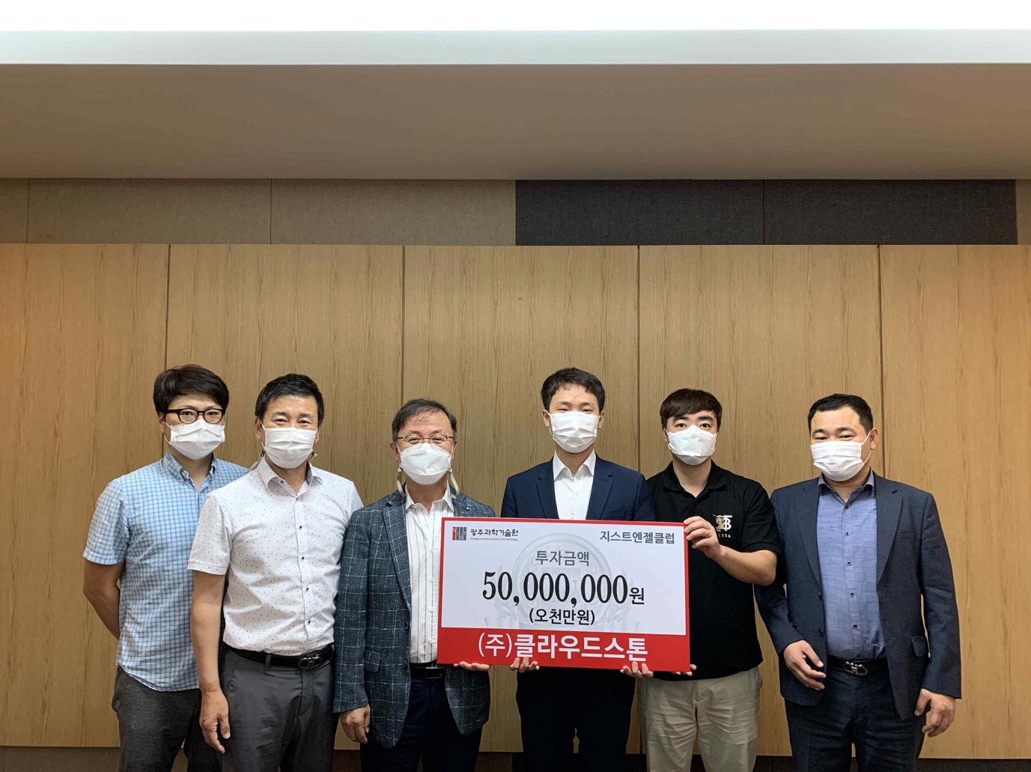

▲ From the left: GIST Angel Club member Kyung-jin Cho, GIST Business Incubator Director Sung-keun Ki, Vice-President for R&D In S. Kim, Cloudstone Co., Ltd., CEO Min-joon Kim, Director of Yangji Accounting Firm Jung-wook Hong, and GIST Labor

Union Chairman Choong-ki Lee