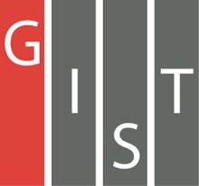

**Gwangju Institute of Science and Technology**

**Official Press Release (https://www.gist.ac.kr/)**

**Section of** Hyo Jung Kim Nayeong Lee

**Public Relations** Section Chief Senior Administrator

(+82) 62-715-2061 (+82) 62-715-2062

**Contact Person** Seung-soo Yoo, Administrator

**for this Article** Section of Public Affairs

+(82) 62-715-2025

**Release Date** 2020.07.01

**Vice Minister of Science and ICT Byung-sun Chung visits GIST to explore future innovative growth measures to boost the local economy**

□ Vice Minister of Science and ICT Byung-sun Chung visited GIST (Gwangju Institute of Science and Technology) on June 30, 2020, and held an 'On-Site Conference of Gwangju Innovators to Improve Regional Economic Vitality' with about 35 people, including GIST President Kiseon Kim, Gwangju Mayor Lee Yong-sup, and representatives of small and medium-sized enterprises in Gwangju.

∘ This meeting was held as part of a regional relay field meeting to enhance the economic vitality of the region based on science and technology and to provide a breakthrough in regional innovative growth in response to COVID-19 and was designed to share regional difficulties and seek solutions together.

□ At this meeting, major strategies for the AI industry in Gwangju and measures to revitalize the local economy using scientific and technological resources were discussed.

∘ △ Following the announcement by the Ministry of Science and ICT on measures to boost regional economic vitality based on science and technology in response to COVID-19 △ Gwangju City introduced 'AI-oriented Industrial Convergence Complex Development Project Promotion Plan' △ GIST AI Research Institute Director JongWon Kim discussed 'Strategies to Promote People-Oriented AI Industry Convergence' △ Gwangju-Jeonnam Regional Organization Consultative Body discussed ways to contribute to revitalizing the local economy.

□ In the meeting, all of the industry-academic-related innovators in Gwangju were able to strengthen their commitment to solve problems in the region, strengthen innovation capabilities, and expand future growth engines based on cooperation in order to overcome problems caused by COVID-19 and to seek new opportunities for growth and development.

∘ The Ministry of Science and ICT explained its implementation projects, such as 'COVID-19 Science and Technology-based Countermeasures for Regional Economic Vitality Enhancement Plan' and post-corona response tasks, and introduced new 'Solving Current Regional Issues with Technology Commercialization' to revitalize the local economy through special R&D zones.

∘ Through the 'People-Centered AI Industry Convergence Promotion Strategy', GIST presented an open-type collaborative ecosystem model centered on AI integrated systems and emphasized the need to create a common infrastructure and build a common platform for this purpose. It also proposed strategic tasks that utilize local specialized resources to enhance competitiveness based on AI convergence.

□ Vice Minister Byung-sun Chung said, "In a difficult situation due to COVID-19, we actively mobilize scientific technology and ICT to enhance the economic vitality of the region, and the government will continue to improve the difficult situations in the field through close communication with research facilities and companies."

∘ In addition, he said, "As the era of decentralization begins, the central government will actively support R&D achievements in innovative growth efforts for future-leading strategic fields, such as AI, futuristic automobiles, smart energy, and photovoltaic industries in Gwangju."

□ President Kiseon Kim said, "GIST is actively promoting the development of AI start-up specialists tailored to the region, focusing on the AI Graduate School and the Artificial Intelligence Research Institute that opened in March of this year. GIST will actively contribute to securing new growth engines for the local community by fostering AI convergence specialists needed for local industries, securing world-class AI core technologies, and building industry-academia-research ecosystems for innovative growth."

□ Meanwhile, at a time when the COVID-19 pandemic is causing major transformation, GIST will hold the 'Post-Corona Era Conversion Forum 2020,' which is jointly organized by Chonnam National University, Gwangju National University of Education, and Maekyung Media Group and will examine the situation of the community and redefine the value of co-prosperity through new daily life stories of post-corona education, science and industry, and climate environment.

∘ This forum will be held on July 2 and 3, 2020, at Chonnam National University Convention Hall and plans to find ways to cooperate between Korea's regions.

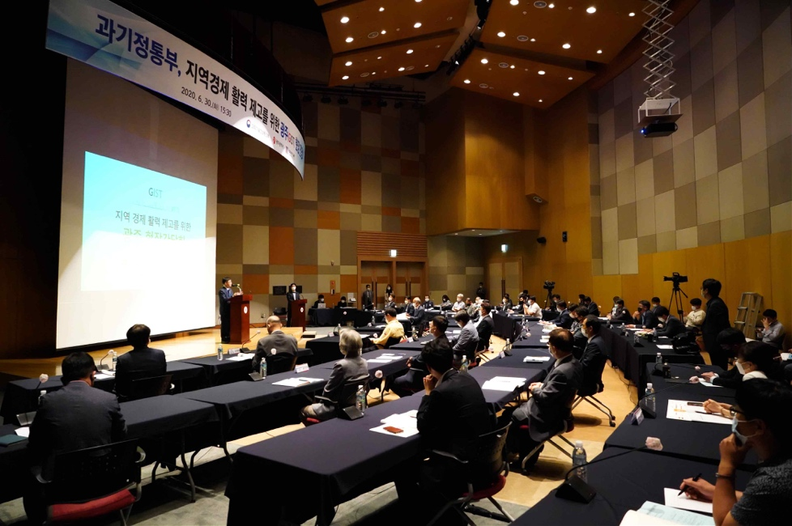

[Photo 1] Gwangju Field Meeting at Oryong Hall

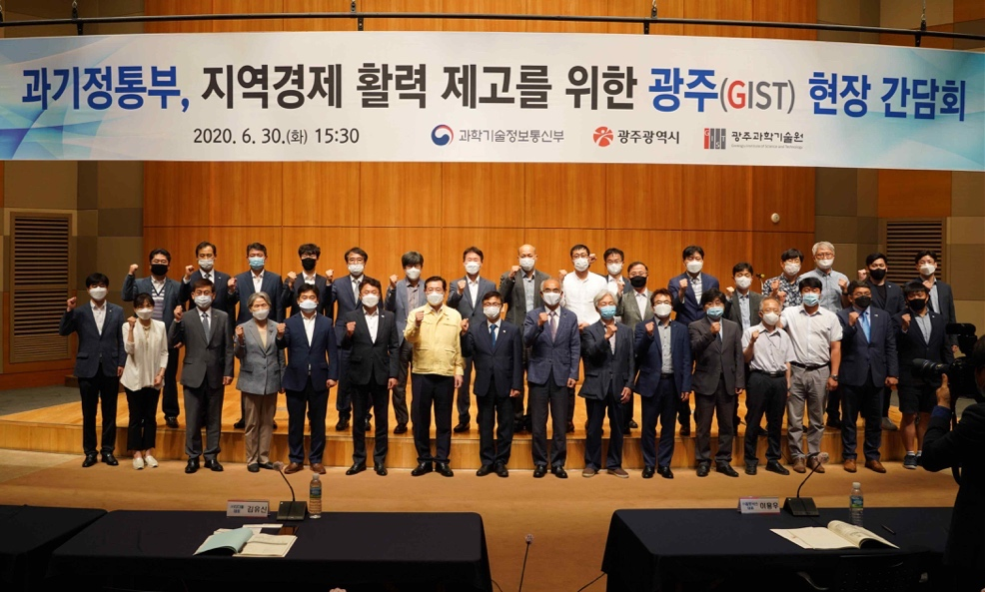

[Photo 2] Gwangju Field Meeting at Oryong Hall group photo