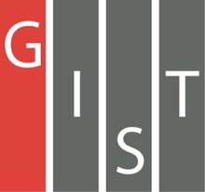

**Gwangju Institute of Science and Technology**

**Official Press Release (https://www.gist.ac.kr/)**

**Section of** Mi-Yeon Kim Nayeong Lee

**Public Affairs** Section Chief Senior Administrator

(+82) 62-715-2020 (+82) 62-715-2024

**Contact Person** Seulhye Kim

**for this Article** Section of International Cooperation

(+82) 62-715-2067

**Release Date** 2018.12.12

**GIST Magazine receives the editorial grand prize award from the '2018 Korea Communication**

**Award Ceremony'**

□ GIST (President Seung Hyeon Moon) Magazine was awarded the editorial grand prize award during the '2018 Korea Communication Award Ceremony.'

□ The '2018 Korea Communication Awards' is sponsored by the Ministry of Culture, Sports and Tourism and the National Assembly. It is the only communication awards ceremony in Korea that focuses on communication and journalism media, which are published by national institutions and public and private companies. This year's awards ceremony was held at the International Press Conference Center in Seoul, Korea, on December 6, 2018.

∘ Starting in 1991 as the 'Korean In-House Newsletter Award,' it marks its 28th anniversary this year and has grown to include 25 categories of awards in print, electronic news, websites, blogs, SNS, and other categories that are published in Korea, as well as special categories, external institutions, and overseas awards in three categories.

□ GIST Magazine has been issued four times a year from March 2010 to 2017, and three times a year since 2017. In November 2018, the 25th anniversary edition of the GIST Magazine was issued as the last issue of this year, with the next issue scheduled for March next year.

∘ GIST Magazine contains diverse and informative contents such as people, departments, laboratories, clubs, entrepreneurship, and admissions to university and graduate schools. GIST Magazine is sent to GIST students, parents, faculty, staff, and alumni. It is also useful as a promotional material for admissions.

□ Dean of International and Public Affairs Yong Chul Kim said, "The articles in GIST Magazines, which covers various news around campus as an in-house newspaper, has been recognized for its quality. In the future, we will continue our efforts to improve the quality and to promote GIST with better articles and lively content."

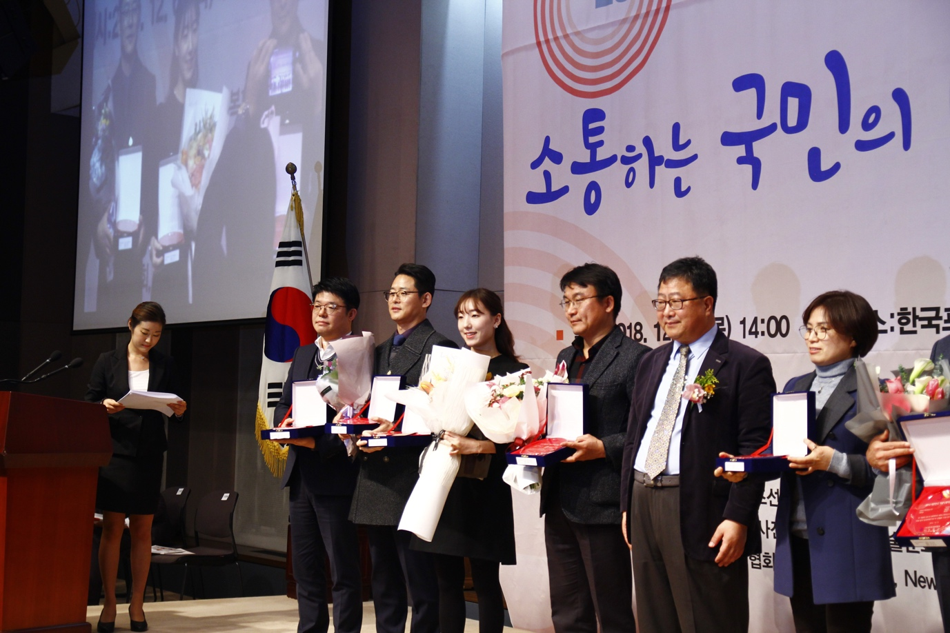

▲ '2018 Korea Communication Award Ceremony'