

**Gwangju Institute of Science and Technology**

**Official Press Release (https://www.gist.ac.kr/)**

**Section of** Hyo Jung Kim Nayeong Lee

**Public Affairs** Section Chief Senior Administrator

(+82) 62-715-2061 (+82) 62-715-2062

**Contact Person** Kyung-hwa Kim, Administrator

**for this Article** Section of Academic Affairs

(+82) 62-715-2042

**Release Date** 2019.08.20

**GIST Graduation ceremony held**

**for the second half of 2019**

□ GIST (President Kiseon Kim) held the “Graduation Ceremony for the Second Half of 2019” at Oryong Hall on August 20, 2019, which was attended by 400 students, parents, and distinguished guests.

∘ A total of 181 recipients were conferred degrees at the ceremony, including 49 Ph.D., 82 master's degrees, and 50 bachelor's degrees.

□ In particular, the Future Talent Award * was given to undergraduates from Jeju Myung-hyun Kim (class of 2012/physics major) and Jong-hyuk Kang (class of 2015/EECS major).

* Future Talent Award is given to graduating students who best represents GIST's 3C1P ideal: creativity, communication, and cooperation.

∘ Myung-hyun Kim received three awards: Future Talent Award, Best Paper Award, and Best Student Award. In addition, he was a student council member and a dormitory board member, developing leadership and a spirit of service. H was also a drummer for a band and conducted supplementary research with Department of Physics and Photon Science Professor Dong-Hee Kim.

∘ Jong-hyuk Kang is one of the founding members of the startup Select Star, which recently attracted 400 million won from Kakao Ventures. The company has been recognized for its outstanding programming skills in developing AI programming, which collects and processes AI data commissioned by companies. He said, "I entered GIST, received SW education, and became interested in related fields. Since March last year, I have been participating in robot research at the GIST Artificial Intelligence Lab."

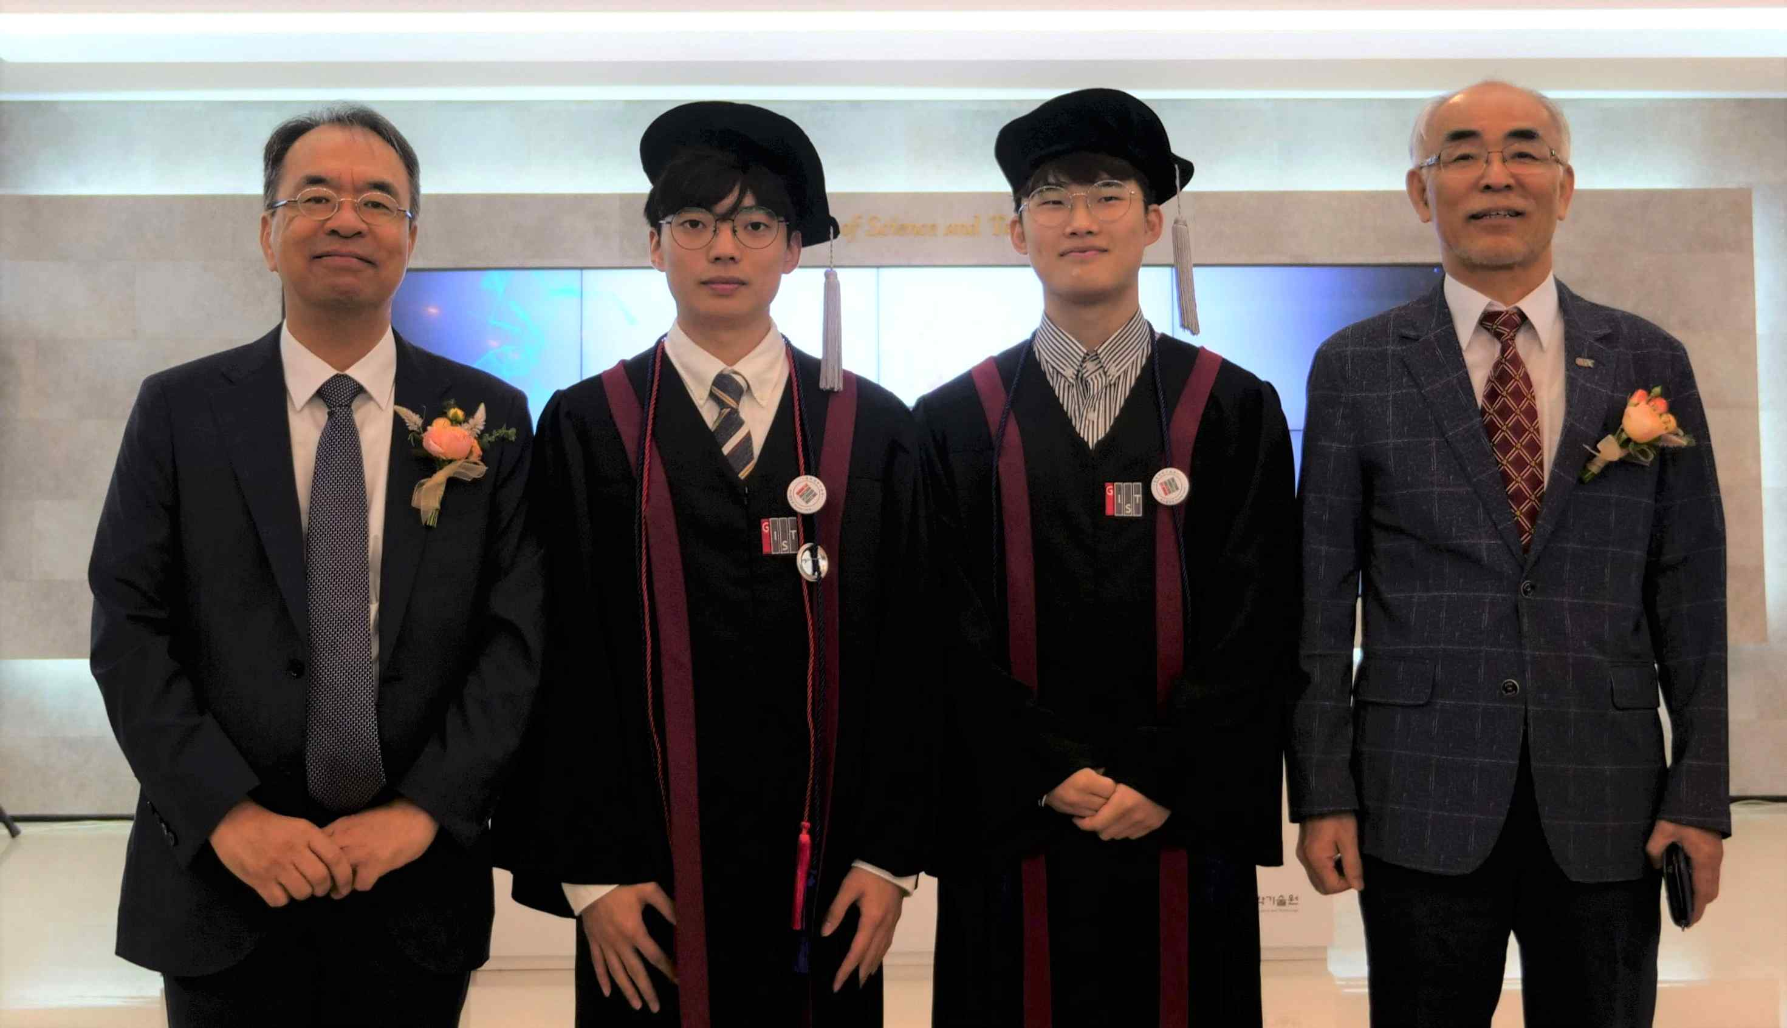

▲ Picture 1 from left: College Dean Yong-Ju Lee, Myung-hyun Kim,

Jong-hyuk Kang, and GIST President Kiseon Kim

□ The average number of papers published by the 49 Ph.D. recipients in Science Citation Index (SCI) journals was about six.

∘ On average, the Ph.D. recipients published 2.65 papers as first-authors, 2.96 papers as co-authors, and about six papers in SCI journals.

□ Dr. Jong-in Kim (Advising Professor Boreom Lee) of the Department of Biomedical Science and Engineering published 15 SCI papers, including five as the first author and ten as the co-author, achieving the best research results among the Ph.D. graduates.

∘ Along with Dr. Jong-in Kim, the Excellent Research Award was given to ▲ School of Electrical Engineering and Computer Science Dr. Joon-hyung Park (Advising Professor Jong Won Shin) ▲ School of Materials Science and Engineering Dr. Sun-kyu Lee (Advising Professor Kwanghee Lee) ▲ School of Mechanical Engineering Dr. Chan-ki Park (Advising Professor Boreom Lee) ▲ School of Earth Sciences and Environmental Engineering Dr. Abayomi Babatunde Alayande (Advising Professor In S. Kim) ▲ School of Life Sciences Dr. Yoon-kyung Won (Advising Professor Jang-Soo Chun) ▲ School of Physics and Chemistry Dr. Jung-woo Han (Advising Professor Jongseok Lee) ▲ Department of Chemistry Dr. Young-woong Suk (Advising Professor Min-Gon Kim).

∘ GIST College also awarded ▲ magna cum laude to chemistry major Min Huh, chemistry major Tae-hong Kang, new materials major Joo-young Jang, and physics major Ji-hwan moon ▲ summa cum laude to chemistry major Sun-yul Kim, life science major Su-in Cho, physics major Myung-hyun Kim, and life science major Hyunsu Ahn.

∘ Special awards for community service was given to ▲ School of Electrical Engineering and Computer Science Dr. Chung-jae Lee ▲ School of Electrical Engineering and Computer Science Dr. Hong-sung An ▲ chemistry major Won-joong Lee.

∘ A merit award was given to School of Materials Science and Engineering student Dae-hee Lim for contributing to the development of the school as a member of the dormitory committee.

□ At the ceremony, GIST President Kiseon Kim said, "I hope you will remember that today's graduation is not the end of your effort but as the beginning of your career, and a new journey, called the 4th Industrial Revolution, is waiting to be challenged. We hope that you will become experts in finding new problems, asking questions, and challenging them while actively coping with rapidly changing social trends and environments with competence and pride obtained from GIST."

□ Meanwhile, GIST received recognition from the world for its outstanding research performance as it is ranked fifth in the category of "citations per faculty" for 2019 that shows the academic influence of the institution's research capabilities and research achievements. In addition, it has been awarded the Grand Prize for Korea's Start-up Excellence University for three consecutive years (2017-2019), and it has faithfully carried out its goal of establishing a national mission of developing science and technology and fostering talented people and leading local industries by leading the project to create an AI cluster in Gwangju.

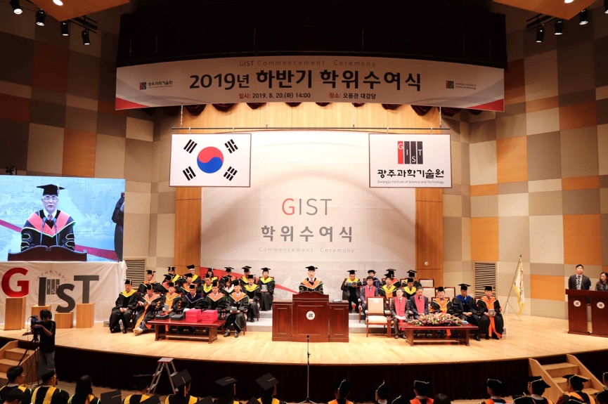

▲ Photo 2: GIST Graduation Ceremony for the Second Half of 2019