

**Gwangju Institute of Science and Technology**

**Official Press Release (https://www.gist.ac.kr/)**

**Section of** Hyo Jung Kim Nayeong Lee

**Public Affairs** Section Chief Senior Administrator

(+82) 62-715-2061 (+82) 62-715-2062

**Contact Person** Professor Jung Won Yoon

**for this Article** Center for Nanorobotics in Brain

(+82) 62-715-5332

**Release Date** 2019.09.26

**Opening ceremony for the Center for**

**Nanorobotics in Brain**

□ GIST (President Kiseon Kim) Center for Nanorobotics in Brain (Director Jung Won Yoon · School of Integrate Technology Professor) held an opening ceremony at GIST Dasan Building on September 26, 2019.

∘ The ceremony was attended by GIST officials and members including, GIST Research Institute Director In S. Kim, Institute of Integrated Technology Dean Sungho Jeong, Dean of Research Ji-Woong Park, Department of Biomedical Science and Engineering Boreom Lee, and Korea Robotics Society President Byung-ju Lee.

□ The Center for Nanorobotics in Brain was established to study source technologies for using nanorobotic platforms to treat brain diseases and enable brain interfaces.

∘ The research center received a total of 7.5 billion won from the Ministry of Trade, Industry and Energy and the Ministry of Science and ICT for ▲ development of robotic drug delivery navigation platforms for the treatment of brain diseases through 'Development of drug-supported micro-nano robot navigation system technology for brain disease treatment' from 2019 to 2022 ▲ the Human Plus Convergence R&D Challenge projectto develop a new concept brain stimulation platform using nanoparticles through the "Nano-BrainStim" task using nanoparticles from 2019 to 2023.

□ The development of medical devices for brain treatment using nanorobots is expected to bring innovation in the medical field. The nanorobots to be developed can perform non-invasive target brain stimulation and brain activation, and maximize the efficiency of brain treatment and minimize side effects through target treatment such as stroke/brain tumor through targeted drug delivery and release. In addition, it will be possible to present a new method of non-invasive treatment of incurable brain tumors through nanoparticle hyperthermia.

∘ The target drug delivery system market for the treatment of brain diseases is expected to reach 90 trillion mega market in 2024. Attempts to develop new products through the commercialization and commercialization of nanorobot navigation systems can bring technological innovation in the medical robot field. The robot industry is expected to contribute greatly to achieving Korea's goal of becoming one of the four global robotics powerhouses. Therefore, the center is expected to enable global market entry through the development of venture companies as well as the practical use of brain nanorobot systems that move around the body like flying drone robots.

□ Center for Nanorobotics in Brain Director Jung Won Yoon said, "In order to develop and utilize robot system technologies for imaging and targetization of bio-compatible nanoparticles, an organic research environment is needed through convergence with research teams in various fields, including new materials/medical robots/brain scientists/medical specialists/medical equipment manufacturers. We will increase our capabilities to lead the nanoparticle robot industry globally by securing the original technology of robotic nanoparticle platforms and promoting the practical application of the nano medical robot industry based on imaging diagnostic devices."

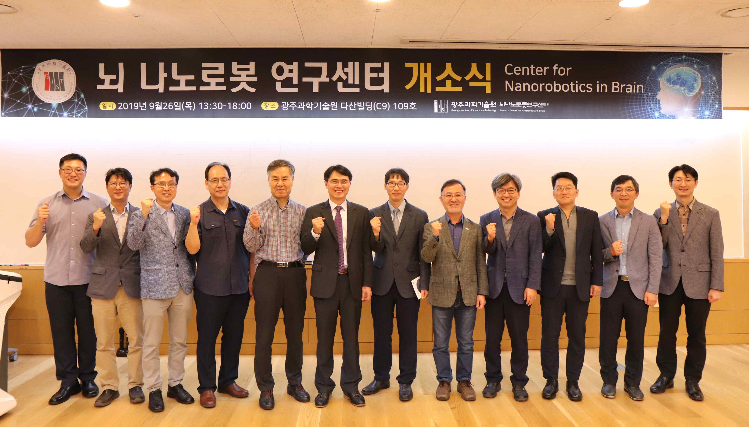

▲ Center for Nanorobotics in Brain opening ceremony