

**Gwangju Institute of Science and Technology**

**Official Press Release (https://www.gist.ac.kr/)**

**Section of** Hyo Jung Kim Nayeong Lee

**Public Affairs** Section Chief Senior Administrator

(+82) 62-715-2061 (+82) 62-715-2062

**Contact Person** Section of Public Relations

**for this Article** (+82) 62-715-2061~3

**Release Date** 2020.03.02

**GIST sends a special transport bus for students from Daegu and North Gyeongsang province**

**in response to COVID-19**

□ Gwangju Institute of Science and Technology (GIST, President Kiseon Kim) is making all-out efforts to preemptively prevent the spread of COVID-19.

∘ Since the beginning of the COVID-19 outbreak, GIST has developed a strong response system and community guidelines for preventative measures and has deployed emergency response personnel with additional funding. In addition, thermal imaging cameras are installed in major buildings with thorough quarantines for the entire campus.

□ For the first time in its history, GIST has cancelled the matriculation and graduation ceremonies (which has been moved to August for participants) and the start of the semester has been postponed to March 13 (Friday), and set the standards for each phase of the school management and has thoroughly applied the methods of observation and isolation. Standards for the management of observation and isolations have also been established.

∘ As a result, about 50 students and faculty members suspected of having overlapping routes with those with confirmed patients or having returned from overseas trips were required to be isolated on a dormitory floor.

□ Because of the numerous COVID-19 patients in Daegu and North Gyeongbuk province, a special bus was arranged to transport student from Daegu to the GIST campus in Gwangju on February 29 to prevent new infections among GIST freshmen and students who have arrived to start the semester in March.

∘ The students who rode the bus sat at a distance of two meters from each other after disinfecting their hands while wearing masks and gloves. These students were placed in a single dormitory room at GIST with controlled access and will be quarantined for 14 days. Students who inevitably move separately from Daegu and Gyeongbuk will be admitted to the dormitory after fever and breath check. Students who arrive separately from Daegu and North Gyeongsang province will also be admitted to the dormitory after checking for fever and respiratory symptoms.

∘ A freshman on the bus said, "I am grateful for GIST officials for allowing me to move safely to Gwangju under the unstable conditions in Daegu and North Gyeongsang province. I hope we can overcome the Korona 19 as soon as possible through all of our efforts."

□ At the same time, GIST is also thoroughly managing a total of 122 foreign students currently attending GIST, and about 20 students from Nepal, Pakistan, China, etc. will be entering the country for the 2020 spring semester.

∘ Accordingly, from the beginning of the CORVID-19 outbreak, GIST, in cooperation with the Ministry of Education-Immigration and Gwangju City Hall, has been providing daily status reports and has managed the daily routine of six Chinese students while actively guiding foreign students on the rules for preventing the spread of CORVID-19.

∘ Since December 1 of last year, two students from China (Hong Kong and Macau) have been quarantined for two weeks in the dormitory and have completed their health monitoring. As a safety precaution, orientation for new international student has been canceled and replaced with an online video to minimize disruptions for the students.

□ GIST Vice President Jong-In Song, who leads the GIST COVID-19 Emergency Response Committee, said, "Since the early days of COVID-19, GIST has been working hard with its members to build a strong response system and prevent the spread of the virus. Until the end of this crisis, we will do our best to manage the safety of the school with the management of our dedicated staff in dealing with this emergency situation."

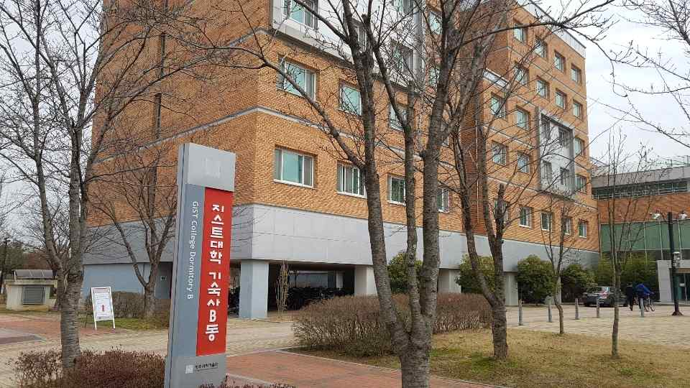

(Photo 1) College dormitory building used as the COVID-19 isolation building

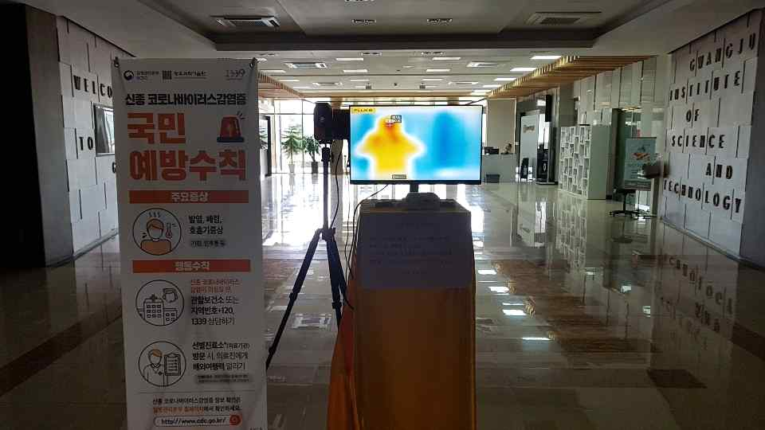

(Photo 2) Installation of a thermal imaging camera in major buildings at GIST

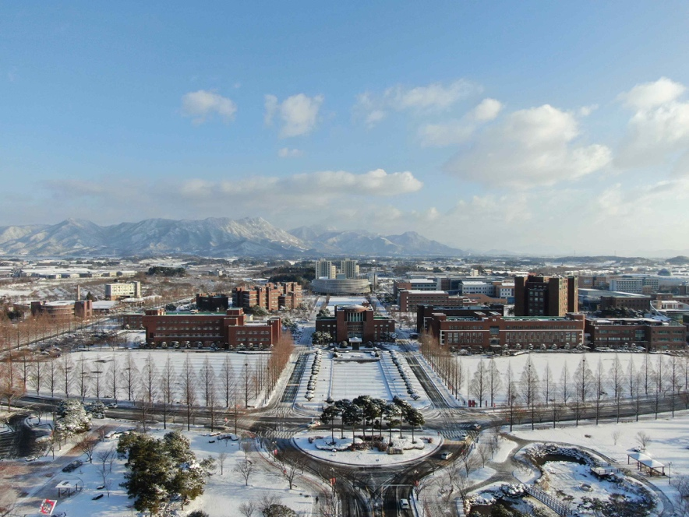

(Photo 3) A view of GIST