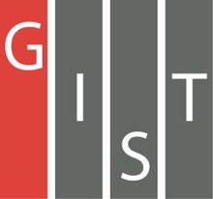

**Gwangju Institute of Science and Technology**

**Official Press Release (https://www.gist.ac.kr/)**

**Section of** Mi-Yeon Kim Nayeong Lee

**Public Affairs** Section Chief Senior Administrator

(+82) 62-715-2020 (+82) 62-715-2024

**Contact Person** Seo-Young Kang, Administrator

**for this Article** International Environmental Research Institute

(+82) 62-715-3393

**Release Date** 2018.07.17

**GIST IERI participates in the 10th International Climate & Environment Industry Fair and introduces the GIST Hope Water Purifier**

□ The GIST International Environmental Research Institute (IERI, Director In Seop Chang) participated in the '10th International Climate & Environmental Industry Fair' at the Kim Daejung Convention Center in Gwangju from July 11 to 13, 2018, and exhibited 'GIST Hope Water Purifier' to supply drinking water to climate-affected areas and introduced a project to support developing countries.

∘ This exhibition was hosted jointly by Gwangju City and Jeonnam Province, and it was very successful with 140 Korean and foreign companies attending on the first day, such as POSCO, Kia Motors, and GS Caltex.

□ The 'GIST Hope Water Purifier' project, introduced in this exhibition, began in 2006 with the Global Water Supply System Project and is a global project to provide safe drinking water supply in developing countries vulnerable to climate change.

∘ The water purifier is a water treatment device utilizing a gravity-driven membrane. The purifier relies on gravity to purify water and does not require any energy. Contaminants and impurities can be removed with high efficiency, and it can be used continuously for at least 10 years without any special maintenance, making it easy for people to use.

∘ In particular, the water purifier was developed with advanced technology so that it can be customized according to local situations such as filtering, disinfecting, and removing pathogenic microorganisms and heavy metals.

□ IERI Director In Seop Chang said, "This international exhibition is a good opportunity to show global technology like the 'GIST Hope Purifier' to visitors. We plan to maximize the benefits of global social contribution by expanding the supply of water treatment equipment in cooperation with government and non-government aid organizations."

□ GIST IERI is a global research institute for proactive response to environmental and climate change, including research and education on sustainable environmental technologies, and provides education and international cooperation to improve human welfare through environmental management and sustainable development in developing countries.

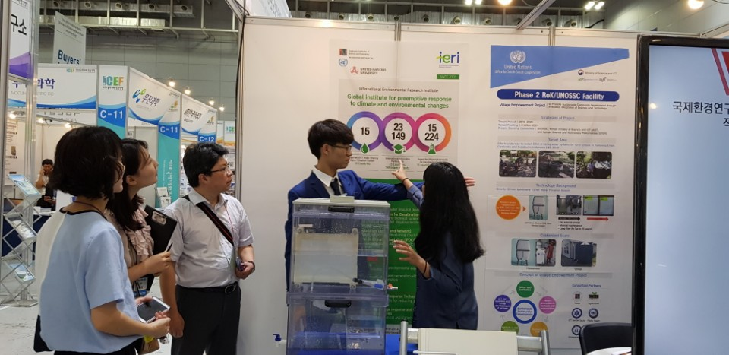

▲ GIST International Environmental Research Institute participates in the 10th International Climate & Environment Industry Fair and introduces the GIST Hope Water Purifier